1.01 Rational and irrational numbers
Year 9 Maths · A5 question sheet · Level 2 · Core
This worksheet practises sorting real numbers into rational and irrational, telling surds apart from other irrational numbers, turning recurring decimals into fractions, and estimating and ordering roots. Tip: before you decide, simplify. $\sqrt{0.09}$ looks irrational, but it is exactly 0.3.

 Understanding
- Put a tick in every column that describes the number. (A surd is an irrational root, like $\sqrt{5}$ or $\sqrt[3]{4}$.)
Number | Integer | Rational | Surd
−11
$\frac{7}{3}$
$\sqrt{45}$
$\sqrt{0.09}$
$0.\dot{8}$
$π$
$\sqrt[3]{64}$
$\sqrt[3]{10}$
$2π$
$−\sqrt{121}$

- Show that each number is rational by writing it as a fraction $\frac{a}{b}$ in simplest form.
  - −3.4 =
  - 0.125 =
  - $2\frac{3}{4}$ =
  - $\sqrt{\frac{4}{9}}$ =
  - $\sqrt{1.21}$ =
  - $\sqrt[3]{−27}$ =
- Every recurring decimal is rational. Example: let x = $0.\dot{5}$. Then 10x = $5.\dot{5}$. Subtract to get 9x = 5, so x = $\frac{5}{9}$. Use this method to write each recurring decimal as a fraction in simplest form. (Hint: for two repeating digits, multiply by 100.)
  - $0.\dot{7}$ =
  - $0.\dot{2}\dot{4}$ =
  - $1.\dot{3}$ =
  - $0.1\dot{6}$ =

 Fluency
- Write rational or irrational for each number. Simplify first if you can.
  - $\sqrt{169}$
  - $\sqrt{170}$
  - $\sqrt{2}×\sqrt{8}$
  - $\sqrt{3}+\sqrt{3}$
  - $π+1$
  - $(\sqrt{5})^{2}$
  - $\frac{\sqrt{12}}{\sqrt{3}}$
  - $\sqrt[3]{100}$
- Without a calculator, write the two integers next to each other that each number lies between.
  - $\sqrt{60}$ is between ______________ and
  - $−\sqrt{20}$ is between ______________ and
  - $\sqrt[3]{30}$ is between ______________ and
  - $\sqrt{200}$ is between ______________ and
  - $3+\sqrt{7}$ is between ______________ and
  - $\sqrt[3]{−50}$ is between ______________ and
- Use a calculator to write each number correct to 3 decimal places.
  - $\sqrt{60}$ ≈
  - $\sqrt[3]{30}$ ≈
  - $3+\sqrt{7}$ ≈
  - $\frac{π}{4}$ ≈
- Write these numbers in order from smallest to largest. Use a calculator, and write each one to 4 decimal places first.
- $\sqrt{10}$, $π$, $3.\dot{1}$, $\frac{19}{6}$, $\sqrt[3]{30}$
- Order:

 Reasoning
- Mark and label these numbers on a copy of the number line in your book, as accurately as you can: $−\sqrt{10}$, $−\frac{5}{4}$, $0.\dot{3}$, $\sqrt{6}$, $\sqrt[3]{20}$.
- 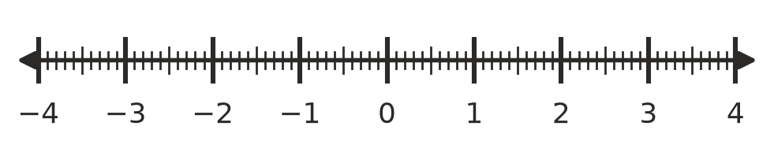
- $\sqrt{6}$ and $π$ are both irrational. Explain why $\sqrt{6}$ is a surd but $π$ is not.
- Is each statement always true, sometimes true or never true? Write Always, Sometimes or Never. For each “Sometimes”, give one example where it is true and one where it is false.
Statement
The square root of a whole number is irrational.
The sum of two rational numbers is rational.
The product of two irrational numbers is irrational.
A recurring decimal is irrational.

- Give an example of each.
  - a surd between 6 and 7
  - an irrational number between 3 and 4 that is not a surd
  - a rational number between $\sqrt{5}$ and $\sqrt{6}$

 Problem solving
- Use Pythagoras’ theorem to find each missing length exactly. Then say whether it is rational or irrational.
- 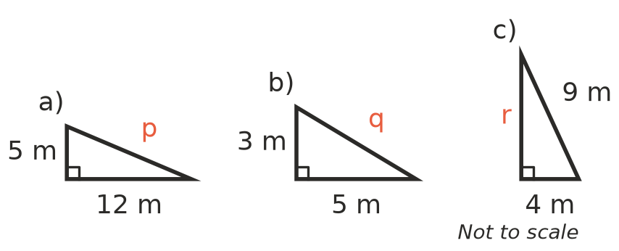
  - p = ______________ rational or irrational?
  - q = ______________ rational or irrational?
  - r = ______________ rational or irrational?
- When a pebble is dropped from a bridge, the time in seconds it takes to hit the water is about $t=\sqrt{\frac{h}{5}}$, where h is the height of the bridge in metres.
  - Find the time for a bridge 20 m high. Is it rational or irrational?
  - Find the time for a bridge 30 m high, exactly and correct to 2 decimal places.
  - A pebble takes 3 seconds to hit the water. How high is the bridge?
- A square courtyard has sides 6 m long. A straight path runs from one corner to the opposite corner.
  - Use Pythagoras’ theorem to find the exact length of the path.
  - Is the length rational or irrational?
  - Find the length of the path correct to the nearest centimetre.

