1.01 Rational and irrational numbers
Year 9 Maths · A5 question sheet · Level 1 · Warm-up
This worksheet practises sorting numbers into integers, rational numbers and irrational numbers, and spotting surds. Tip: a number is rational if you can write it as a fraction $\frac{a}{b}$ of two integers. A surd is a root, like $\sqrt{7}$, that does not work out to a whole number or a fraction, so its decimal goes on forever without repeating.

 Understanding
- Complete each sentence with one of these words: integer, rational, irrational, surd.
  - A number that can be written as a fraction $\frac{a}{b}$ of two integers (where b is not 0) is
  - A positive or negative whole number, or zero, is an
  - A number whose decimal goes on forever without a repeating pattern is
  - An irrational root such as $\sqrt{7}$ is called a
- Work out each root.
  - $\sqrt{25}$ =
  - $\sqrt{64}$ =
  - $\sqrt{100}$ =
  - $\sqrt{144}$ =
  - $\sqrt[3]{8}$ =
  - $\sqrt[3]{27}$ =
- Show that each number is rational by writing it as a fraction $\frac{a}{b}$.
  - 0.7 =
  - −6 =
  - 2.5 =
  - 0.25 =
  - $1\frac{1}{3}$ =
  - $\sqrt{49}$ =

 Fluency
- Put a tick in every column that describes the number.
Number | Integer | Rational
9
−4
$\frac{3}{5}$
$\sqrt{10}$
0.6
$π$
$\sqrt{36}$
−2.75

- Write surd or not a surd for each number. If it is not a surd, write its value.
  - $\sqrt{3}$
  - $\sqrt{9}$
  - $\sqrt{20}$
  - $\sqrt{81}$
  - $\sqrt{50}$
  - $\sqrt{1}$
- The square numbers are 1, 4, 9, 16, 25, 36, 49, 64, 81 and 100. Use them to write the two whole numbers next to each other that each root lies between.
  - $\sqrt{10}$ is between ______________ and
  - $\sqrt{30}$ is between ______________ and
  - $\sqrt{55}$ is between ______________ and
  - $\sqrt{90}$ is between ______________ and
- Use a calculator to write each number correct to 2 decimal places. Check that each answer fits with Question 6.
  - $\sqrt{10}$ ≈
  - $\sqrt{30}$ ≈
  - $\sqrt{55}$ ≈
  - $\sqrt{90}$ ≈

 Reasoning
- Mark and label these numbers on a copy of the number line in your book, as accurately as you can: −2.5, $\frac{1}{2}$, $\sqrt{4}$, $\sqrt{7}$, $π$.
- 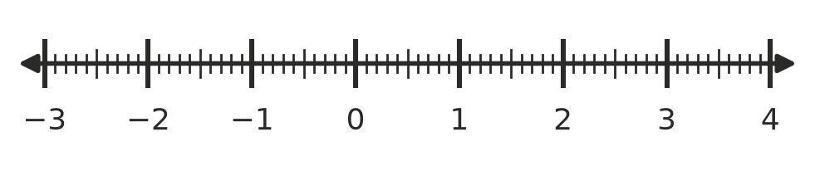
- Write these numbers in order from smallest to largest. You may use a calculator.
- $\sqrt{5}$, 2, 2.5, $\frac{3}{2}$, $\sqrt{9}$
- Order:
- Ella says $\sqrt{16}$ is a surd because it has a square root sign. Is she right? Explain.

 Problem solving
- A square tile has an area of 12 cm².
  - Write the exact side length of the tile.
  - Is the side length rational or irrational?
  - Use a calculator to find the side length correct to 1 decimal place.
  - Find the perimeter of the tile, correct to 1 decimal place.
- Use Pythagoras’ theorem, $c^{2}=a^{2}+b^{2}$, to find each missing length. Write the exact length, then say whether it is rational or irrational.
- 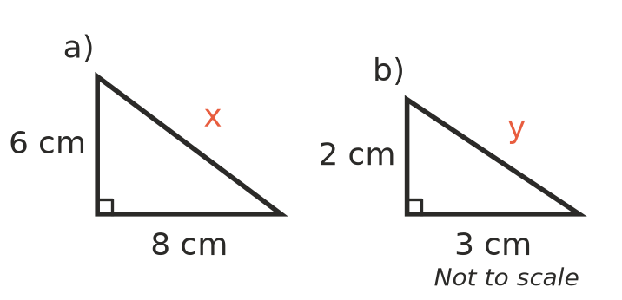
  - x = ______________ rational or irrational?
  - y = ______________ rational or irrational?

