Quadratics: Practice test 3
Year 9 Maths · Test · Test 3
Name: ____________________ Date: ______________
Time: 45 minutes
Total: 40 marks
Show your working in the boxes. Then write each final answer on the answer sheet on the last page. Write coordinates as (x, y).

 Section A: No calculator
- This question is about quadratic relationships.
  - Which two of these equations are quadratic: A: $y=x^{2}−9$, B: $y=x(x+1)−x^{2}$, C: $y=\frac{x^{2}}{4}$, D: $y=3x−4$? Write the letters. (1 mark)

  - Use second differences to show that this table follows a quadratic rule. Then find the value of y when x = 3. (1 mark)
x | −2 | −1 | 0 | 1 | 2 | 3
y | 9 | 4 | 1 | 0 | 1

- Use the graph of the parabola to answer each part.
- 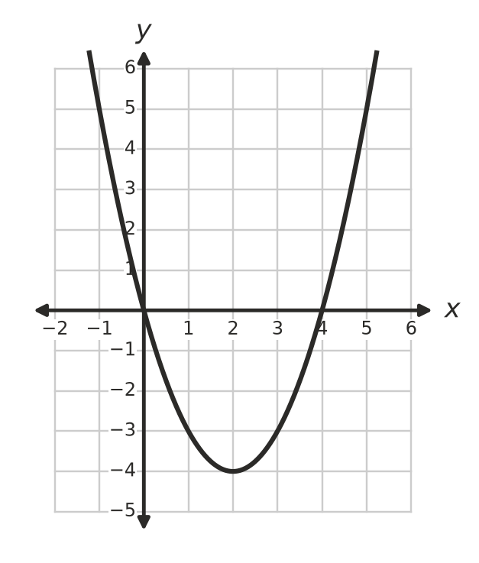
  - Write the coordinates of the turning point. Is it a maximum or a minimum? (1 mark)

  - Write the equation of the axis of symmetry. (1 mark)

  - Write the x-intercepts. (1 mark)

  - Write the y-intercept. (1 mark)

- Graphs A and B are both in the form $y=ax^{2}$. The marked points are on the graphs. Choose the equation of each graph from: $y=4x^{2}$, $y=\frac{1}{4}x^{2}$, $y=−4x^{2}$, $y=−\frac{1}{4}x^{2}$. (2 marks)
- 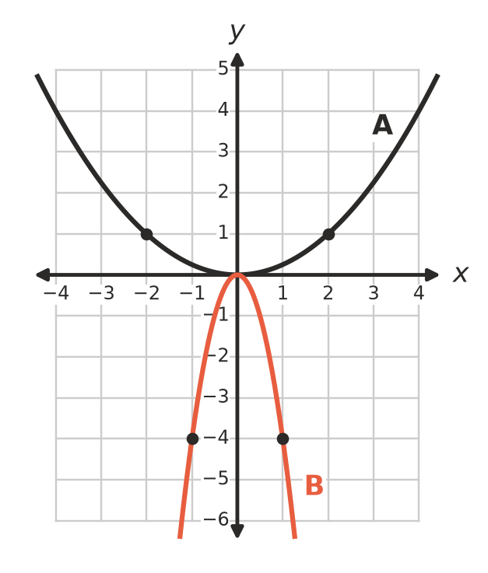

- The parabola $y=x^{2}+k$ passes through the point (−2, −1).
  - Find the value of k. (1 mark)

  - Describe how the graph of $y=x^{2}$ has been moved to make this parabola. (1 mark)

- This question is about turning point form.
  - Describe the transformations that change the graph of $y=x^{2}$ into the graph of $y=3(x−1)^{2}+4$. (2 marks)

  - Write the coordinates of the turning point of $y=−(x+6)^{2}−2$. Is it a maximum or a minimum? (1 mark)

- A parabola has the equation $y=−(x−2)(x−6)$.
  - Write the x-intercepts. (1 mark)

  - Find the coordinates of the turning point. (2 marks)

- A parabola has the equation $y=x^{2}+2x−15$.
  - Write the y-intercept. (1 mark)

  - Find the equation of the axis of symmetry. (1 mark)

  - Find the coordinates of the turning point. (1 mark)

- The graph of $y=x^{2}+2x−3$ is shown.
- 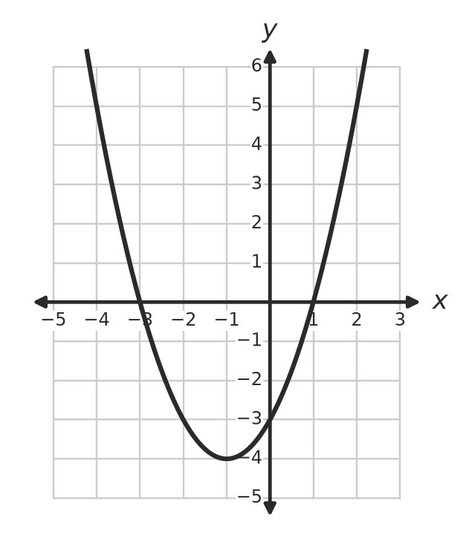
  - How many solutions does $x^{2}+2x−3=−4$ have? Write the solution(s). (1 mark)

  - Use the graph to solve $x^{2}+2x−3=5$. (1 mark)

- Solve each equation.
  - $3x^{2}=75$ (1 mark)

  - $(x−4)^{2}−36=0$ (1 mark)

- Solve each equation by factorising.
  - $x^{2}+3x−40=0$ (1 mark)

  - $x^{2}+12=7x$ (2 marks)

- Josh solved $(x−3)(x+2)=6$ like this: “$x−3=6$ or $x+2=6$, so x = 9 or x = 4.” Explain Josh’s mistake, then solve the equation correctly. (2 marks)

 Section B: Calculator allowed
- A model rocket is launched straight up from the ground at a school science day. Its height h metres after t seconds is $h=29.4t−4.9t^{2}$.
  - Find the height of the rocket after 1 second. (1 mark)

  - After how many seconds does the rocket land? (1 mark)

  - Find the greatest height of the rocket. (1 mark)

  - Use guess and check (or a graph) to find both times when the rocket is 30 m high. Give each answer correct to 1 decimal place. (2 marks)

- A rectangular dog run is x metres wide and (x + 7) metres long. Its area is 44 m².
  - Write an equation for the area, and rearrange it so that one side is 0. (1 mark)

  - Solve the equation to find the width and length of the dog run. (2 marks)

  - Fencing costs $23.75 per metre. Find the cost of fencing all the way around the dog run. (1 mark)

- The equation $x^{2}−5x+2=0$ has one solution between 0 and 1.
  - Substitute x = 0 and x = 1 into $x^{2}−5x+2$ to show why there is a solution between 0 and 1. (1 mark)

  - Use guess and check to find this solution correct to 1 decimal place. Show your trials. (2 marks)

 Answer sheet
Name: ____________________
Write your final answer for each question in the table.
Question | Answer | Marks | Question | Answer | Marks
1a |  | /1 | 8a |  | /1
1b |  | /1 | 8b |  | /1
2a |  | /1 | 9a |  | /1
2b |  | /1 | 9b |  | /1
2c |  | /1 | 10a |  | /1
2d |  | /1 | 10b |  | /2
3 |  | /2 | 11 |  | /2
4a |  | /1 | 12a |  | /1
4b |  | /1 | 12b |  | /1
5a |  | /2 | 12c |  | /1
5b |  | /1 | 12d |  | /2
6a |  | /1 | 13a |  | /1
6b |  | /2 | 13b |  | /2
7a |  | /1 | 13c |  | /1
7b |  | /1 | 14a |  | /1
7c |  | /1 | 14b |  | /2
 |  |  |  | Total | /40

