Quadratics: Practice test 2
Year 9 Maths · Test · Test 2
Name: ____________________ Date: ______________
Time: 45 minutes
Total: 40 marks
Show your working in the boxes. Then write each final answer on the answer sheet on the last page. Write coordinates as (x, y).

 Section A: No calculator
- This question is about quadratic relationships.
  - Which two of these equations are quadratic: A: $y=4−x^{2}$, B: $y=2^{x}$, C: $y=(x+3)^{2}$, D: $y=6x−1$? Write the letters. (1 mark)

  - Use second differences to show that this table follows a quadratic rule. Then find the value of y when x = 6. (1 mark)
x | 1 | 2 | 3 | 4 | 5 | 6
y | 1 | 6 | 13 | 22 | 33

- Use the graph of the parabola to answer each part.
- 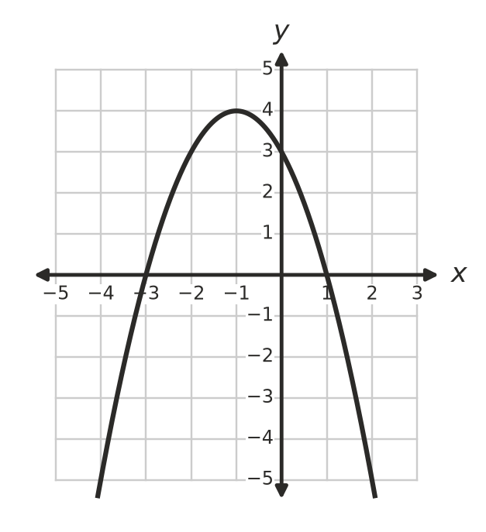
  - Write the coordinates of the turning point. Is it a maximum or a minimum? (1 mark)

  - Write the equation of the axis of symmetry. (1 mark)

  - Write the x-intercepts. (1 mark)

  - Write the y-intercept. (1 mark)

- Describe how each graph is different from the graph of $y=x^{2}$.
  - $y=5x^{2}$ (1 mark)

  - $y=−\frac{1}{3}x^{2}$ (1 mark)

- A parabola with the equation $y=(x−h)^{2}$ passes through the point (1, 4). Find the two possible values of h. (2 marks)

- This question is about turning point form.
  - The graph of $y=x^{2}$ is translated 2 units right and 6 units down. Write the equation of the new graph. (1 mark)

  - A parabola has its turning point at (−1, 3) and passes through the point (0, 5). Find its equation in the form $y=a(x−h)^{2}+k$. (2 marks)

- A parabola has the equation $y=(x+1)(x−7)$.
  - Write the x-intercepts. (1 mark)

  - Find the coordinates of the turning point. (2 marks)

- A parabola has the equation $y=x^{2}−8x+12$.
  - Write the y-intercept. (1 mark)

  - Find the equation of the axis of symmetry. (1 mark)

  - Find the coordinates of the turning point. (1 mark)

- The graph of $y=x^{2}+2x−8$ is shown.
- 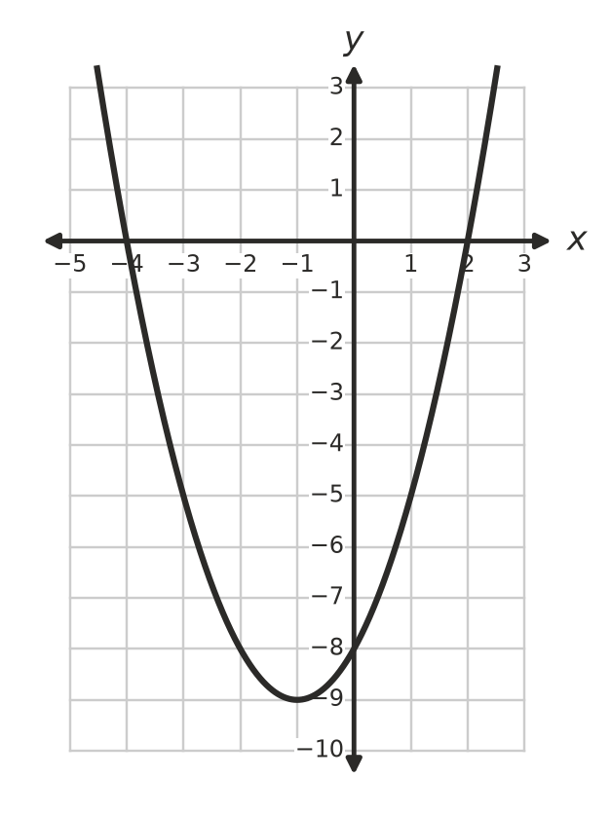
  - Use the graph to solve $x^{2}+2x−8=0$. (1 mark)

  - Use the graph to solve $x^{2}+2x−8=−8$. (1 mark)

- Solve each equation.
  - $x^{2}−81=0$ (1 mark)

  - $(x+2)^{2}=25$ (1 mark)

- Solve each equation by factorising.
  - $x^{2}−11x+28=0$ (1 mark)

  - $x(x+4)=21$ (2 marks)

- Write a quadratic equation that has the solutions x = −5 and x = 2. Give your answer in factorised form, then expand it to the form $x^{2}+bx+c=0$. (2 marks)

 Section B: Calculator allowed
- A diver jumps from a platform at the beach. Her height h metres above the water after t seconds is $h=−5t^{2}+10t+15$.
  - How high is the platform? (1 mark)

  - Find her greatest height above the water. (1 mark)

  - Show that she reaches the water after 3 seconds. (1 mark)

  - Use guess and check (or a graph) to find when she is 12 m above the water on the way down. Give your answer correct to 1 decimal place. (2 marks)

- A square photo with sides of x cm has a border 2 cm wide all the way around it. The total area of the photo and border is 210.25 cm².
  - Write an equation for the total area in terms of x. (1 mark)

  - Solve your equation to find the side length of the photo. (2 marks)

  - Find the area of the border. (1 mark)

- The equation $x^{2}+2x=10$ has one positive solution.
  - Substitute x = 2 and x = 3 into $x^{2}+2x$ to show that the solution is between 2 and 3. (1 mark)

  - Use guess and check to find the solution correct to 1 decimal place. Show your trials. (2 marks)

 Answer sheet
Name: ____________________
Write your final answer for each question in the table.
Question | Answer | Marks | Question | Answer | Marks
1a |  | /1 | 8a |  | /1
1b |  | /1 | 8b |  | /1
2a |  | /1 | 9a |  | /1
2b |  | /1 | 9b |  | /1
2c |  | /1 | 10a |  | /1
2d |  | /1 | 10b |  | /2
3a |  | /1 | 11 |  | /2
3b |  | /1 | 12a |  | /1
4 |  | /2 | 12b |  | /1
5a |  | /1 | 12c |  | /1
5b |  | /2 | 12d |  | /2
6a |  | /1 | 13a |  | /1
6b |  | /2 | 13b |  | /2
7a |  | /1 | 13c |  | /1
7b |  | /1 | 14a |  | /1
7c |  | /1 | 14b |  | /2
 |  |  |  | Total | /40

