Quadratics: Practice test 1
Year 9 Maths · Test · Test 1
Name: ____________________ Date: ______________
Time: 45 minutes
Total: 40 marks
Show your working in the boxes. Then write each final answer on the answer sheet on the last page. Write coordinates as (x, y).

 Section A: No calculator
- This question is about quadratic relationships.
  - Which two of these equations are quadratic: A: $y=5x^{2}−1$, B: $y=3x+7$, C: $y=x(x−4)$, D: $y=\frac{2}{x}$? Write the letters. (1 mark)

  - Use second differences to show that this table follows a quadratic rule. Then find the value of y when x = 5. (1 mark)
x | 0 | 1 | 2 | 3 | 4 | 5
y | 2 | 3 | 6 | 11 | 18

- Use the graph of the parabola to answer each part.
- 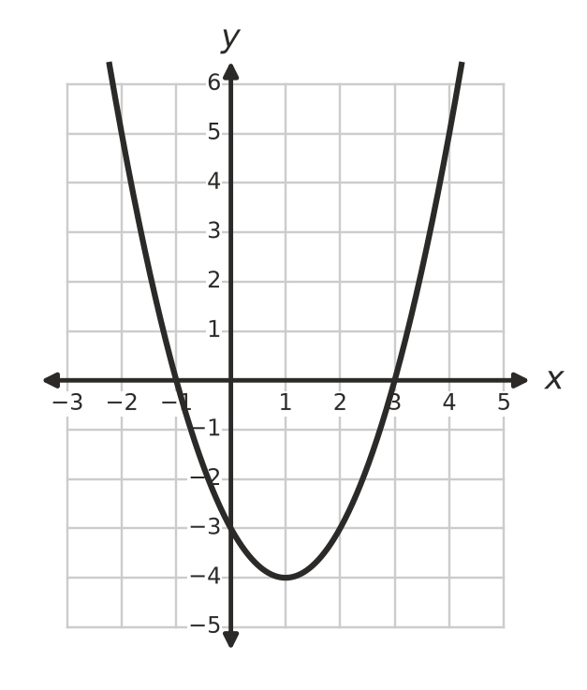
  - Write the coordinates of the turning point. Is it a maximum or a minimum? (1 mark)

  - Write the equation of the axis of symmetry. (1 mark)

  - Write the x-intercepts. (1 mark)

  - Write the y-intercept. (1 mark)

- The graph shows three parabolas, A, B and C. Write the letter of the graph that matches each equation: (i) $y=\frac{1}{2}x^{2}$, (ii) $y=−2x^{2}$, (iii) $y=3x^{2}$. (2 marks)
- 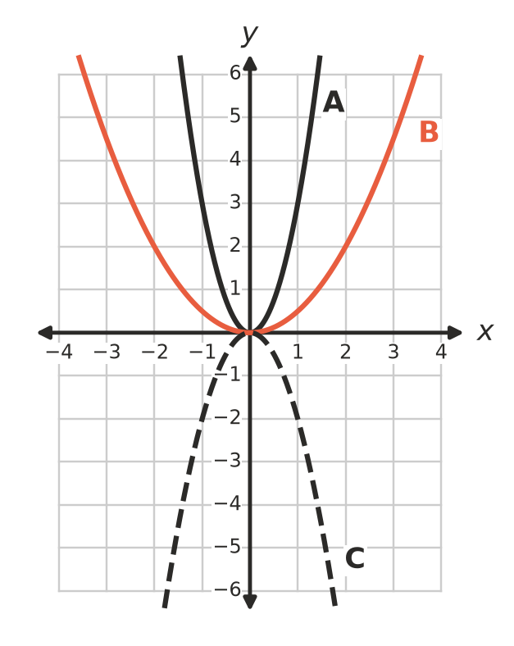

- The parabola $y=x^{2}+k$ passes through the point (3, 5).
  - Find the value of k. (1 mark)

  - Describe how the graph of $y=x^{2}$ has been moved to make this parabola. (1 mark)

- This question is about turning point form.
  - Describe the transformations that change the graph of $y=x^{2}$ into the graph of $y=−(x+3)^{2}+5$. (2 marks)

  - Write the coordinates of the turning point of $y=2(x−4)^{2}−7$. (1 mark)

- A parabola has the equation $y=(x−2)(x+6)$.
  - Write the x-intercepts. (1 mark)

  - Find the coordinates of the turning point. (2 marks)

- A parabola has the equation $y=x^{2}+6x+5$.
  - Write the y-intercept. (1 mark)

  - Find the equation of the axis of symmetry. (1 mark)

  - Find the coordinates of the turning point. (1 mark)

- The graph of $y=−x^{2}+2x+8$ is shown.
- 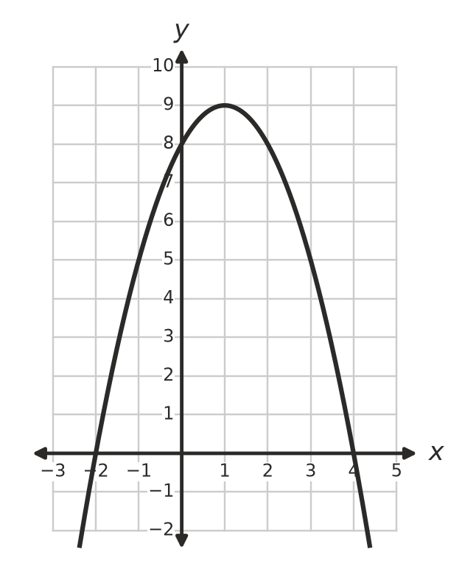
  - Use the graph to solve $−x^{2}+2x+8=0$. (1 mark)

  - How many solutions does $−x^{2}+2x+8=10$ have? Use the graph to explain. (1 mark)

- Solve each equation.
  - $x^{2}=64$ (1 mark)

  - $(x−5)^{2}=9$ (1 mark)

- Solve each equation by factorising.
  - $x^{2}+5x−14=0$ (1 mark)

  - $x^{2}=6x+16$ (2 marks)

- Mia says that the equation $x^{2}+9=0$ has the solutions x = 3 and x = −3. Explain why Mia is wrong, and say how many solutions the equation has. (2 marks)

 Section B: Calculator allowed
- A footy is kicked straight up from the ground. Its height h metres after t seconds is $h=20t−5t^{2}$.
  - Find the height of the footy after 1.5 seconds. (1 mark)

  - After how many seconds does the footy land on the ground? (1 mark)

  - Find the greatest height of the footy, and the time when it reaches it. (1 mark)

  - Use guess and check (or a graph) to find both times when the footy is 12 m high. Give each answer correct to 1 decimal place. (2 marks)

- A rectangular vegie garden is 3 m longer than it is wide. Its area is 40 m². Let the width be x metres.
  - Show that $x^{2}+3x−40=0$. (1 mark)

  - Solve the equation. Explain why one of the solutions does not make sense here. (2 marks)

  - Garden edging costs $14.90 per metre. Find the cost of edging all the way around the garden. (1 mark)

- The equation $x^{2}−3x−2=0$ has one solution between 3 and 4.
  - Substitute x = 3 and x = 4 into $x^{2}−3x−2$ to show why there is a solution between 3 and 4. (1 mark)

  - Use guess and check to find this solution correct to 1 decimal place. Show your trials. (2 marks)

 Answer sheet
Name: ____________________
Write your final answer for each question in the table.
Question | Answer | Marks | Question | Answer | Marks
1a |  | /1 | 8a |  | /1
1b |  | /1 | 8b |  | /1
2a |  | /1 | 9a |  | /1
2b |  | /1 | 9b |  | /1
2c |  | /1 | 10a |  | /1
2d |  | /1 | 10b |  | /2
3 |  | /2 | 11 |  | /2
4a |  | /1 | 12a |  | /1
4b |  | /1 | 12b |  | /1
5a |  | /2 | 12c |  | /1
5b |  | /1 | 12d |  | /2
6a |  | /1 | 13a |  | /1
6b |  | /2 | 13b |  | /2
7a |  | /1 | 13c |  | /1
7b |  | /1 | 14a |  | /1
7c |  | /1 | 14b |  | /2
 |  |  |  | Total | /40

