5.09 Solutions to quadratics
Year 9 Maths · Worksheet · Level 3 · Challenge
Name: ____________________ Date: ______________
This worksheet practises solving quadratic equations graphically and numerically, including intersections with lines and answers to two decimal places. Tip: to solve “quadratic = line”, graph both and read the $x$-values where they meet. For a decimal answer, find where the value changes sign in a table, then halve the gap until you know the rounded answer.

 Understanding
- The graph shows $y=x^{2}+2x−3$.
- 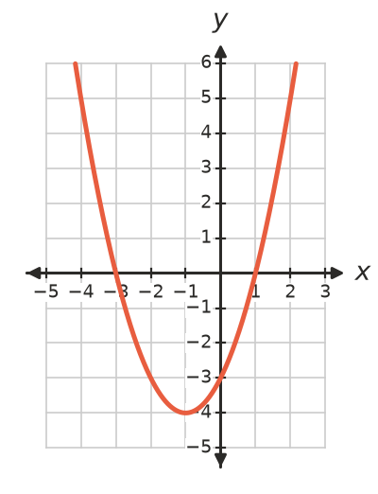
  - Solve $x^{2}+2x−3=0$. ______________
  - Solve $x^{2}+2x−3=5$. ______________
  - Solve $x^{2}+2x=0$ using the same graph. Which horizontal line do you need? ______________
  - For which values of $k$ does $x^{2}+2x−3=k$ have two solutions? ______________
- Consider the equation $x^{2}−6x+c=0$. Write it as $(x−3)^{2}+c−9=0$ to decide which values of $c$ give:
  - two solutions ______________
  - one solution ______________
  - no solutions ______________

 Fluency
- The graph shows $y=x^{2}−1$ and $y=2x+2$.
- 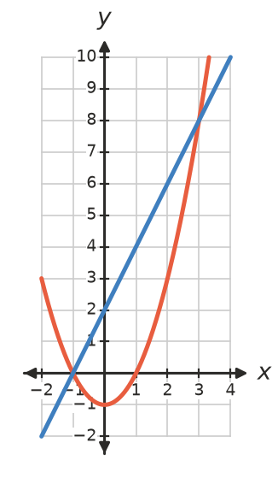
  - Write the coordinates of the points where they meet. ______________
  - Write the quadratic equation, in the form $x^{2}+bx+c=0$, that these $x$-values solve. ______________
- Use a table of values and a calculator to find the positive solution of $x^{2}−3x−1=0$ to two decimal places. Show the values you tried.

- The graph shows $y=−x^{2}+2x+4$. The grid lines are 0.5 units apart.
- 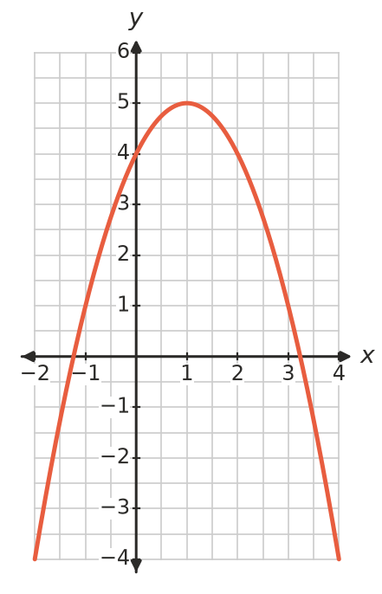
  - Estimate the solutions of $−x^{2}+2x+4=0$ to one decimal place. ______________
  - Use the graph to solve $−x^{2}+2x+4=4$. ______________

 Reasoning
- Explain how to solve $x^{2}−x−6=0$ using only the graph of $y=x^{2}$ and one straight line. Which line is it, and what are the solutions?

- Show that $x^{2}+4x+7=0$ has no solutions.

 Problem solving
- An arrow is fired across a paddock. Its height is $h=−0.02x^{2}+0.8x+1.5$ metres when it has travelled $x$ m horizontally.
  - Find its greatest height. ______________
  - A target’s centre is 7.5 m high. At what two distances could it be placed for the arrow to hit the centre? ______________
  - Use technology to find how far the arrow travels before hitting the ground, to one decimal place. ______________
- A photo 20 cm by 30 cm has a border of width $x$ cm all around it. The total area of the photo and border is 1000 cm².
  - Show that $(20+2x)(30+2x)=1000$ simplifies to $x^{2}+25x−100=0$.

  - Use a table of values or technology to find the width of the border to one decimal place. ______________
- Use the graphs of $y=x^{2}$ and $y=3x+4$ (sketch them or use technology) to find all values of $x$ for which $x^{2}$ is greater than $3x+4$.

- Find the value of $k$ for which the line $y=2x+k$ just touches the parabola $y=x^{2}$. Where does it touch? (Tip: write $x^{2}−2x−k$ in turning point form.)

