5.09 Solutions to quadratics
Year 9 Maths · A5 question sheet · Level 2 · Core
This worksheet practises solving quadratic equations with graphs, tables and technology. Tip: to solve an equation like $x^{2}−x−6=4$, draw the horizontal line $y=4$ on the graph of $y=x^{2}−x−6$ and read the $x$-values where they meet. If no exact answer shows up in a table, narrow it down: try values closer and closer together.

 Understanding
- The graph shows $y=x^{2}−x−6$.
- 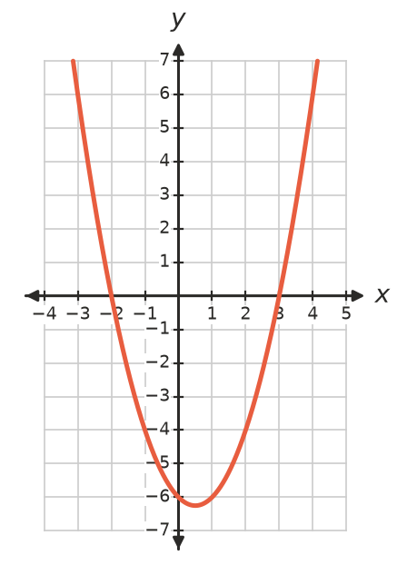
  - Solve $x^{2}−x−6=0$.
  - Solve $x^{2}−x−6=−4$.
  - Solve $x^{2}−x−6=6$.
  - The turning point is (0.5, −6.25). For which value of $k$ does $x^{2}−x−6=k$ have exactly one solution?
- Without drawing, write the number of solutions of each equation. Think about the turning point and the concavity.
Equation
$(x−3)^{2}+2=0$
$−(x+1)^{2}+5=0$
$2(x−4)^{2}=0$
$x^{2}−6x+9=0$
$−x^{2}−4=0$

 Fluency
- The graph shows $y=x^{2}$ and $y=x+2$.
- 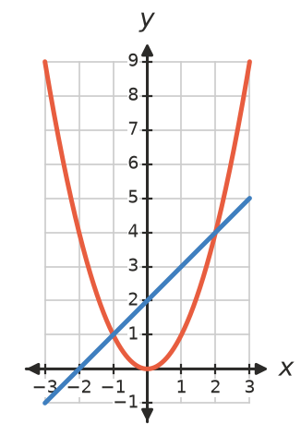
  - Write the coordinates of the points where they meet.
  - Which equation do the $x$-values of these points solve?
- The graph shows $y=x^{2}−2x$. Use it to solve each equation.
- 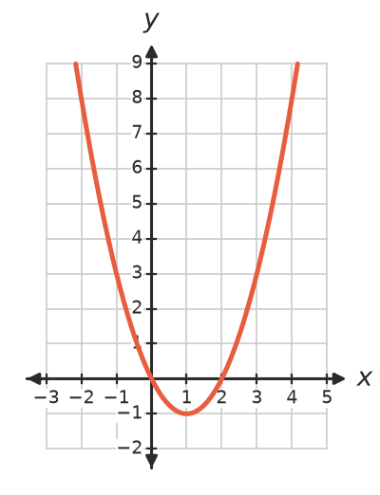
  - $x^{2}−2x=0$
  - $x^{2}−2x=3$
  - $x^{2}−2x=8$
  - $x^{2}−2x=−1$
  - $x^{2}−2x=−2$
- Use a calculator. The equation $x^{2}+2x−5=0$ has a solution between 1 and 2.
$x$ | 1 | 1.2 | 1.4 | 1.6 | 1.8 | 2
$x^{2}+2x−5$

  - Copy and complete the table. Between which two values in the table is the solution?
  - Work out $x^{2}+2x−5$ for $x=1.45$. Use this to give the solution to one decimal place.
- The graph shows $y=x^{2}−4x+1$. The grid lines are 0.5 units apart. Estimate the solutions of $x^{2}−4x+1=0$ to one decimal place.
- 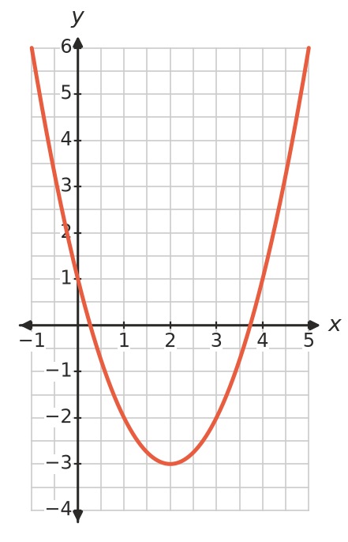

 Reasoning
- Explain why the solutions of $x^{2}−2x=3$ are the $x$-coordinates of the points where $y=x^{2}−2x$ meets $y=3$.
- Zoe graphed $y=x^{2}+4$ and said, “$x^{2}+4=0$ has no solutions.” Explain why she is right.

 Problem solving
- The graph shows the height, $h$ m, of a kicked footy after it has travelled $x$ m.
- 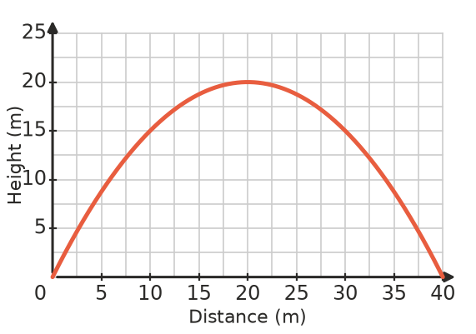
  - How far has the ball travelled when it is 15 m high? (Two answers.)
  - When is the ball 20 m high?
  - Does the ball ever reach 25 m?
- A rectangle has a perimeter of 20 cm. Its width is $x$ cm, so its area is $A=x(10−x)$ cm².
  - Use a table of values for $x=1$ to 9 to find the widths that give an area of 21 cm².
  - Can the area be 30 cm²? Explain.
- Use graphing software to solve $x^{2}=2x+1$. Give the solutions to two decimal places.
- Use a table of values and a calculator to find the positive solution of $x^{2}+x=10$, to one decimal place.

