5.09 Solutions to quadratics
Year 9 Maths · A5 question sheet · Level 1 · Warm-up
This worksheet practises solving quadratic equations by reading graphs and tables. Tip: the solutions of $x^{2}−2x−3=0$ are the $x$-values where the graph of $y=x^{2}−2x−3$ has $y=0$, so they are the $x$-intercepts. A quadratic equation can have 2, 1 or 0 solutions.

 Understanding
- The graph shows $y=x^{2}−2x−3$.
- 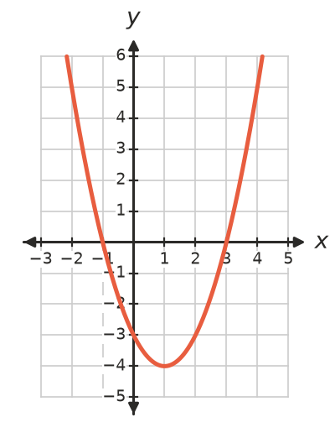
  - Write the $x$-intercepts.
  - Write the solutions of $x^{2}−2x−3=0$.
- The grid shows three parabolas. How many solutions does each equation $y=0$ have?
- 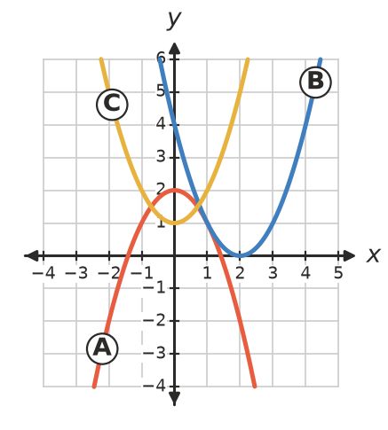
  - Graph A: $2−x^{2}=0$
  - Graph B: $(x−2)^{2}=0$
  - Graph C: $x^{2}+1=0$
- Check by substituting. Is each value a solution of $x^{2}−3x−4=0$? Write Yes or No.
  - $x=4$
  - $x=2$
  - $x=−1$

 Fluency
- The graph shows $y=x^{2}−4$. Use it to solve each equation. (Tip: draw the horizontal line $y=5$, and so on, and read where it meets the parabola.)
- 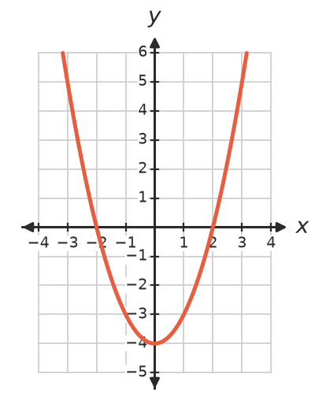
  - $x^{2}−4=0$
  - $x^{2}−4=5$
  - $x^{2}−4=−4$
  - $x^{2}−4=−5$
- The rule is $y=x^{2}+x−6$.
$x$ | −4 | −3 | −2 | −1 | 0 | 1 | 2 | 3
$y$

  - Copy and complete the table.
  - Use the table to write the solutions of $x^{2}+x−6=0$.
- The graph shows $y=4x−x^{2}$. Use it to solve each equation.
- 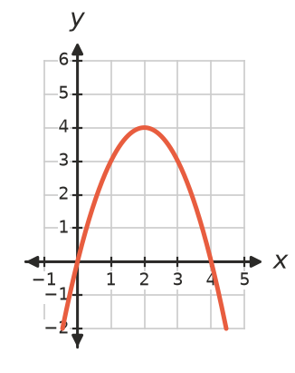
  - $4x−x^{2}=0$
  - $4x−x^{2}=3$
  - $4x−x^{2}=4$
  - $4x−x^{2}=5$

 Reasoning
- Explain why a quadratic equation can have two solutions, one solution or no solutions. You may draw sketches.
- Ben says $x^{2}=9$ has only one solution, $x=3$. Explain why he is wrong.

 Problem solving
- The graph shows the height of a ball after $t$ seconds.
- 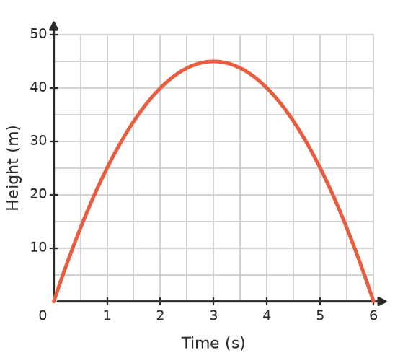
  - At what two times is the ball 25 m high?
  - At what two times is it 40 m high?
  - Why are there two answers to each part?
  - Is the ball ever 50 m high? Explain.
- The graph shows $y=x^{2}−3$. The grid lines are 0.5 units apart.
- 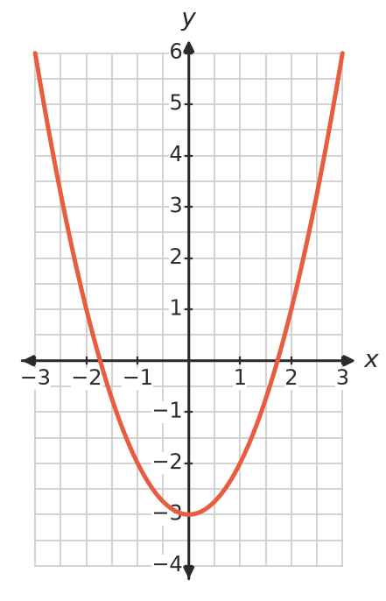
  - Estimate the solutions of $x^{2}−3=0$ to one decimal place.
  - Check with a calculator: what is $\sqrt{3}$ to two decimal places?
- Find the positive solution of $x^{2}+x=20$ by trying whole numbers. Show your tries.

