5.08 Standard form
Year 9 Maths · Worksheet · Level 2 · Core
Name: ____________________ Date: ______________
This worksheet practises quadratics in standard form $y=ax^{2}+bx+c$, and changing between the three forms. Tip: expand to get standard form; factorise to get factorised form. The axis of symmetry is $x=−\frac{b}{2a}$, and you substitute that value to find the turning point.

 Understanding
- Fill in the table.
Equation | $a$ | $b$ | $c$ | $y$-intercept | Concave up or down
$y=3x^{2}−x+7$
$y=−2x^{2}+5x$
$y=4−x^{2}$
$y=\frac{1}{2}x^{2}+3x−2$
$y=(x+1)(x−2)$

- Which features can you read straight from each form? Write them in the table.
Form | Features you can read straight away
Standard form, $y=ax^{2}+bx+c$
Factorised form, $y=a(x−p)(x−q)$
Turning point form, $y=a(x−h)^{2}+k$

 Fluency
- Write each equation in standard form.
  - $y=(x+4)(x−6)$ ______________
  - $y=2(x−3)(x+1)$ ______________
  - $y=−(x−2)(x−5)$ ______________
  - $y=(x+3)^{2}−7$ ______________
  - $y=−2(x−1)^{2}+8$ ______________
- Write each equation in factorised form, then write the $x$-intercepts.
  - $y=x^{2}−2x−8$ ______________
  - $y=x^{2}+9x+20$ ______________
  - $y=x^{2}−10x+21$ ______________
  - $y=x^{2}−16$ ______________
  - $y=x^{2}+7x$ ______________
- Find the axis of symmetry and the turning point.
  - $y=x^{2}−8x+12$ ______________
  - $y=−x^{2}+6x−5$ ______________
  - $y=2x^{2}+8x+3$ ______________
  - $y=−3x^{2}+6x+1$ ______________
- Sketch $y=x^{2}+2x−8$ on the grid. Label the intercepts and the turning point.
- 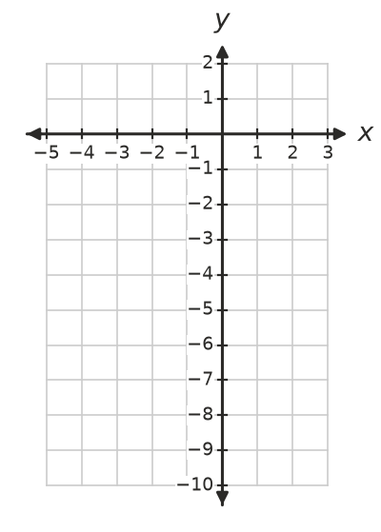

 Reasoning
- Show that $y=(x−3)^{2}−1$ and $y=(x−2)(x−4)$ are the same quadratic. Which features does each form show?

- Use graphing software to draw $y=x^{2}+bx+4$ for $b=−4$, $b=0$ and $b=4$.
  - Which point do all three graphs pass through? Why? ______________
  - Which of the graphs touch the $x$-axis at exactly one point? Where? ______________

 Problem solving
- A ball is thrown upwards from a cliff. Its height after $t$ seconds is $h=−5t^{2}+20t+25$ metres.
  - How high is the cliff? ______________
  - Factorise to find when the ball reaches the ground below the cliff. ______________
  - Find the greatest height of the ball. ______________
- At a school fundraiser, the profit from selling smoothies at $x$ dollars each is $P=−20x^{2}+200x−320$ dollars.
  - What is the profit if the price is $3? ______________
  - Show that $P=−20(x−2)(x−8)$, and write the two prices that give no profit. ______________
  - Which price gives the greatest profit? What is that profit? ______________
- The graph of $y=x^{2}+bx+c$ has $x$-intercepts 2 and −5. Find $b$ and $c$.

- The graph of $y=x^{2}+bx+c$ passes through (0, 3) and (1, 0). Find $b$ and $c$, then find the other $x$-intercept.

