5.08 Standard form
Year 9 Maths · Worksheet · Level 1 · Warm-up
Name: ____________________ Date: ______________
This worksheet practises quadratics in standard form, $y=ax^{2}+bx+c$. Tip: $c$ is the $y$-intercept, and the sign of $a$ tells you if the graph is concave up or down. To find the $x$-intercepts, factorise. The axis of symmetry is $x=−\frac{b}{2a}$.

 Understanding
- Write the values of $a$, $b$ and $c$.
Equation | $a$ | $b$ | $c$
$y=x^{2}+5x+6$
$y=2x^{2}−3x+1$
$y=−x^{2}+4x$
$y=x^{2}−7$
$y=3+2x−x^{2}$

- Write the $y$-intercept, and say whether the graph is concave up or down.
  - $y=x^{2}−4x+3$ ______________
  - $y=−x^{2}+2x+8$ ______________
  - $y=2x^{2}+x−5$ ______________
- The graph shows $y=x^{2}+x−6$.
- 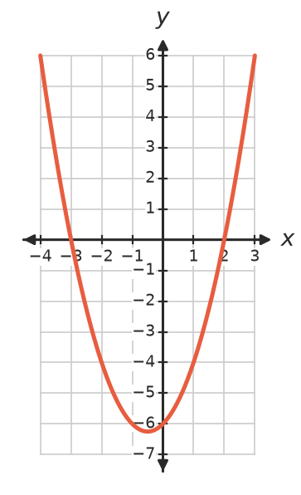
  - What is the $y$-intercept? Which number in the equation tells you this? ______________
  - Write the $x$-intercepts. ______________

 Fluency
- Expand to write each equation in standard form.
  - $y=(x+2)(x+3)$ ______________
  - $y=(x−1)(x+4)$ ______________
  - $y=(x−5)(x−2)$ ______________
- Expand to write each equation in standard form.
  - $y=(x−1)^{2}+2$ ______________
  - $y=(x+3)^{2}−4$ ______________
- Factorise, then write the $x$-intercepts.
  - $y=x^{2}+6x+8$ ______________
  - $y=x^{2}−5x+6$ ______________
  - $y=x^{2}+x−12$ ______________
- Use $x=−\frac{b}{2a}$ to find the axis of symmetry, then substitute to find the turning point.
  - $y=x^{2}−6x+5$ ______________
  - $y=x^{2}+4x+1$ ______________

 Reasoning
- Explain why the $y$-intercept of $y=ax^{2}+bx+c$ is always $c$.

- Which form is quickest for finding each feature? Choose from: turning point form, factorised form, standard form.
  - The turning point ______________
  - The $x$-intercepts ______________
  - The $y$-intercept ______________

 Problem solving
- For $y=x^{2}−4x−5$:
  - Factorise and write the $x$-intercepts. ______________
  - Write the $y$-intercept. ______________
  - Find the turning point. ______________
  - Sketch the graph on the grid.
- 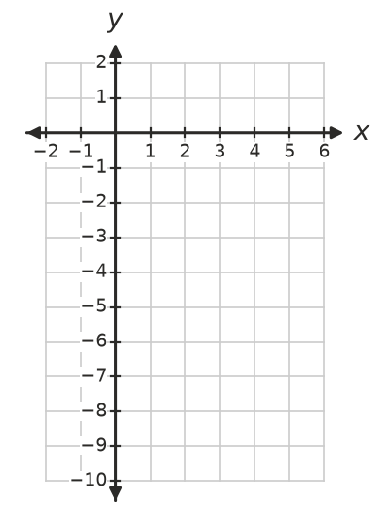
- A ball is thrown from the top of a building. Its height after $t$ seconds is $h=−5t^{2}+10t+15$ metres.
  - How high is the building? (Find $h$ when $t=0$.) ______________
  - Check that $h=−5(t−3)(t+1)$ gives the same values for $t=1$. When does the ball hit the ground? ______________
  - The greatest height is at $t=1$. What is it? ______________

