5.08 Standard form
Year 9 Maths · A5 question sheet · Level 3 · Challenge
This worksheet practises moving between standard form, factorised form and turning point form, and using standard form to model and solve problems. Tip: to change $y=x^{2}+bx+c$ into turning point form, complete the square: halve $b$, write ${\left(x+\frac{b}{2}\right)}^{2}$, then subtract ${\left(\frac{b}{2}\right)}^{2}$ to keep the equation balanced.

 Understanding
- Write each quadratic in factorised form and in turning point form.
Standard form | Factorised form
$y=x^{2}−6x+5$
$y=2x^{2}+4x−6$
$y=−x^{2}+2x+8$

- Complete the square to write each equation in turning point form, then write the turning point.
  - $y=x^{2}+8x+10$
  - $y=x^{2}−5x+4$

 Fluency
- Find the turning point of each graph.
  - $y=3x^{2}−12x+7$
  - $y=−2x^{2}−6x+1$
  - $y=0.5x^{2}+3x−1$
- Find $b$ and $c$.
  - $y=x^{2}+bx+c$ has turning point (3, −7).
  - $y=−x^{2}+bx+c$ has $x$-intercepts 1 and 5.
  - $y=2x^{2}+bx+c$ passes through (0, −3) and (2, 5).
- Sketch $y=−x^{2}+2x+3$ and $y=2x^{2}−4x−6$ on the same grid. Label their intercepts and turning points. What do you notice?
- 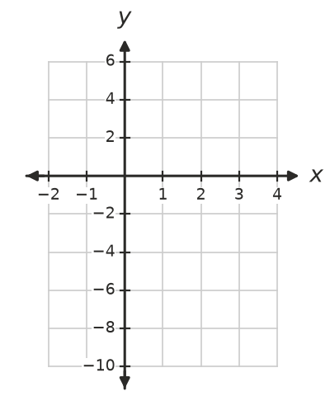
- What I notice:

 Reasoning
- The graph of $y=x^{2}+bx+c$ crosses the horizontal line $y=c$ at two points. Find their $x$-coordinates, and use them to show that the axis of symmetry is $x=−\frac{b}{2}$.
- Use graphing software to draw $y=x^{2}+bx+9$ for $b=−8,−6,−4,0,4,6,8$.
  - Which values of $b$ give two $x$-intercepts, one, or none?
  - Explain why $b=6$ gives exactly one $x$-intercept.

 Problem solving
- The profit from a car wash fundraiser when it charges $x$ dollars per car is $P=−10x^{2}+160x−390$ dollars.
  - Factorise to find the two prices that make no profit.
  - Which price gives the greatest profit, and what is it?
- A firework rocket is launched from a platform. Its height after $t$ seconds is $h=−5t^{2}+40t+45$ metres.
  - Factorise to find when it would reach the ground.
  - Find its greatest height.
  - The firework explodes on the way up when it is 120 m high. When does it explode?
- Find the equation $y=ax^{2}+bx+c$ of the parabola through (0, 4), (1, 3) and (2, 6).
- Show that $y=x^{2}−4x+7$ has no $x$-intercepts by writing it in turning point form.
- The graph of $y=x^{2}+bx+c$ touches the $x$-axis only at $x=−4$. Find $b$ and $c$.

