5.07 Factorised form
Year 9 Maths · Worksheet · Level 3 · Challenge
Name: ____________________ Date: ______________
This worksheet practises factorised form $y=a(x−p)(x−q)$ with fractions, converting between forms, proofs and modelling. Tip: a bracket like $(2x−1)$ is 0 when $x=\frac{1}{2}$. To change factorised form into turning point form, find the turning point first, then use the same value of $a$.

 Understanding
- Fill in the table.
Equation | $x$-intercepts | $y$-intercept | Axis of symmetry | Turning point
$y=−2(x−1)(x−5)$
$y=\frac{1}{2}(x+4)(x−2)$
$y=(2x−1)(x+3)$
$y=−x(x+7)$

- Find the equations of parabolas A and B in factorised form.
- 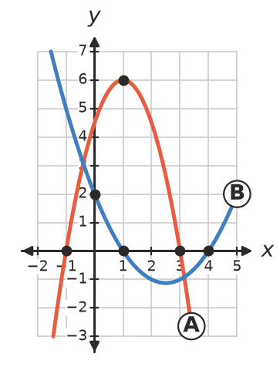
  - Parabola A: ______________
  - Parabola B: ______________

 Fluency
- Find each equation in factorised form.
  - $x$-intercepts −2 and 6, passes through (2, 8) ______________
  - Touches the $x$-axis only at $x=3$, passes through (0, 18) ______________
  - $x$-intercepts 0 and 5, turning point has $y$-value −10 ______________
- Write each equation in factorised form. Check by expanding both forms.
  - $y=(x−2)^{2}−9$ ______________
  - $y=−2(x+1)^{2}+8$ ______________
- Write each equation in turning point form.
  - $y=(x−1)(x−7)$ ______________
  - $y=−3(x+2)(x−4)$ ______________

 Reasoning
- For $y=a(x−p)(x−q)$:
  - Show that the $y$-intercept is $apq$. ______________
  - Show that the $y$-value of the turning point is $−\frac{a(q−p)^{2}}{4}$. Check with $y=−2(x−1)(x−5)$ from Question 1.

- Sam says a parabola has $x$-intercepts 2 and 6 and turning point (3, −5). Explain why this is impossible.

 Problem solving
- A golf ball’s path is $h=−0.004x(x−150)$, where $h$ m is its height and $x$ m is the horizontal distance from the tee.
  - How far does the ball travel before landing? ______________
  - What is its greatest height? ______________
  - A tree 15 m tall stands 120 m from the tee, in the ball’s path. Does the ball clear the tree? Show your working.

- A bridge arch meets the river bank at $x=0$ and $x=80$ (in metres) and is 20 m high in the middle.
  - Find the equation of the arch in the form $y=ax(x−80)$. ______________
  - How high is the arch 10 m from each end? ______________
- A rectangular pen is made from 30 m of fencing. It is $x$ m wide.
  - Show that its area is $A=x(15−x)$. ______________
  - What width gives the greatest area, and what is that area? ______________
- A parabola has $x$-intercepts −3 and 5 and passes through (1, −8).
  - Find its equation in factorised form. ______________
  - Explain why (1, −8) is its turning point. ______________
- How many different parabolas have $x$-intercepts 2 and 6? Find the one that passes through (4, 12).

