5.07 Factorised form
Year 9 Maths · Worksheet · Level 2 · Core
Name: ____________________ Date: ______________
This worksheet practises quadratics in factorised form $y=a(x−p)(x−q)$: finding features, sketching, writing equations and modelling. Tip: the $x$-intercepts are $p$ and $q$, the axis of symmetry is $x=\frac{p+q}{2}$, and the $y$-intercept is $a×(−p)×(−q)$. To find $a$, substitute one more point.

 Understanding
- Fill in the table.
Equation | $x$-intercepts | $y$-intercept | Axis of symmetry | Turning point
$y=(x−1)(x−7)$
$y=(x+2)(x−4)$
$y=−(x+3)(x−1)$
$y=2x(x−4)$

- Match each equation to a graph: $y=(x−1)(x+3)$, $y=−(x−1)(x+3)$, $y=(x+1)(x−3)$.
- 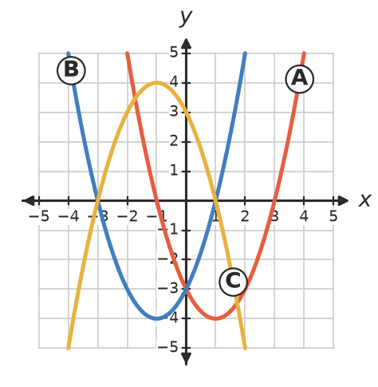
  - $y=(x−1)(x+3)$ is graph ______________
  - $y=−(x−1)(x+3)$ is graph ______________
  - $y=(x+1)(x−3)$ is graph ______________

 Fluency
- Sketch each parabola on its grid. Label the intercepts and the turning point.
  - $y=(x+1)(x−5)$
- 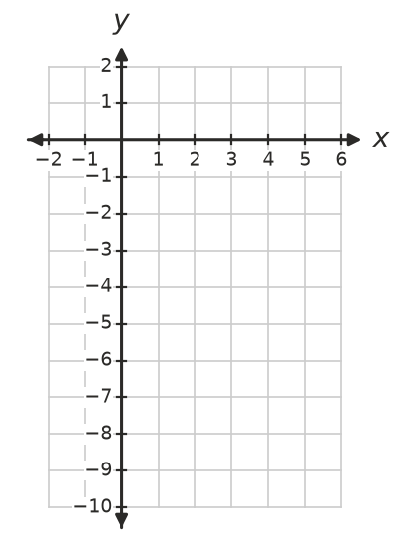
  - $y=−(x+4)(x−2)$
- 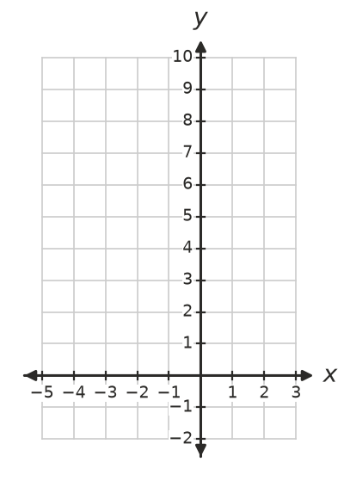
- Write each equation in factorised form.
  - $x$-intercepts −3 and 2, $a=1$ ______________
  - $x$-intercepts 1 and 6, concave down, $a=−1$ ______________
  - $x$-intercepts −4 and 0, passes through (−2, 8) ______________
- Find $a$.
  - $y=a(x−1)(x−5)$ passes through (0, 10). ______________
  - $y=a(x+2)(x−3)$ passes through (2, 8). ______________
- Find the equations of parabolas A and B in factorised form.
- 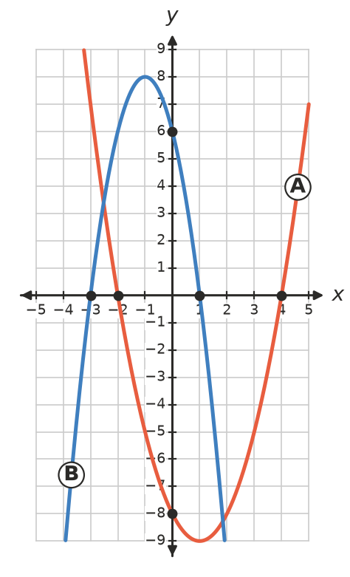
  - Parabola A: ______________
  - Parabola B: ______________

 Reasoning
- Explain why the turning point of a parabola in factorised form is always halfway between its $x$-intercepts.

- Lily says $y=(x−3)^{2}$ has two $x$-intercepts, 3 and 3. Explain what the graph really looks like near $x=3$.

- Two parabolas both have $x$-intercepts 2 and 6. One has turning point (4, −4) and the other has turning point (4, 8). Write both equations in factorised form.

 Problem solving
- A footy is kicked from the ground. Its height is $h=−0.05x(x−40)$ metres when it has travelled $x$ metres horizontally.
  - How far from the kicker does the ball land? ______________
  - What is its greatest height? ______________
  - How high is it when it has travelled 10 m? ______________
- A rectangular vegetable patch has a width of $x$ m and a length of $(12−x)$ m.
  - Write its area $A$ in factorised form, and give the two values of $x$ that make $A=0$. ______________
  - What width gives the largest area, and what is that area? ______________
- An archway is in the shape of a parabola. It meets the ground at $x=0$ and $x=6$ (in metres) and is 4.5 m high in the middle.
  - Find its equation in the form $y=ax(x−6)$. ______________
  - How high is the arch 1 m from one end? ______________

