5.07 Factorised form
Year 9 Maths · A5 question sheet · Level 1 · Warm-up
This worksheet practises quadratics in factorised form, $y=a(x−p)(x−q)$. Tip: the $x$-intercepts are where a bracket equals 0, so they are $p$ and $q$. The axis of symmetry is halfway between them. To find the turning point, substitute that $x$-value into the equation.

 Understanding
- Write the $x$-intercepts of each graph.
  - $y=(x−2)(x−6)$
  - $y=(x+1)(x−3)$
  - $y=(x+4)(x+2)$
  - $y=x(x−5)$
- The graph shows $y=(x−1)(x−5)$.
- 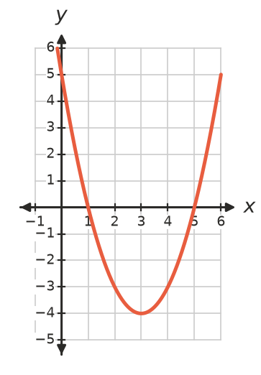
  - Write the $x$-intercepts.
  - Write the equation of the axis of symmetry.
  - Write the turning point.
  - Write the $y$-intercept.
- Find the $y$-intercept of each graph by substituting $x=0$.
  - $y=(x−2)(x−3)$
  - $y=(x+1)(x−4)$
  - $y=(x+5)(x+2)$

 Fluency
- Write the axis of symmetry of each graph.
  - $y=(x−2)(x−8)$
  - $y=(x+3)(x−1)$
  - $y=x(x+6)$
- Find the turning point of each graph. Use your answers to Question 4.
  - $y=(x−2)(x−8)$
  - $y=(x+3)(x−1)$
- Follow the steps to sketch $y=(x+2)(x−4)$.
  - Write the $x$-intercepts.
  - Write the $y$-intercept.
  - Write the axis of symmetry.
  - Find the turning point.
  - Plot these points on a copy of the grid in your book and draw the parabola.
- 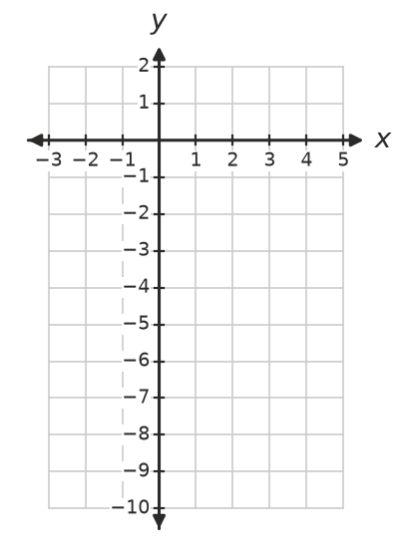

 Reasoning
- Is each graph concave up or concave down? Look at the number in front of the brackets.
  - $y=(x−4)(x+2)$
  - $y=−(x+1)(x−5)$
  - $y=−2x(x−3)$
- Ali says the $x$-intercepts of $y=(x+3)(x−2)$ are 3 and −2. Explain his mistake and give the correct $x$-intercepts.

 Problem solving
- Write the equation, in factorised form, of a concave up parabola (with $a=1$) that has these $x$-intercepts.
  - 3 and 7
  - −2 and 5
  - 0 and −4
- A ball is hit up into the air. Its height after $t$ seconds is $h=−5t(t−4)$ metres.
  - When is the ball on the ground?
  - When is the ball highest?
  - What is its greatest height?
- Write the equation of this parabola in factorised form. (It is concave up and $a=1$.)
- 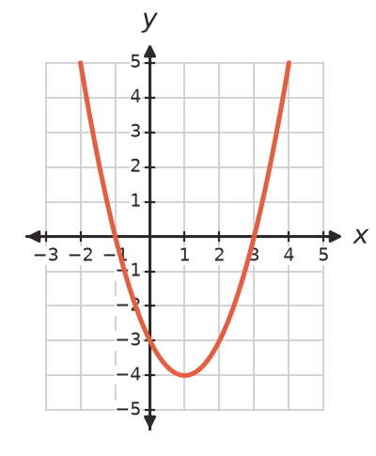
- Equation:

