5.06 Turning point form
Year 9 Maths · Worksheet · Level 2 · Core
Name: ____________________ Date: ______________
This worksheet practises the turning point form $y=a(x−h)^{2}+k$: reading its features, sketching it, writing equations and solving problems. Tip: the turning point is ($h$, $k$) and $a$ tells you the shape. To find $a$ from a graph, substitute the turning point and one other point, then solve for $a$.

 Understanding
- Fill in the table.
Equation | Turning point | Max or min | Axis of symmetry | $y$-intercept
$y=2(x−1)^{2}+3$
$y=−(x+2)^{2}+4$
$y=3(x−2)^{2}−12$
$y=−\frac{1}{2}(x+4)^{2}−1$
$y=(x−5)^{2}−25$

- Describe how each graph is made from $y=x^{2}$. Describe the dilation or reflection first, then the translations.
  - $y=2(x−3)^{2}+1$ ______________
  - $y=−(x+1)^{2}−4$ ______________
  - $y=\frac{1}{2}(x−2)^{2}−3$ ______________

 Fluency
- Write each equation in turning point form.
  - Turning point (4, −2), same shape as $y=x^{2}$ ______________
  - Turning point (−1, 5), same shape as $y=x^{2}$ but concave down ______________
  - Turning point (0, −3), same shape as $y=2x^{2}$ ______________
  - Turning point (3, 0), same shape as $y=−3x^{2}$ ______________
- Find the $x$-intercepts, if there are any.
  - $y=(x−2)^{2}−9$ ______________
  - $y=(x+1)^{2}−16$ ______________
  - $y=−(x−4)^{2}+1$ ______________
  - $y=2(x+3)^{2}−8$ ______________
  - $y=(x−1)^{2}+4$ ______________
- Sketch $y=(x+1)^{2}−4$ on the grid. Label the turning point and the intercepts.
- 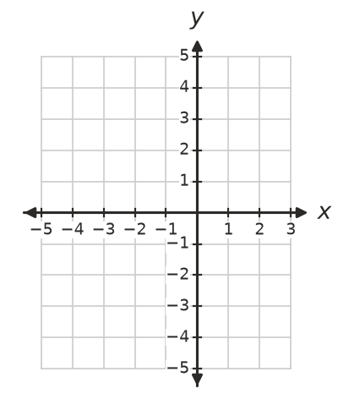
- Find $a$.
  - $y=a(x−2)^{2}−3$ passes through (0, 5). ______________
  - $y=a(x+1)^{2}+6$ passes through (1, −2). ______________

 Reasoning
- Explain how you can tell from $a$ and $k$ how many $x$-intercepts the graph of $y=a(x−h)^{2}+k$ has, without solving. Use your rule for each graph below.
  - $y=3(x−1)^{2}+2$ ______________
  - $y=−2(x+5)^{2}+7$ ______________
  - $y=4(x−6)^{2}$

- Kai wrote the equation of a parabola with turning point (−3, 2) and the same shape as $y=x^{2}$ as $y=(x−3)^{2}+2$. Explain his mistake and correct it.

 Problem solving
- Find the equation of this parabola in turning point form.
- 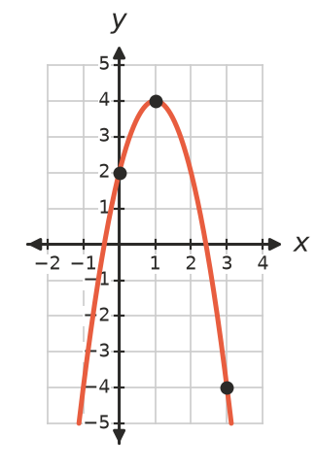

- A jet of water from a garden fountain follows the curve $h=−0.5(x−3)^{2}+4.5$, where $h$ m is the height and $x$ m is the horizontal distance from the nozzle.
  - What is the greatest height, and how far from the nozzle is it? ______________
  - How high is the nozzle? ______________
  - How far from the nozzle does the water land? ______________
  - How high is the water 1 m from the nozzle? ______________
- The cable of a small suspension bridge hangs in the shape $y=0.01(x−50)^{2}+5$, where $x$ m is the distance from the left tower (from 0 to 100) and $y$ m is the height above the road.
  - What is the lowest height of the cable, and where is it? ______________
  - How high is the cable where it meets the towers? ______________
  - Where is the cable 14 m above the road? ______________
- A parabola has turning point (2, −8) and passes through the origin.
  - Find its equation in turning point form. ______________
  - Find its other $x$-intercept. ______________

