5.06 Turning point form
Year 9 Maths · A5 question sheet · Level 3 · Challenge
This worksheet practises turning point form $y=a(x−h)^{2}+k$ with harder equations, exact answers and modelling. Tip: when you transform a point of $y=x^{2}$, apply the dilation or reflection to its $y$-value first, then add the translations.

 Understanding
- Copy and fill in the table.
Equation | Turning point | Max or min | $y$-intercept
$y=−3(x−2)^{2}+12$
$y=\frac{1}{2}(x+1)^{2}−8$
$y=−(x−0.5)^{2}+2.25$
$y=2(x+3)^{2}+1$

- The graph of $y=x^{2}$ is transformed into $y=−2(x+3)^{2}+5$.
  - Describe the transformations in order.
  - The point (1, 1) is on $y=x^{2}$. Where does it end up? Check by substituting.

 Fluency
- Find each equation in turning point form.
  - Turning point (3, −4), passes through (5, 4)
  - Turning point (−2, 6), passes through (1, −12)
  - Turning point (−4, 3), passes through (0, −5)
- Find the exact $x$-intercepts. Use surds where needed.
  - $y=(x−1)^{2}−5$
  - $y=−2(x+3)^{2}+18$
  - $y=3(x−2)^{2}−27$
- Find the equations of parabolas A and B in turning point form.
- 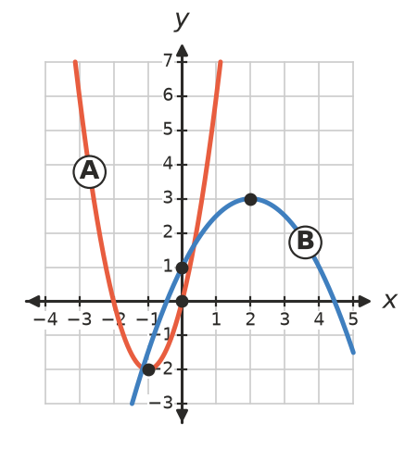
  - Parabola A:
  - Parabola B:

 Reasoning
- Explain why the greatest value of $y=−3(x−4)^{2}+7$ is 7. Which value of $x$ gives it?
- Two parabolas have the same shape as $y=x^{2}$ and the same turning point (2, 5). One passes through (0, 1) and the other through (0, 9). Find both equations and explain how they are related.
- Is it possible for a parabola to have turning point (1, −3) and pass through both (3, −5) and (−2, 4)? Explain.

 Problem solving
- Water leaves a fountain nozzle at ground level. It reaches a greatest height of 3.2 m when it is 2 m from the nozzle, horizontally.
  - Find the equation of the water’s path in turning point form.
  - How far from the nozzle does the water land?
  - How high is the water 0.5 m from the nozzle?
- A basketball’s path is modelled by $h=−0.16(x−3)^{2}+4.05$, where $h$ m is its height and $x$ m is the horizontal distance from the player.
  - What is the ball’s greatest height, and how far from the player is it?
  - At what height does the player release the ball?
  - The ring is 3.05 m high and 5.5 m from the player. Show that the ball passes through the ring.
- Find $k$ for $y=2(x−3)^{2}+k$ so that:
  - the graph passes through the origin
  - the $x$-intercepts are 1 and 5
  - the graph has no $x$-intercepts
- A parabola has $x$-intercepts −1 and 7 and a maximum height of 8.
  - Find its equation in turning point form.
  - Find its $y$-intercept.

