5.06 Turning point form
Year 9 Maths · A5 question sheet · Level 1 · Warm-up
This worksheet practises reading and writing quadratics in turning point form, $y=a(x−h)^{2}+k$. Tip: the turning point is ($h$, $k$). Remember the sign inside the bracket flips: $y=(x−2)^{2}+3$ has turning point (2, 3), but $y=(x+2)^{2}+3$ has turning point (−2, 3).

 Understanding
- Copy and fill in the table.
Equation | Turning point
$y=(x−2)^{2}+3$
$y=(x+1)^{2}−4$
$y=(x−5)^{2}−1$
$y=(x+3)^{2}+2$
$y=−(x−4)^{2}+6$

- The graph shows $y=(x−2)^{2}−1$.
- 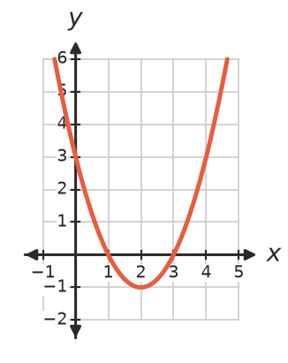
  - Write the turning point.
  - Write the equation of the axis of symmetry.
  - Write the $y$-intercept.
  - Write the $x$-intercepts.
- Describe how to move $y=x^{2}$ onto each graph.
  - $y=(x−3)^{2}+2$
  - $y=(x+4)^{2}−5$
  - $y=−(x−1)^{2}+3$

 Fluency
- Write the equation of the graph of $y=x^{2}$ after it is moved:
  - 2 units right and 5 units up
  - 3 units left and 1 unit down
  - 4 units right and 6 units down
- Find the $y$-intercept of each graph by substituting $x=0$.
  - $y=(x−1)^{2}+4$
  - $y=(x+2)^{2}−7$
  - $y=(x−3)^{2}−10$
- The rule is $y=(x−1)^{2}−4$.
$x$ | −2 | −1 | 0 | 1 | 2 | 3 | 4
$y$

  - Copy and complete the table and plot the graph.
- 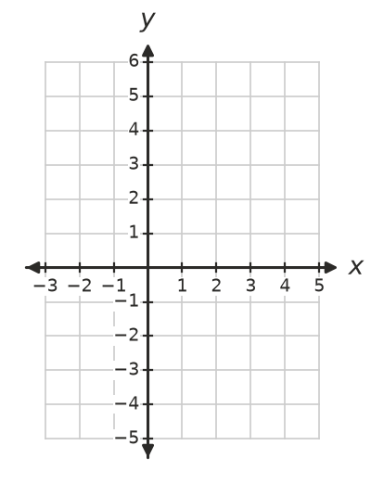
  - Write the turning point and the $x$-intercepts.

 Reasoning
- Does each graph have two $x$-intercepts or none? Think about where the turning point is and which way the graph opens.
  - $y=(x−2)^{2}+5$
  - $y=(x+1)^{2}−9$
  - $y=−(x−3)^{2}−2$
  - $y=−(x+4)^{2}+1$
- Nia says the turning point of $y=(x+5)^{2}−2$ is (5, −2). Explain her mistake and give the correct turning point.

 Problem solving
- This parabola has the same shape as $y=x^{2}$. Write its equation in turning point form.
- 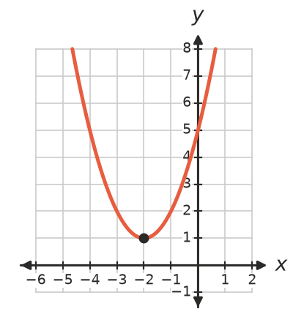
- Equation:
- A ball is thrown so that its height after $t$ seconds is $h=−(t−3)^{2}+9$ metres.
  - What is the greatest height, and when is it reached?
  - How high is the ball at $t=0$?
  - When does the ball land?
  - How high is the ball after 1 second?
- Find the $x$-intercepts of $y=(x−3)^{2}−4$. (Tip: put $y=0$, so $(x−3)^{2}=4$. What numbers squared give 4?)

