5.05 Horizontal translations
Year 9 Maths · Worksheet · Level 3 · Challenge
Name: ____________________ Date: ______________
This worksheet practises graphs of the form $y=a(x−h)^{2}$, finding $a$ and $h$ from points, and using symmetry. Tip: $(x−h)^{2}$ and $(h−x)^{2}$ are always equal, so $y=(5−x)^{2}$ is the same graph as $y=(x−5)^{2}$.

 Understanding
- Match each equation to a graph: $y=(x−1.5)^{2}$, $y=2(x+2)^{2}$, $y=−0.5(x−3)^{2}$, $y=−(x+1)^{2}$.
- 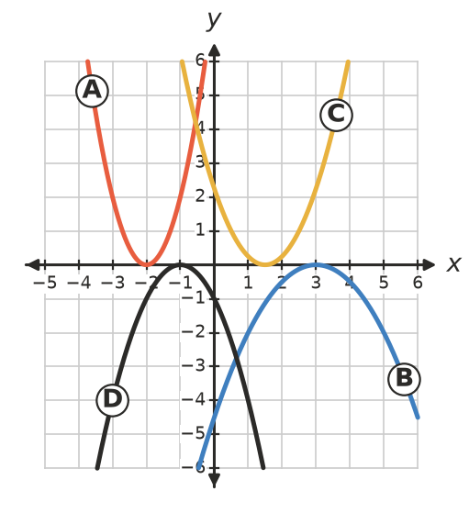
  - $y=(x−1.5)^{2}$ is graph ______________
  - $y=2(x+2)^{2}$ is graph ______________
  - $y=−0.5(x−3)^{2}$ is graph ______________
  - $y=−(x+1)^{2}$ is graph ______________
- Fill in the table.
Equation | Turning point | Max or min | $y$-intercept
$y=−2(x−3)^{2}$
$y=0.5(x+4)^{2}$
$y=(2−x)^{2}$
$y=−(x+0.5)^{2}$

 Fluency
- Find all possible values of $h$.
  - $y=(x−h)^{2}$ passes through (1, 16). ______________
  - $y=(x−h)^{2}$ passes through (−2, 0.25). ______________
- Each graph has the form $y=a(x−h)^{2}$. Find its equation.
  - Turning point (2, 0), passes through (4, 12) ______________
  - Turning point (−1, 0), $y$-intercept −2 ______________
- Describe the transformation that maps the first graph onto the second.
  - $y=(x−3)^{2}$ onto $y=(x+5)^{2}$ ______________
  - $y=2(x+1)^{2}$ onto $y=−2(x−4)^{2}$ ______________

 Reasoning
- Show that $(h−x)^{2}=(x−h)^{2}$ by expanding both. Use this to explain why the turning point of $y=(5−x)^{2}$ is (5, 0).

- Show that the graphs of $y=(x−h)^{2}$ and $y=(x+h)^{2}$ always meet at (0, $h^{2}$). Use symmetry to explain why.

- Explain why the graph of $y=x^{2}+6x+9$ has turning point (−3, 0). (Tip: factorise.) Then find the turning point of $y=x^{2}−10x+25$.

 Problem solving
- A dip in a country road is modelled by $y=0.004(x−50)^{2}$ for $x$ from 0 to 100, where $x$ m is the horizontal distance and $y$ m is the height above the lowest point.
  - How high are the two ends of the dip? ______________
  - Where is the road 2.5 m above the lowest point? ______________
- The graph of $y=(x−h)^{2}$ passes through (2, 9) and (8, 9). Find $h$ and check your answer.

- A parabola of the form $y=a(x−h)^{2}$ passes through (1, 8), (3, 0) and (5, 8). Find its equation.

- For the graph of $y=(x−h)^{2}$:
  - Write the $y$-intercept in terms of $h$. ______________
  - The $y$-intercept is 49 and the turning point is to the left of the $y$-axis. Find the equation. ______________

