5.05 Horizontal translations
Year 9 Maths · Worksheet · Level 1 · Warm-up
Name: ____________________ Date: ______________
This worksheet practises graphs of the form $y=(x−h)^{2}$. Tip: the turning point is where the bracket equals 0. For $y=(x−3)^{2}$ that is $x=3$, so the graph moves 3 units right. For $y=(x+3)^{2}$ it is $x=−3$, so the graph moves 3 units left.

 Understanding
- Complete the tables.
$x$ | 0 | 1 | 2 | 3 | 4
$y=(x−2)^{2}$

$x$ | −3 | −2 | −1 | 0 | 1
$y=(x+1)^{2}$

  - Where is the turning point of $y=(x−2)^{2}$? ______________
  - Where is the turning point of $y=(x+1)^{2}$? ______________
- The dashed graph is $y=x^{2}$. Graphs A and B are $y=(x−3)^{2}$ and $y=(x+2)^{2}$.
- 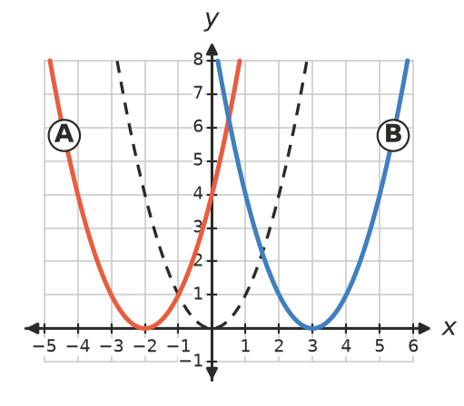
  - Which graph is $y=(x−3)^{2}$? ______________
  - Which graph is $y=(x+2)^{2}$? ______________
- Write the turning point of each graph.
  - $y=(x−4)^{2}$ ______________
  - $y=(x+5)^{2}$ ______________
  - $y=(x−1)^{2}$ ______________
  - $y=(x+3)^{2}$ ______________

 Fluency
- Describe how to move $y=x^{2}$ onto each graph.
  - $y=(x−6)^{2}$ ______________
  - $y=(x+2)^{2}$ ______________
  - $y=(x+7)^{2}$ ______________
- Write the equation of the graph of $y=x^{2}$ after it is moved:
  - 1 unit right ______________
  - 4 units left ______________
  - 5 units right ______________
- Find the $y$-intercept of each graph by substituting $x=0$.
  - $y=(x−3)^{2}$ ______________
  - $y=(x+4)^{2}$ ______________
  - $y=(x−1)^{2}$ ______________
- The rule is $y=(x−1)^{2}$.
$x$ | −2 | −1 | 0 | 1 | 2 | 3 | 4
$y$

  - Complete the table and plot the graph.
- 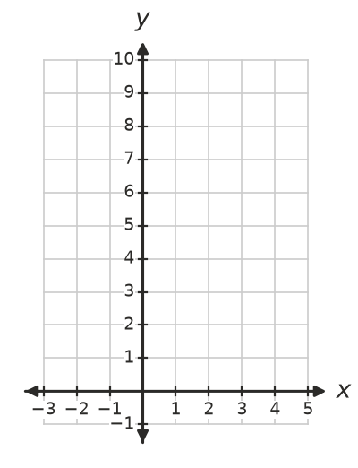
  - Write the equation of the axis of symmetry. ______________

 Reasoning
- Jo says $y=(x−3)^{2}$ is the graph of $y=x^{2}$ moved 3 units left, “because of the minus sign”. Explain why she is wrong.

- Write the equation of the axis of symmetry of each graph.
  - $y=(x−5)^{2}$ ______________
  - $y=(x+2)^{2}$ ______________

 Problem solving
- Find $h$ in $y=(x−h)^{2}$.
  - The turning point is (6, 0). ______________
  - The turning point is (−4, 0). ______________
- Which of these points lie on the graph of $y=(x+2)^{2}$? Show your checking.
- (1, 9) (0, 2) (−4, 4) (−2, 0)

