5.05 Horizontal translations
Year 9 Maths · A5 question sheet · Level 2 · Core
This worksheet practises graphs of the form $y=a(x−h)^{2}$. Tip: the turning point is ($h$, 0), the axis of symmetry is $x=h$, and you find the $y$-intercept by substituting $x=0$. Watch the sign: $y=(x+4)^{2}$ means $h=−4$.

 Understanding
- Match each equation to a graph: $y=(x−2)^{2}$, $y=(x+3)^{2}$, $y=−(x−1)^{2}$, $y=2(x+1)^{2}$.
- 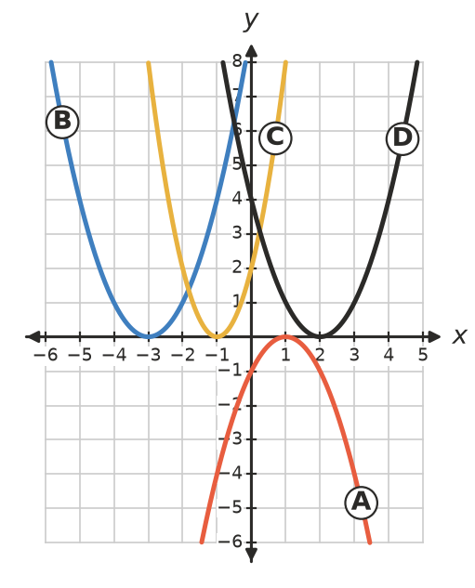
  - $y=(x−2)^{2}$ is graph
  - $y=(x+3)^{2}$ is graph
  - $y=−(x−1)^{2}$ is graph
  - $y=2(x+1)^{2}$ is graph
- Copy and fill in the table.
Equation | Turning point | Axis of symmetry
$y=(x−4)^{2}$
$y=(x+6)^{2}$
$y=−(x−2)^{2}$
$y=3(x+1)^{2}$

 Fluency
- Describe how each graph is made from $y=x^{2}$.
  - $y=(x+5)^{2}$
  - $y=−(x−3)^{2}$
  - $y=2(x−1)^{2}$
  - $y=\frac{1}{2}(x+4)^{2}$
- Write the equation of each graph.
  - Turning point (7, 0), same shape as $y=x^{2}$
  - Turning point (−2, 0), same shape as $y=x^{2}$ but concave down
  - $y=3x^{2}$ moved 1 unit left
- Sketch $y=(x+2)^{2}$ and $y=(x−2)^{2}$ on the grid.
- 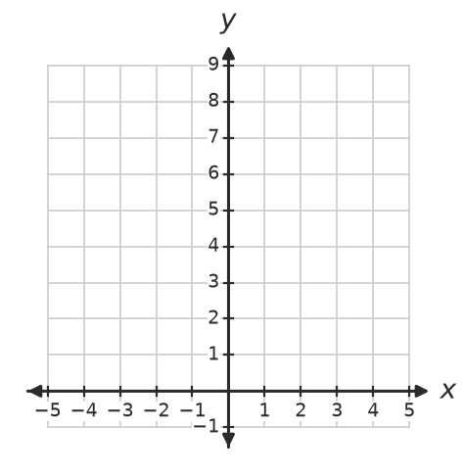
  - Where do the two graphs meet?
- Find all possible values of $h$, then write the equations.
  - $y=(x−h)^{2}$ passes through (0, 9).
  - $y=(x−h)^{2}$ passes through (5, 4).

 Reasoning
- Explain why the graph of $y=(x−h)^{2}$ always touches the $x$-axis at exactly one point.
- Compare the graphs of $y=x^{2}−4$ and $y=(x−4)^{2}$. Describe how each is made from $y=x^{2}$ and write the turning point of each.
- The graph of $y=(x−3)^{2}$ passes through (0, 9). Use symmetry to find another point on it with a $y$-value of 9.

 Problem solving
- Find the equation of this parabola. It has the same shape as $y=x^{2}$.
- 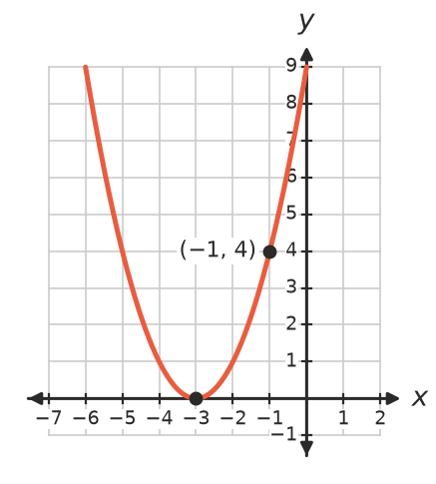
  - Equation:
  - Check your equation using its $y$-intercept.
- A ramp at a skate park follows the curve $y=0.25(x−4)^{2}$ for $x$ from 0 to 4, where $x$ m is the horizontal distance and $y$ m is the height.
  - How high is the top of the ramp, at $x=0$?
  - Where is the bottom of the ramp, and how high is it?
  - How high is the ramp at $x=2$?
- Write the equation of a concave up parabola with the same shape as $y=x^{2}$, axis of symmetry $x=−5$ and its turning point on the $x$-axis. Then find its $y$-intercept.

