5.04 Vertical translations
Year 9 Maths · Worksheet · Level 3 · Challenge
Name: ____________________ Date: ______________
This worksheet practises graphs of the form $y=ax^{2}+k$, finding $a$ and $k$, and modelling with these graphs. Tip: the turning point is (0, $k$). The graph has two $x$-intercepts when $a$ and $k$ have opposite signs, and none when they have the same sign.

 Understanding
- Match each equation to a graph: $y=0.5x^{2}−2$, $y=2x^{2}−2$, $y=−0.5x^{2}+3$, $y=−x^{2}+3$.
- 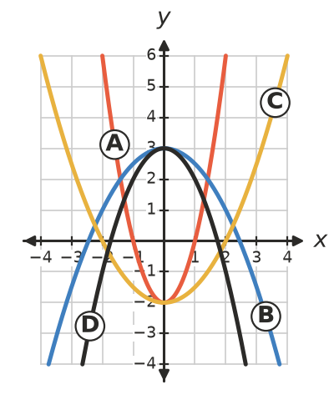
  - $y=0.5x^{2}−2$ is graph ______________
  - $y=2x^{2}−2$ is graph ______________
  - $y=−0.5x^{2}+3$ is graph ______________
  - $y=−x^{2}+3$ is graph ______________
- Fill in the table. Give $x$-intercepts exactly, or to two decimal places.
Equation | Turning point | Max or min | $x$-intercepts
$y=3x^{2}−12$
$y=−2x^{2}+18$
$y=0.5x^{2}−8$
$y=−4x^{2}−1$
$y=2x^{2}−10$

 Fluency
- Each graph has the form $y=ax^{2}+k$. Find $a$ and $k$.
  - It passes through (0, 3) and (2, 11). ______________
  - It passes through (1, −1) and (3, 15). ______________
  - It passes through (2, 0) and (0, 6). ______________
- Write the equation after each set of transformations of $y=x^{2}+4$.
  - Translate down 10 units, then reflect in the $x$-axis. ______________
  - Reflect in the $x$-axis, then translate down 10 units. ______________
  - Describe the single translation that maps $y=2x^{2}−5$ onto $y=2x^{2}+3$. ______________
- Find $k$.
  - $y=x^{2}+k$ passes through (−3, 2). ______________
  - $y=x^{2}+k$ has $x$-intercepts −5 and 5. ______________
  - $y=x^{2}+k$ has exactly one $x$-intercept. ______________
  - $y=−2x^{2}+k$ has $x$-intercepts −3 and 3. ______________

 Reasoning
- Explain why $y=ax^{2}+k$ has two $x$-intercepts when $a>0$ and $k<0$. Then describe all the combinations of signs of $a$ and $k$ that give no $x$-intercepts.

- For a positive number $k$, the graph of $y=x^{2}−k$ has two $x$-intercepts.
  - Show that the distance between them is $2\sqrt{k}$.

  - Find $k$ if the $x$-intercepts are 10 units apart. ______________

 Problem solving
- The top of an arched window has the shape $y=−2x^{2}+2$, where $x$ m is the distance from the centre and $y$ m is the height above the bottom of the arch.
  - How wide is the bottom of the arch, and how high is it in the middle? ______________
  - How high is the arch 0.5 m from the centre? ______________
  - A rectangular pane of glass 1 m wide fits under the arch, centred, touching the arch at its top corners. What is its area? ______________
- A rock is dropped from a cliff 80 m high. On the Moon its height after $t$ seconds is $h=80−0.8t^{2}$ metres. On Earth it would be $h=80−5t^{2}$ metres.
  - How long does the rock take to reach the ground on the Moon? ______________
  - How long would it take on Earth? ______________
- Find the points where $y=x^{2}−7$ and $y=2x^{2}−16$ meet.

- The graphs of $y=x^{2}+k$ and $y=8−x^{2}$ are drawn on the same axes.
  - For which values of $k$ do the graphs meet? ______________
  - For which value of $k$ do they meet at exactly one point? ______________
- A logo is made from a parabola of the form $y=ax^{2}+k$. It has turning point (0, 6) and $x$-intercepts −3 and 3. Find its equation.

