5.04 Vertical translations
Year 9 Maths · Worksheet · Level 2 · Core
Name: ____________________ Date: ______________
This worksheet practises graphs of the form $y=ax^{2}+k$. Tip: $a$ sets the shape (as in $y=ax^{2}$) and $k$ moves the graph up or down. The turning point is (0, $k$), and the $y$-intercept is $k$ too. To find the $x$-intercepts, put $y=0$ and solve.

 Understanding
- Match each equation to a graph: $y=x^{2}+1$, $y=x^{2}−3$, $y=−x^{2}+2$, $y=−x^{2}−1$.
- 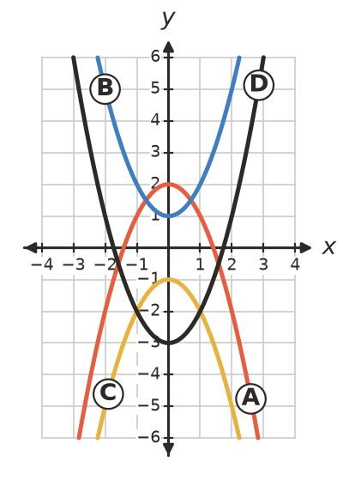
  - $y=x^{2}+1$ is graph ______________
  - $y=x^{2}−3$ is graph ______________
  - $y=−x^{2}+2$ is graph ______________
  - $y=−x^{2}−1$ is graph ______________
- Describe how each graph is made from $y=x^{2}$.
  - $y=x^{2}−8$ ______________
  - $y=−x^{2}+3$ ______________
  - $y=3x^{2}+2$ ______________
  - $y=\frac{1}{2}x^{2}−5$ ______________

 Fluency
- Fill in the table.
Equation | Turning point | Max or min | $y$-intercept | $x$-intercepts
$y=x^{2}−9$
$y=x^{2}+4$
$y=−x^{2}+1$
$y=2x^{2}−8$
$y=−x^{2}−3$

- Write the equation of each graph.
  - $y=x^{2}$ moved down 6 units ______________
  - $y=−x^{2}$ moved up 2 units ______________
  - $y=4x^{2}$ moved down 1 unit ______________
  - Turning point (0, 5), same shape as $y=−2x^{2}$ ______________
- Find $k$.
  - $y=x^{2}+k$ passes through (3, 4). ______________
  - $y=x^{2}+k$ passes through (−2, 10). ______________
  - $y=x^{2}+k$ passes through (5, 30). ______________
  - $y=−x^{2}+k$ passes through (4, −7). ______________
- Sketch $y=x^{2}−3$ and $y=−x^{2}+5$ on the grid. Label each turning point.
- 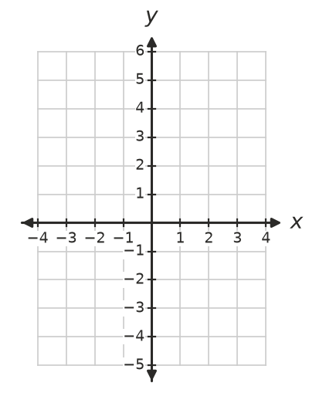
  - Where do the two graphs meet? ______________

 Reasoning
- Explain why $y=x^{2}+k$ has no $x$-intercepts when $k$ is positive. For which value of $k$ does it have exactly one $x$-intercept?

- Sam says the graph of $y=x^{2}−5$ is the graph of $y=x^{2}$ moved 5 units to the left. Explain his mistake.

 Problem solving
- A jet of water from a fountain follows the curve $h=4−x^{2}$, where $h$ m is the height and $x$ m is the horizontal distance from the middle of the jet.
  - What is the greatest height of the water? ______________
  - The water hits the ground on both sides. How far apart are these two points? ______________
  - How high is the water 1 m from the middle? ______________
- A parabola of the form $y=ax^{2}+k$ has turning point (0, −3) and passes through (2, 5). Find its equation.

- Find the points where $y=x^{2}+1$ and $y=9−x^{2}$ meet.

- A ball is dropped from a 45 m high lookout. Its height after $t$ seconds is $h=45−5t^{2}$ metres.
  - How high is the ball after 2 seconds? ______________
  - When does it hit the ground? ______________
  - Describe the graph of $h=45−5t^{2}$ as a transformation of $h=−5t^{2}$. ______________

