5.04 Vertical translations
Year 9 Maths · Worksheet · Level 1 · Warm-up
Name: ____________________ Date: ______________
This worksheet practises graphs of the form $y=x^{2}+k$. Tip: adding $k$ moves (translates) the whole graph of $y=x^{2}$ up $k$ units, or down if $k$ is negative. The turning point moves from (0, 0) to (0, $k$).

 Understanding
- Complete the table.
$x$ | −2 | −1 | 0 | 1 | 2
$y=x^{2}$
$y=x^{2}+3$
$y=x^{2}−2$

  - How do the $y$-values for $y=x^{2}+3$ compare with those for $y=x^{2}$? ______________
  - How do the $y$-values for $y=x^{2}−2$ compare with those for $y=x^{2}$? ______________
- The dashed graph is $y=x^{2}$. Write the equations of graphs A and B.
- 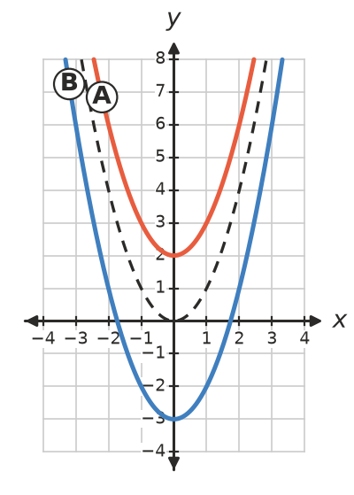
  - Graph A: ______________
  - Graph B: ______________
- Write the turning point of each graph.
  - $y=x^{2}+5$ ______________
  - $y=x^{2}−1$ ______________
  - $y=x^{2}−7$ ______________
  - $y=−x^{2}+4$ ______________

 Fluency
- Describe how to move the first graph onto the second.
  - $y=x^{2}$ onto $y=x^{2}+6$ ______________
  - $y=x^{2}$ onto $y=x^{2}−4$ ______________
  - $y=2x^{2}$ onto $y=2x^{2}+1$ ______________
- Write the equation of the graph of $y=x^{2}$ after it is moved:
  - up 3 units ______________
  - down 5 units ______________
  - down 1 unit ______________
- The rule is $y=x^{2}−4$.
$x$ | −3 | −2 | −1 | 0 | 1 | 2 | 3
$y$

  - Complete the table and plot the graph.
- 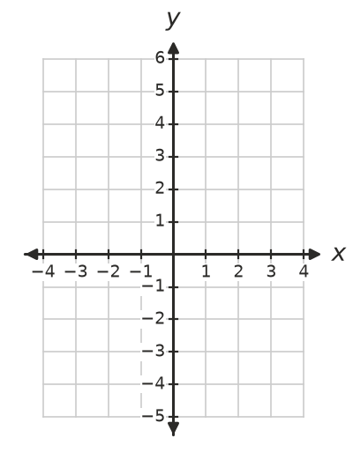
  - Write the $x$-intercepts. ______________
- Write the $y$-intercept of each graph.
  - $y=x^{2}+8$ ______________
  - $y=x^{2}−9$ ______________

 Reasoning
- Does the graph of $y=x^{2}+2$ cross the $x$-axis? Explain.

- Look at these three graphs: $y=x^{2}−9$, $y=x^{2}+1$ and $y=x^{2}$. Which one has:
  - two $x$-intercepts? ______________
  - one $x$-intercept? ______________
  - no $x$-intercepts? ______________

 Problem solving
- The graph of $y=x^{2}+k$ passes through the given point. Find $k$.
  - (2, 7) ______________
  - (3, 5) ______________
- Find the $x$-intercepts. (Tip: put $y=0$. Which numbers squared give the answer?)
  - $y=x^{2}−16$ ______________
  - $y=x^{2}−25$ ______________

