5.03 Basic quadratics
Year 9 Maths · Worksheet · Level 1 · Warm-up
Name: ____________________ Date: ______________
This worksheet practises graphs of the form $y=ax^{2}$. Tip: all of these graphs have their turning point at (0, 0). The number $a$ changes the shape: a bigger $a$ makes the parabola narrower, an $a$ between 0 and 1 makes it wider, and a negative $a$ flips it upside down.

 Understanding
- Complete the table.
$x$ | −2 | −1 | 0 | 1 | 2
$y=x^{2}$
$y=2x^{2}$
$y=\frac{1}{2}x^{2}$

- The grid shows $y=x^{2}$, $y=3x^{2}$ and $y=\frac{1}{3}x^{2}$. Match each equation to a graph.
- 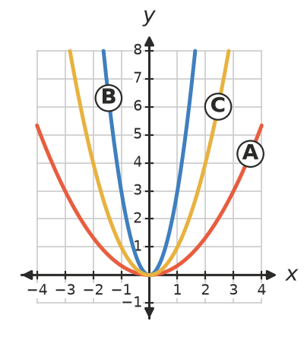
  - $y=x^{2}$ is graph ______________
  - $y=3x^{2}$ is graph ______________
  - $y=\frac{1}{3}x^{2}$ is graph ______________
- Write narrower or wider (than $y=x^{2}$), or flipped.
  - When $a$ is bigger than 1, the graph of $y=ax^{2}$ is ______________ .
  - When $a$ is between 0 and 1, the graph is ______________ .
  - When $a$ is negative, the graph is ______________ .

 Fluency
- Fill in the table.
Equation | Turning point | Concave up or down | Narrower or wider than $y=x^{2}$
$y=4x^{2}$
$y=−x^{2}$ |  |  | same width
$y=0.2x^{2}$
$y=−3x^{2}$

- The rule is $y=−x^{2}$.
$x$ | −3 | −2 | −1 | 0 | 1 | 2 | 3
$y$

  - Complete the table. Square first, then make the answer negative.
  - Plot the graph on the grid. The dashed curve is $y=x^{2}$.
- 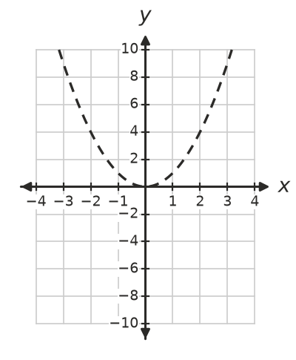
  - Describe how the graph of $y=−x^{2}$ is related to the graph of $y=x^{2}$. ______________
- Find $y$ when $x=3$.
  - $y=2x^{2}$ ______________
  - $y=−x^{2}$ ______________
  - $y=5x^{2}$ ______________
  - $y=−4x^{2}$ ______________

 Reasoning
- Write these in order from the narrowest graph to the widest graph.
- $y=2x^{2}$, $y=0.5x^{2}$, $y=5x^{2}$, $y=x^{2}$
- Answer: ______________
- Does each point lie on the graph? Check by substituting.
  - (2, 12) on $y=3x^{2}$ ______________
  - (−3, 18) on $y=2x^{2}$ ______________
  - (1, −4) on $y=4x^{2}$ ______________
- Explain why every graph of the form $y=ax^{2}$ passes through the point (0, 0).

 Problem solving
- Each graph has the form $y=ax^{2}$. Find $a$.
  - It passes through (1, 5). ______________
  - It passes through (2, 12). ______________
  - It passes through (2, −8). ______________
- A skate park half-pipe has the shape $y=0.25x^{2}$, where $x$ m is the distance from the centre and $y$ m is the height. The edges are 4 m from the centre on each side.
  - How high are the edges? ______________
  - How wide is the half-pipe from edge to edge? ______________
  - How high is the ramp 2 m from the centre? ______________

