5.03 Basic quadratics
Year 9 Maths · A5 question sheet · Level 3 · Challenge
This worksheet practises graphs of the form $y=ax^{2}$, finding $a$ from a point, and using these graphs to model real shapes. Tip: on the graph of $y=ax^{2}$, the point where $x=1$ is always (1, $a$), and if $(p,q)$ is on the graph, so is $(−p,q)$.

 Understanding
- Match each equation to a graph: $y=1.5x^{2}$, $y=0.4x^{2}$, $y=−0.4x^{2}$, $y=−2.5x^{2}$.
- 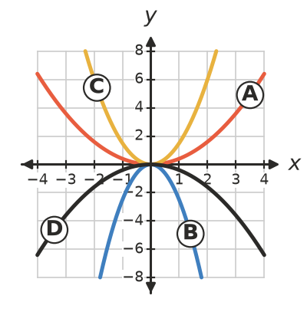
  - $y=1.5x^{2}$ is graph
  - $y=0.4x^{2}$ is graph
  - $y=−0.4x^{2}$ is graph
  - $y=−2.5x^{2}$ is graph
- Write these in order from the narrowest graph to the widest graph.
- $y=−5x^{2}$, $y=0.3x^{2}$, $y=2x^{2}$, $y=−0.5x^{2}$, $y=x^{2}$

 Fluency
- Each graph has the form $y=ax^{2}$. Find $a$ as a fraction or decimal.
  - It passes through (−3, 6).
  - It passes through (0.5, 2).
  - It passes through (−4, −2).
  - It passes through (10, 25).
- The graph of $y=ax^{2}$ passes through (3, −12).
  - Find $a$.
  - Find $y$ when $x=−6$.
  - Find $x$ when $y=−27$.
- Describe the transformation that maps the first graph onto the second.
  - $y=2x^{2}$ onto $y=−6x^{2}$
  - $y=6x^{2}$ onto $y=1.5x^{2}$

 Reasoning
- The point $(p,q)$ lies on the graph of $y=ax^{2}$. Show that the points $(−p,q)$ and $(2p,4q)$ also lie on the graph.
- Explain why $y=ax^{2}$ is not a parabola when $a=0$.
- Each graph has the form $y=ax^{2}$.
- 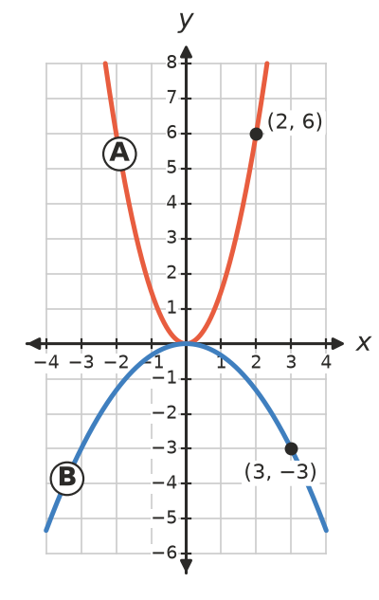
  - Find the equation of graph A.
  - Find the equation of graph B.

 Problem solving
- A satellite dish is 1.2 m wide and 0.18 m deep. Its cross-section has the shape $y=ax^{2}$ with the centre of the dish at (0, 0).
  - Find $a$.
  - The receiver is placed at the focus, which is $\frac{1}{4a}$ m above the centre of the dish. How high above the centre is the receiver?
- An object dropped on Earth falls $d=4.9t^{2}$ metres in $t$ seconds.
  - How far does it fall in 2 seconds?
  - How long does it take to fall 44.1 m?
  - Why do we only use positive values of $t$ here?
- A car’s braking distance is about $d=0.006v^{2}$ metres, where $v$ is its speed in km/h.
  - Find the braking distance at 50 km/h and at 100 km/h.
  - Explain why doubling the speed makes the braking distance four times as long.
  - At about what speed is the braking distance 37.5 m? Give your answer to the nearest km/h.
- The graph of $y=ax^{2}$ passes through (3, 4).
  - Find $a$.
  - Find where this graph meets the horizontal line $y=16$.

