5.03 Basic quadratics
Year 9 Maths · A5 question sheet · Level 2 · Core
This worksheet practises graphs of the form $y=ax^{2}$: how $a$ stretches or flips the parabola, and how to find $a$ from a point. Tip: the size of $a$ (ignoring its sign) controls the width, and the sign controls the direction. To find $a$, substitute a point and divide: $a=\frac{y}{x^{2}}$.

 Understanding
- Match each equation to a graph: $y=2x^{2}$, $y=0.5x^{2}$, $y=−x^{2}$, $y=−3x^{2}$.
- 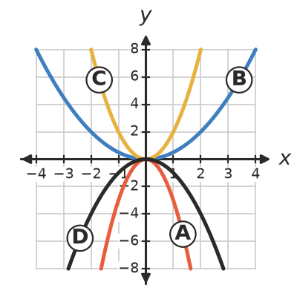
  - $y=2x^{2}$ is graph
  - $y=0.5x^{2}$ is graph
  - $y=−x^{2}$ is graph
  - $y=−3x^{2}$ is graph
- Is each statement true or false?
Statement
$y=−2x^{2}$ has a maximum turning point.
$y=0.1x^{2}$ is narrower than $y=x^{2}$.
$y=3x^{2}$ and $y=−3x^{2}$ are reflections of each other in the $x$-axis.
Every graph of the form $y=ax^{2}$ has the axis of symmetry $x=0$.
$y=4x^{2}$ passes through (1, 4) and (−1, 4).

 Fluency
- Copy and complete the table, then plot both graphs on a copy of the grid in your book.
$x$ | −2 | −1 | 0 | 1 | 2
$y=3x^{2}$
$y=−\frac{1}{2}x^{2}$

- 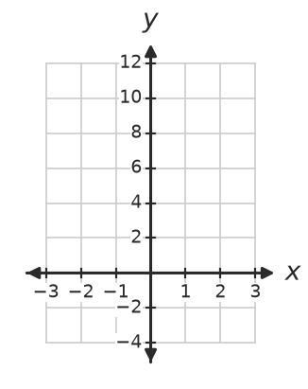
- Describe how each graph is made from $y=x^{2}$. Use the words dilation (stretch) and reflection.
  - $y=4x^{2}$
  - $y=−x^{2}$
  - $y=\frac{1}{3}x^{2}$
  - $y=−2x^{2}$
- Each graph has the form $y=ax^{2}$. Find $a$.
  - It passes through (3, 18).
  - It passes through (−2, −12).
  - It passes through (4, 4).
  - It passes through (6, −9).
- The points are on the graph of $y=−2x^{2}$. Find the missing coordinates.
  - (3, ?)
  - (?, −32) (there are two answers)
  - (−0.5, ?)

 Reasoning
- Use the $y$-values at $x=3$ to explain why the graph of $y=2x^{2}$ is narrower than the graph of $y=x^{2}$.
- Ella says $y=−3x^{2}$ is wider than $y=x^{2}$ because −3 is less than 1. Explain her mistake.
- The graph of $y=ax^{2}$ passes through (2, 6).
  - Find $a$.
  - Does it also pass through (−2, 6)? Explain.
  - Does it pass through (4, 24)? Explain.

 Problem solving
- The graph has the form $y=ax^{2}$.
- 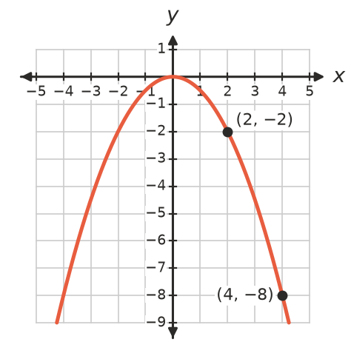
  - Use the marked point (2, −2) to find its equation.
  - Check your equation with the other marked point.
- A satellite dish is 80 cm wide and 8 cm deep. Its cross-section has the shape $y=ax^{2}$, with the centre of the dish at (0, 0).
  - Write the coordinates of the point on the right-hand rim.
  - Find $a$.
  - How deep is the dish 20 cm from the centre?
- A skate ramp has the shape $y=0.25x^{2}$, where $x$ m is the distance from the centre and $y$ m is the height.
  - How high is the ramp 4 m from the centre?
  - A rider goes up to a height of 2.25 m. How far from the centre is she?

