5.02 Graphs and features of quadratics
Year 9 Maths · Worksheet · Level 2 · Core
Name: ____________________ Date: ______________
This worksheet practises reading and using the features of a parabola: the turning point, the axis of symmetry, the intercepts and the concavity. Tip: a parabola is symmetrical, so the axis of symmetry is always halfway between the two $x$-intercepts, and it passes through the turning point.

 Understanding
- The graph shows $y=x^{2}+2x−8$. Fill in the table.
- 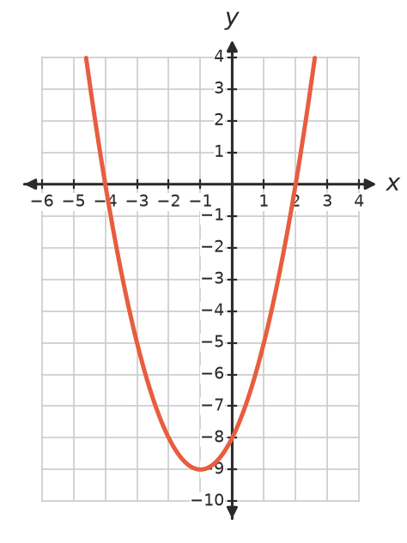
Feature | Answer
Turning point
Maximum or minimum
Axis of symmetry
$x$-intercepts
$y$-intercept
Concave up or down

- The graph shows $y=−x^{2}+6x−5$. Fill in the table.
- 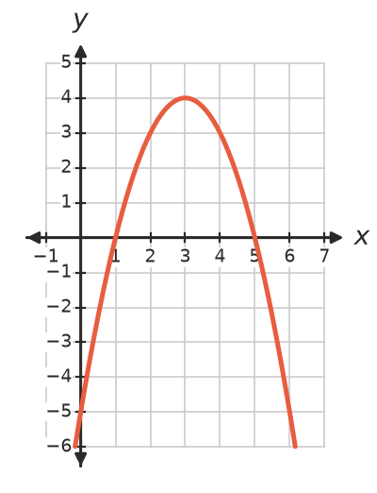
Feature | Answer
Turning point
Maximum or minimum
Axis of symmetry
$x$-intercepts
$y$-intercept
Concave up or down

- Is each statement true or false?
Statement | True or false
Every parabola has exactly two $x$-intercepts.
The graph of $y=ax^{2}+bx+c$ crosses the $y$-axis exactly once.
The axis of symmetry passes through the turning point.
A concave down parabola has a maximum turning point.
The turning point is always on the $y$-axis.

 Fluency
- The rule is $y=x^{2}−6x+5$.
$x$ | 0 | 1 | 2 | 3 | 4 | 5 | 6
$y$

  - Complete the table, then plot the graph.
- 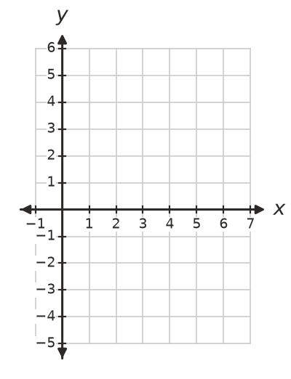
  - Write the turning point and the axis of symmetry. ______________
  - Write the $x$-intercepts and the $y$-intercept. ______________
- The rule is $y=8−2x−x^{2}$.
$x$ | −4 | −3 | −2 | −1 | 0 | 1 | 2
$y$

  - Complete the table, then plot the graph.
- 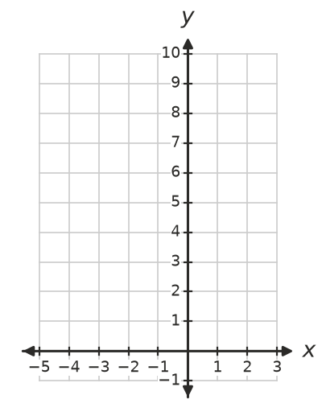
  - Write the turning point. Is it a maximum or a minimum? ______________
  - Write the $x$-intercepts and the axis of symmetry. ______________
- Write the axis of symmetry of a parabola with these $x$-intercepts.
  - −3 and 5 ______________
  - 2 and 8 ______________
  - −6 and −1 ______________
  - −4 and 4 ______________
- A parabola has its axis of symmetry at $x=−1$. Use symmetry to find a second point on the parabola with the same $y$-value.
  - (2, 7) ______________
  - (−3, 0) ______________
  - (0, −5) ______________

 Reasoning
- The grid shows three parabolas.
- 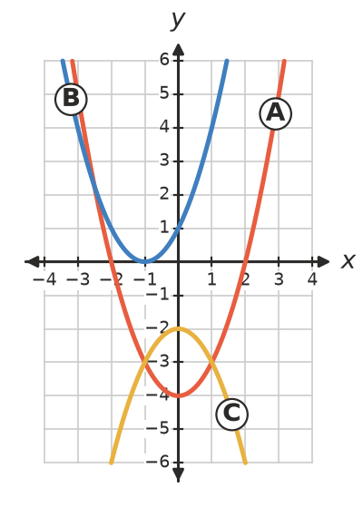
  - How many $x$-intercepts does each parabola have? ______________
  - Explain how the position of the turning point and the concavity tell you how many $x$-intercepts a parabola has.

- Liam says the turning point of $y=x^{2}−4x+3$ is (0, 3), because that is where the graph crosses the $y$-axis. Explain his mistake. Use the table of values for $x=0$ to 4 to find the real turning point.

 Problem solving
- The graph shows the height of a ball, $h$ m, after $t$ seconds.
- 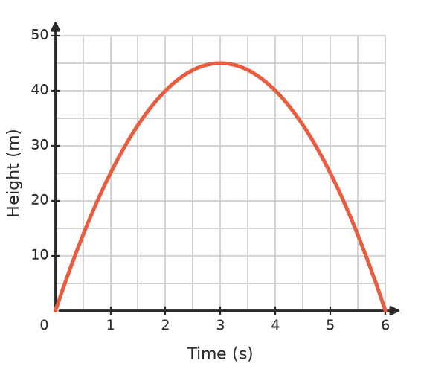
  - What is the maximum height, and when is it reached? ______________
  - When does the ball land? ______________
  - How high is the ball after 1 second? ______________
  - At what two times is the ball 40 m high? ______________
- A parabola has $x$-intercepts −2 and 6, and the $y$-value of its turning point is −8.
  - Write the coordinates of the turning point. ______________
  - Sketch the parabola on the grid. Mark the intercepts and the turning point.
- 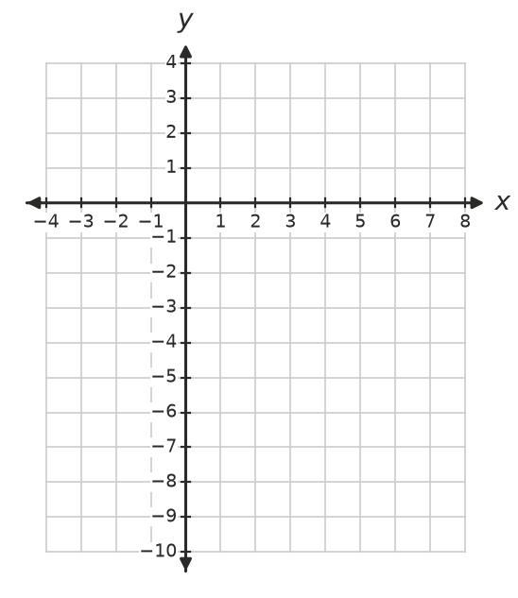
  - Is it concave up or concave down? Explain. ______________
- The arch under a footbridge is a parabola. It is 40 m wide at ground level and 10 m high in the middle.
- 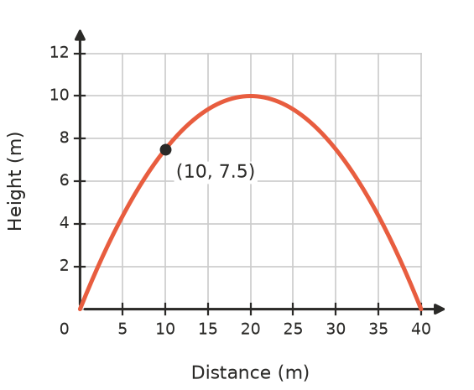
  - Write the equation of the axis of symmetry. ______________
  - Write the coordinates of the turning point. ______________
  - The arch is 7.5 m high at a point 10 m from the left end. Where else is it 7.5 m high? ______________

