5.02 Graphs and features of quadratics
Year 9 Maths · Worksheet · Level 1 · Warm-up
Name: ____________________ Date: ______________
This worksheet practises reading the key features of a parabola from its graph. Tip: the turning point is the lowest or highest point. The axis of symmetry is the vertical line through the turning point, written like $x=1$. The graph crosses the $x$-axis at the $x$-intercepts and the $y$-axis at the $y$-intercept.

 Understanding
- The graph shows a parabola. The dashed line is its axis of symmetry.
- 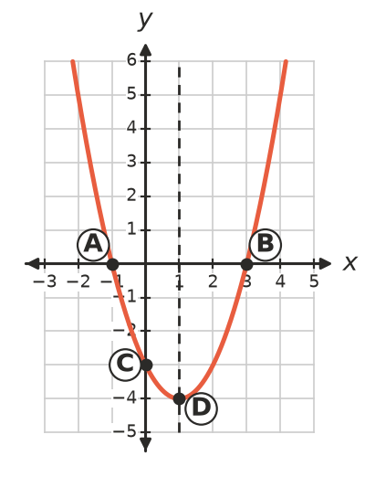
  - Which letter is the turning point? ______________
  - Which letters are the $x$-intercepts? ______________
  - Which letter is the $y$-intercept? ______________
  - Write the equation of the axis of symmetry. ______________
  - Is the parabola concave up (U-shaped) or concave down (cap-shaped)? ______________
  - Is the turning point a maximum or a minimum? ______________
- The graph shows $y=4−x^{2}$.
- 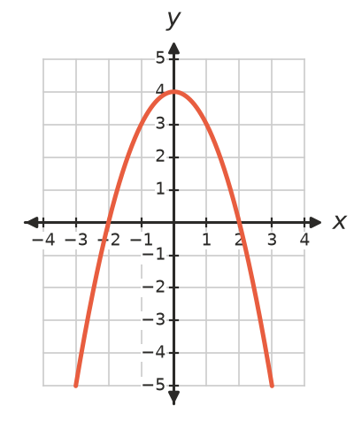
  - Write the coordinates of the turning point. ______________
  - Is it a maximum or a minimum? ______________
  - Write the equation of the axis of symmetry. ______________
  - Write the $x$-intercepts. ______________
  - Write the $y$-intercept. ______________

 Fluency
- The graph shows $y=x^{2}−4x+3$. Fill in the table.
- 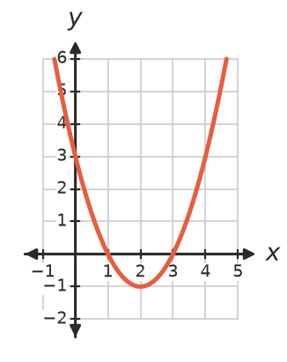
Feature | Answer
Turning point
Maximum or minimum
Axis of symmetry
$x$-intercepts
$y$-intercept
Concave up or down

- The graph shows $y=3−2x−x^{2}$. Fill in the table.
- 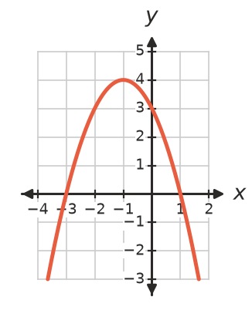
Feature | Answer
Turning point
Maximum or minimum
Axis of symmetry
$x$-intercepts
$y$-intercept
Concave up or down

- The rule is $y=x^{2}+2x−3$.
$x$ | −4 | −3 | −2 | −1 | 0 | 1 | 2
$y$

  - Complete the table.
  - Plot the points and join them with a smooth curve.
- 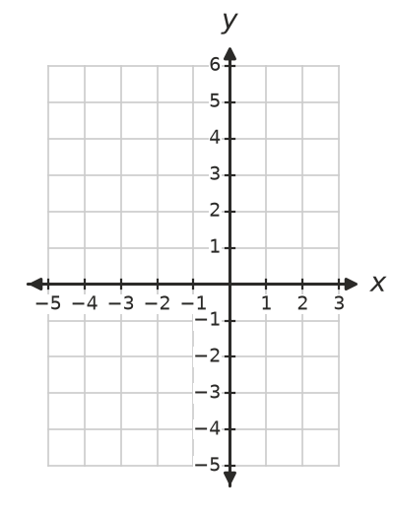
  - Write the turning point. ______________
  - Write the $x$-intercepts and the $y$-intercept. ______________
  - Write the equation of the axis of symmetry. ______________

 Reasoning
- The grid shows two parabolas, A and B.
- 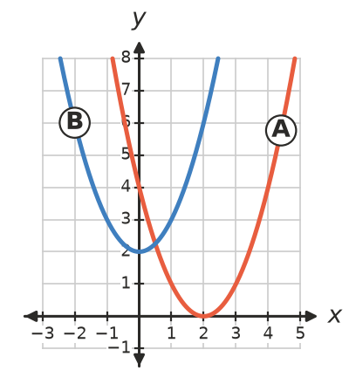
  - How many $x$-intercepts does each parabola have? ______________
  - Write the turning point of each parabola. ______________
- A parabola has $x$-intercepts at −1 and 5. Explain how to find its axis of symmetry, then write its equation.

- A parabola has its axis of symmetry at $x=3$. It passes through the point (1, 7). Write the coordinates of another point on the parabola with a $y$-value of 7. ______________

 Problem solving
- The graph shows the height of a ball thrown into the air.
- 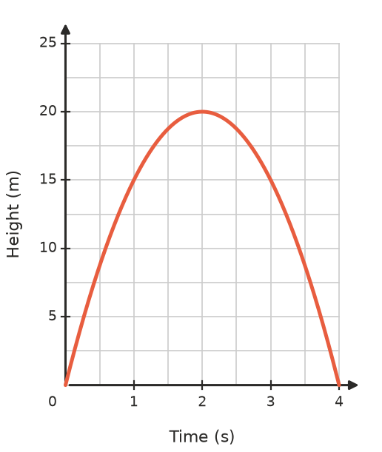
  - What is the greatest height of the ball? ______________
  - When does it reach this height? ______________
  - When does the ball land? ______________
  - How high is the ball after 1 second? ______________
  - At what other time is the ball at this same height? ______________
- A parabola has its turning point at (−2, 1) and passes through (0, 5).
  - Write the equation of its axis of symmetry. ______________
  - Use symmetry to find another point on the parabola. ______________
  - Is the turning point a maximum or a minimum? Explain. ______________

