5.02 Graphs and features of quadratics
Year 9 Maths · A5 question sheet · Level 3 · Challenge
This worksheet practises finding and using the features of parabolas, including turning points that are not on grid points. Tip: find the axis of symmetry first (halfway between two points with the same $y$-value), then substitute it into the rule to find the $y$-value of the turning point.

 Understanding
- The graph shows $y=x^{2}−3x−4$.
- 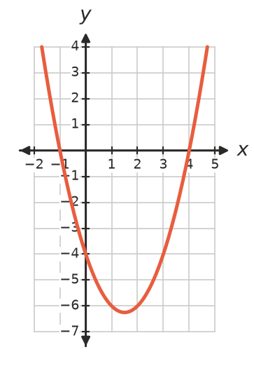
  - Write the $x$-intercepts and the $y$-intercept.
  - Write the equation of the axis of symmetry.
  - Substitute to find the exact turning point.
- The graph shows $y=−2x^{2}−4x+6$.
- 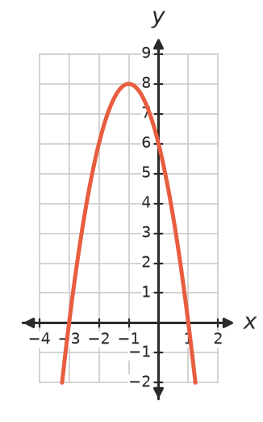
Feature
Turning point
Maximum or minimum
Axis of symmetry
$x$-intercepts
$y$-intercept

 Fluency
- The rule is $y=2x^{2}−8x+3$.
$x$ | 0 | 1 | 2 | 3 | 4
$y$

  - Copy and complete the table, then plot the graph.
- 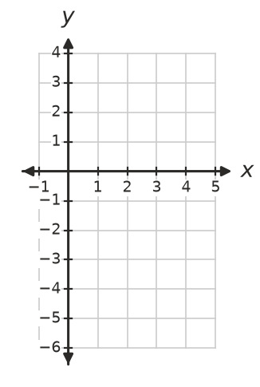
  - Write the turning point and the axis of symmetry.
  - Estimate the $x$-intercepts to one decimal place.
- Write the axis of symmetry of a parabola with these $x$-intercepts.
  - −7 and 2
  - −3.5 and 1.5
  - $p$ and $q$
- A parabola passes through (−4, 6) and (2, 6), and its minimum $y$-value is −3.
  - Write the equation of the axis of symmetry.
  - Write the turning point.
  - It also passes through (0, −1). Find another point on it.
- A parabola has turning point (3, −2) and $y$-intercept 7.
  - Find another point on the parabola.
  - How many $x$-intercepts does it have? Explain.

 Reasoning
- Can a parabola have turning point (2, 5), be concave down and pass through (4, 8)? Explain.
- Two different parabolas both have $x$-intercepts 1 and 5. Explain how their turning points can be different. Give the turning point of each parabola below.
  - $y=(x−1)(x−5)$
  - $y=−2(x−1)(x−5)$
- Write how many $x$-intercepts each parabola has.
Turning point | Concavity
(2, 3) | up
(2, 3) | down
(−1, 0) | down
(0, −4) | up
(5, −1) | down

 Problem solving
- A netball is passed from one player to another. The graph shows its height, $h$ m, when it is $x$ m along the court.
- 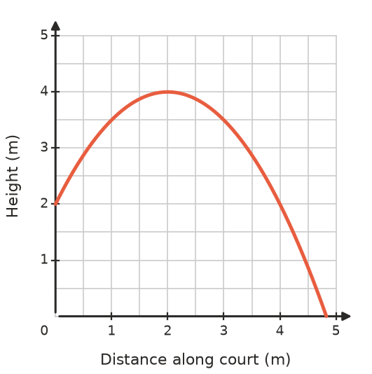
  - How high was the ball when it was thrown?
  - What was its greatest height, and how far along was it then?
  - It was caught at the same height it was thrown from. How far did it travel?
  - If nobody had caught it, about how far along would it have hit the ground?
- A tunnel entrance is a parabola with equation $h=6−\frac{3}{8}x^{2}$, where $h$ m is the height and $x$ m is the distance from the centre line.
  - What is the greatest height of the tunnel?
  - How wide is the tunnel at ground level?
  - Can a truck 3 m wide and 4.2 m tall drive through the middle of the tunnel? Show your working.
  - What is the widest a 4.5 m tall truck could be and still fit?
- A parabola passes through (−1, 4), (5, 4) and (2, −5).
  - Explain why (2, −5) must be the turning point.
  - The parabola also passes through (0, −1). Find another point on it.

