5.02 Graphs and features of quadratics
Year 9 Maths · A5 question sheet · Level 1 · Warm-up
This worksheet practises reading the key features of a parabola from its graph. Tip: the turning point is the lowest or highest point. The axis of symmetry is the vertical line through the turning point, written like $x=1$. The graph crosses the $x$-axis at the $x$-intercepts and the $y$-axis at the $y$-intercept.

 Understanding
- The graph shows a parabola. The dashed line is its axis of symmetry.
- 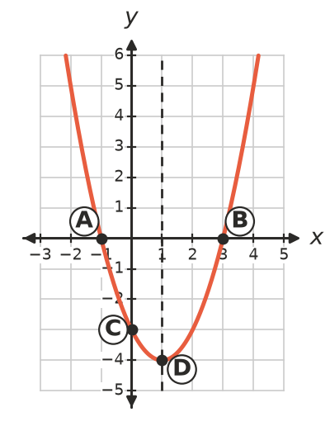
  - Which letter is the turning point?
  - Which letters are the $x$-intercepts?
  - Which letter is the $y$-intercept?
  - Write the equation of the axis of symmetry.
  - Is the parabola concave up (U-shaped) or concave down (cap-shaped)?
  - Is the turning point a maximum or a minimum?
- The graph shows $y=4−x^{2}$.
- 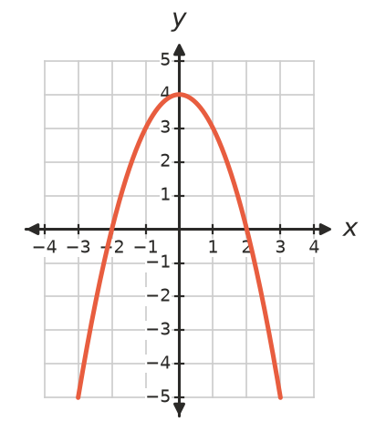
  - Write the coordinates of the turning point.
  - Is it a maximum or a minimum?
  - Write the equation of the axis of symmetry.
  - Write the $x$-intercepts.
  - Write the $y$-intercept.

 Fluency
- The graph shows $y=x^{2}−4x+3$. Copy and fill in the table.
- 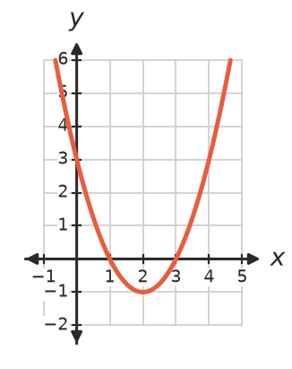
Feature
Turning point
Maximum or minimum
Axis of symmetry
$x$-intercepts
$y$-intercept
Concave up or down

- The graph shows $y=3−2x−x^{2}$. Copy and fill in the table.
- 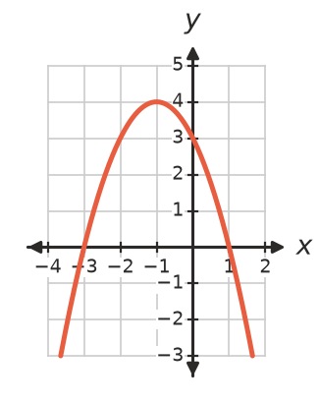
Feature
Turning point
Maximum or minimum
Axis of symmetry
$x$-intercepts
$y$-intercept
Concave up or down

- The rule is $y=x^{2}+2x−3$.
$x$ | −4 | −3 | −2 | −1 | 0 | 1 | 2
$y$

  - Copy and complete the table.
  - Plot the points and join them with a smooth curve.
- 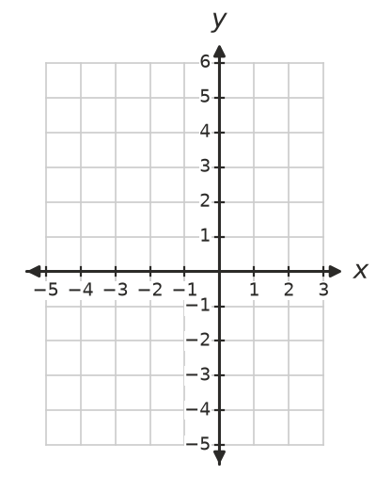
  - Write the turning point.
  - Write the $x$-intercepts and the $y$-intercept.
  - Write the equation of the axis of symmetry.

 Reasoning
- The grid shows two parabolas, A and B.
- 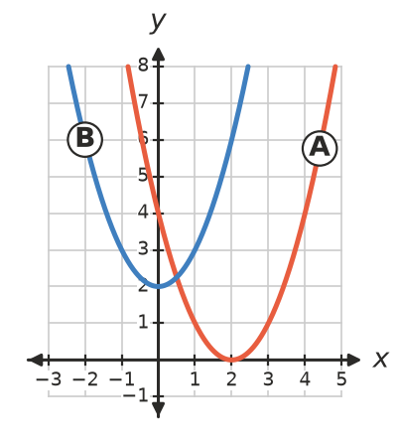
  - How many $x$-intercepts does each parabola have?
  - Write the turning point of each parabola.
- A parabola has $x$-intercepts at −1 and 5. Explain how to find its axis of symmetry, then write its equation.
- A parabola has its axis of symmetry at $x=3$. It passes through the point (1, 7). Write the coordinates of another point on the parabola with a $y$-value of 7.

 Problem solving
- The graph shows the height of a ball thrown into the air.
- 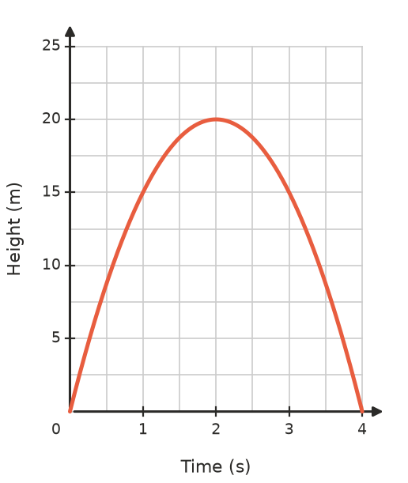
  - What is the greatest height of the ball?
  - When does it reach this height?
  - When does the ball land?
  - How high is the ball after 1 second?
  - At what other time is the ball at this same height?
- A parabola has its turning point at (−2, 1) and passes through (0, 5).
  - Write the equation of its axis of symmetry.
  - Use symmetry to find another point on the parabola.
  - Is the turning point a maximum or a minimum? Explain.

