5.01 Quadratic relationships
Year 9 Maths · Worksheet · Level 1 · Warm-up
Name: ____________________ Date: ______________
This worksheet practises spotting quadratic relationships in equations, tables and graphs. Tip: in a quadratic equation the highest power of $x$ is $x^{2}$. Its graph is a U-shaped curve called a parabola.

 Understanding
- Is each equation quadratic? Write Yes or No.
Equation | Quadratic?
$y=x^{2}+3$
$y=4x−1$
$y=5−x^{2}$
$y=x^{3}$
$y=2x^{2}−x$
$y=7$

- Which of these graphs are parabolas? Answer: ______________
- 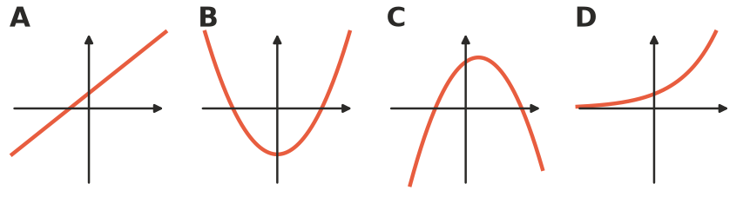
- The rule is $y=x^{2}$.
$x$ | −3 | −2 | −1 | 0 | 1 | 2 | 3
$y$

  - Complete the table. Remember that a negative number squared is positive.
  - Plot the points on the grid and join them with a smooth curve.
- 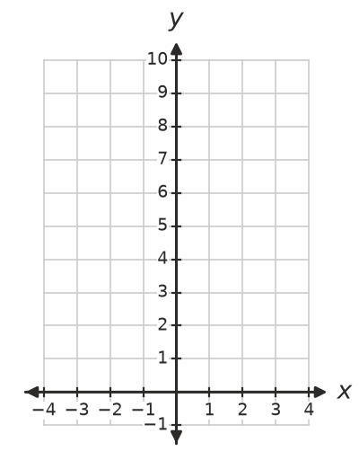
  - What is the smallest $y$-value on your graph? ______________
  - Which $y$-values appear twice in the table? ______________

 Fluency
- Complete the table for $y=x^{2}+2$.
$x$ | −2 | −1 | 0 | 1 | 2
$y$

- Complete the table for $y=2x^{2}$.
$x$ | −2 | −1 | 0 | 1 | 2
$y$

- Find $y$ when $x=4$.
  - $y=x^{2}$ ______________
  - $y=x^{2}−5$ ______________
  - $y=3x^{2}$ ______________
  - $y=x^{2}+2x$ ______________
- This table is for $y=x^{2}$.
$x$ | 0 | 1 | 2 | 3 | 4
$y$ | 0 | 1 | 4 | 9 | 16

  - Write the first differences (how much $y$ goes up each step). ______________
  - Write the second differences (the differences between the first differences). ______________
  - What do you notice about the second differences? ______________

 Reasoning
- Look at the two tables. One is linear and one is quadratic. Which is which? Explain using differences.
- Table A
$x$ | 0 | 1 | 2 | 3 | 4
$y$ | 3 | 5 | 7 | 9 | 11

- Table B
$x$ | 0 | 1 | 2 | 3 | 4
$y$ | 1 | 2 | 5 | 10 | 17

- Mia says $y=3x+2$ is quadratic because it has three numbers in it. Explain why she is wrong.

 Problem solving
- A square tile has sides of $x$ cm. Its area is $A=x^{2}$ cm².
Side, $x$ (cm) | 1 | 2 | 3 | 4 | 5
Area, $A$ (cm²)

  - Complete the table.
  - Is the relationship between side length and area linear or quadratic? ______________
  - What side length gives an area of 64 cm²? ______________
- A garden bed is $x$ metres wide and $(x+3)$ metres long.
  - Write an expression for its area. Expand the brackets. ______________
  - Find the area when $x=2$. ______________
  - Is the area formula quadratic? Explain. ______________

