5.01 Quadratic relationships
Year 9 Maths · A5 question sheet · Level 3 · Challenge
This worksheet practises recognising quadratic relationships, finding rules from tables and modelling real situations. Tip: for $y=ax^{2}+bx+c$, when $x$ goes up in steps of 1, the second differences are all equal to $2a$.

 Understanding
- Is each equation quadratic? Write Yes or No. Simplify first.
Equation
$y=(2x−1)(x+4)$
$y=(x+2)^{2}−(x−2)^{2}$
$y+3x^{2}=2x$
$y=x^{2}(x−1)$
$y=\frac{x^{2}+4x}{2}$
$xy=5$
$y=(x−1)^{2}−x(x−4)$

- Which graphs show $y$ as a quadratic function of $x$?
- 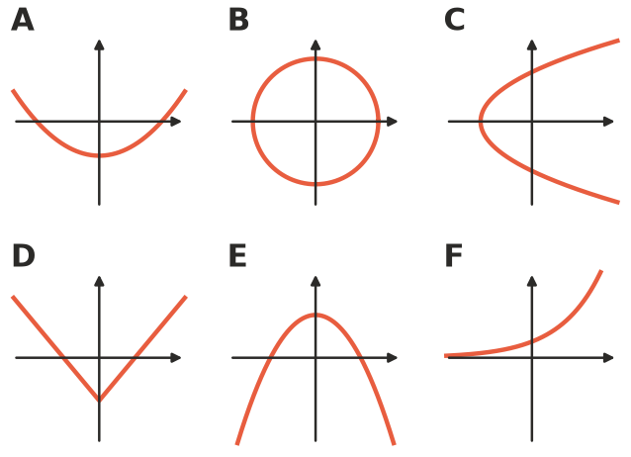

 Fluency
- This table goes up in steps of 2.
$x$ | −2 | 0 | 2 | 4 | 6
$y$ | 13 | 1 | −3 | 1 | 13

  - Use differences to show that the relationship is quadratic.
  - Check that the rule $y=x^{2}−4x+1$ fits every point.
  - Find $y$ when $x=10$.
- The rule is $y=2x^{2}−3x−2$.
$x$ | −2 | −1 | 0 | 1 | 2 | 3
$y$

  - Copy and complete the table.
  - Find the second differences. How do they compare with the coefficient of $x^{2}$?
- This table follows a rule of the form $y=ax^{2}+c$. Find the rule.
$x$ | 0 | 1 | 2 | 3
$y$ | −5 | −2 | 7 | 22

- The sequence 2, 8, 18, 32, 50, … is quadratic.
  - Find the next two terms.
  - Find a rule for the $n$th term.

 Reasoning
- Use algebra to show that for $y=ax^{2}+bx+c$, the second difference is $2a$. (Work out $y$ at $x$, $x+1$ and $x+2$, then find the differences.)
- Explain why, for $y=x^{2}$, doubling $x$ makes $y$ four times as big, but for $y=2x$ doubling $x$ only doubles $y$.

 Problem solving
- These dot patterns continue in the same way.
- 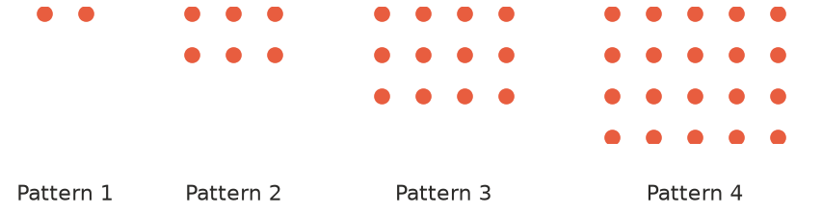
  - How many dots are in Patterns 5 and 6?
  - Write a rule for the number of dots, $D$, in Pattern $n$.
  - Which pattern has 110 dots?
  - Can a pattern have exactly 100 dots? Explain.
- A rope 36 m long is laid out to make a rectangle $x$ m wide.
  - Write a rule for the area, $A$, of the rectangle.
  - Use a table with $x=2,4,6,…,16$ to find the widths that give an area of 72 m².
  - What is the largest possible area?
- A model rocket’s height after $t$ seconds is $h=30t−5t^{2}$ metres.
Time, $t$ (s) | 0 | 1 | 2 | 3 | 4 | 5 | 6
Height, $h$ (m)

  - Copy and complete the table.
  - Show that the relationship is quadratic.
  - What is the greatest height, and when is it reached?
  - When does the rocket land?
- The number of diagonals in a polygon with $n$ sides is $D=\frac{n(n−3)}{2}$.
Sides, $n$ | 4 | 5 | 6 | 7 | 8
Diagonals, $D$

  - Copy and complete the table.
  - Use second differences to show that this is quadratic.
  - Which polygon has 35 diagonals?

