5.01 Quadratic relationships
Year 9 Maths · A5 question sheet · Level 2 · Core
This worksheet practises recognising quadratic relationships from equations, graphs and tables, and using them in real situations. Tip: simplify an equation before you decide. In a table with equal steps in $x$, a linear relationship has equal first differences and a quadratic has equal second differences.

 Understanding
- Is each equation quadratic? Write Yes or No. Expand or rearrange first if you need to.
Equation
$y=3x^{2}−2x+1$
$y=4−3x$
$y=x(x−5)$
$y=2^{x}$
$y=(x+1)^{2}−x^{2}$
$y=\frac{x^{2}}{4}−1$
$x^{2}+y=6$

- Which graphs show a quadratic relationship?
- 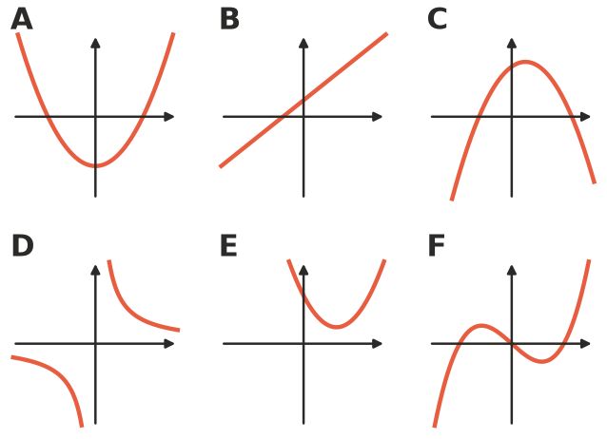

 Fluency
- The rule is $y=x^{2}−4$.
$x$ | −3 | −2 | −1 | 0 | 1 | 2 | 3
$y$

  - Copy and complete the table.
  - Plot the points and join them with a smooth curve.
- 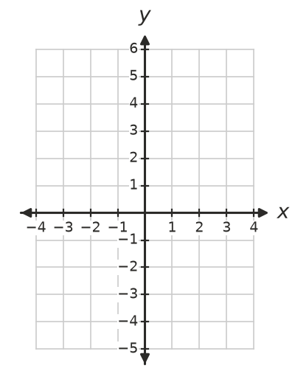
  - Where does the graph cross the $x$-axis?
  - What are the coordinates of the lowest point?
- Copy and complete the table for $y=6−x^{2}$.
$x$ | −3 | −2 | −1 | 0 | 1 | 2 | 3
$y$

- Use differences to decide whether each table is linear, quadratic or neither.
- Table A
$x$ | 0 | 1 | 2 | 3 | 4
$y$ | 2 | 5 | 8 | 11 | 14

- Table B
$x$ | 0 | 1 | 2 | 3 | 4
$y$ | 1 | 3 | 9 | 19 | 33

- Table C
$x$ | 0 | 1 | 2 | 3 | 4
$y$ | 1 | 2 | 4 | 8 | 16

- Table D
$x$ | 1 | 2 | 3 | 4 | 5
$y$ | 10 | 7 | 2 | −5 | −14

  - Table A
  - Table B
  - Table C
  - Table D
- The numbers 3, 6, 11, 18, 27, … follow a quadratic pattern. Use second differences to find the next two numbers.

 Reasoning
- Show that $y=(x+3)^{2}−x^{2}$ is not quadratic, even though it contains a square.
- Ben says, “Any curved graph is a parabola.” Explain why he is wrong. Give an example.

 Problem solving
- At youth group, every person shakes hands once with every other person.
People, $n$ | 2 | 3 | 4 | 5 | 6
Handshakes, $H$

  - Copy and complete the table. (Draw dots and lines on scrap paper if it helps.)
  - Use second differences to show that the relationship is quadratic.
  - The rule is $H=\frac{n(n−1)}{2}$. How many handshakes are there with 10 people?
- A farmer has 20 m of fencing to make a rectangular pen. The pen is $x$ m wide.
  - Write an expression for the length of the pen.
  - Write a rule for the area, $A$, of the pen.
  - Copy and complete the table.
Width, $x$ (m) | 1 | 2 | 3 | 4 | 5 | 6 | 7
Area, $A$ (m²)

  - Which width gives the largest area? What shape is the pen then?
- A stone is dropped from a high cliff. After $t$ seconds it has fallen $d=5t^{2}$ metres.
  - Copy and complete the table.
Time, $t$ (s) | 0 | 1 | 2 | 3 | 4
Distance, $d$ (m)

  - How far does the stone fall during the third second (from $t=2$ to $t=3$)?
  - Explain why the graph of $d$ against $t$ is not a straight line.

