Probability: Practice test 3
Year 9 Maths · Test · Test 3
Name: ____________________ Date: ______________
Time: 45 minutes
Total: 40 marks
Show your working in the boxes. Then write each final answer on the answer sheet on the last page. Write probabilities as fractions in simplest form unless the question asks for something else.

 Section A: No calculator
- For a traffic survey, students counted the number of people in each car that drove past the school gate.
People in the car | 1 | 2 | 3 | 4 or more
Number of cars | 64 | 48 | 20 | 18

  - Find the relative frequency of a car with exactly 2 people. (1 mark)

  - Estimate the probability that the next car has more than 1 person in it. (1 mark)

  - On another day, 600 cars drive past. About how many of them would you expect to have only 1 person? (1 mark)

- For a Year 9 student chosen at random, the probability that the student has been to the snow (S) is 0.35, the probability that the student has been on a plane (P) is 0.6, and the probability that the student has done both is 0.2.
- 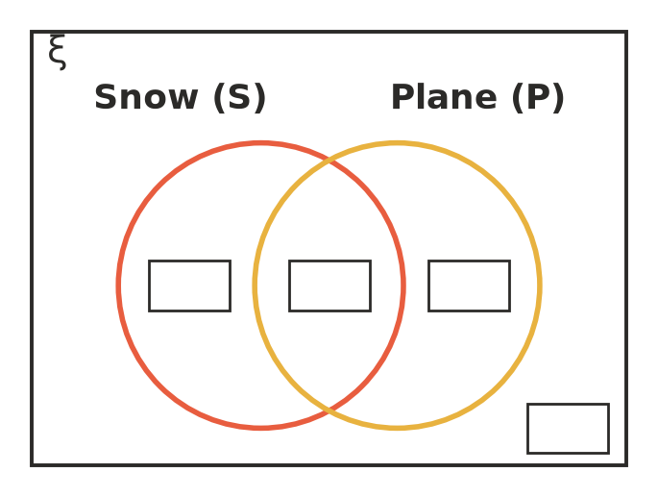
  - Write the probability for each of the four regions of the Venn diagram as a decimal. (2 marks)

  - Find the probability that the student has been to the snow or on a plane (or both). Write it as a decimal. (1 mark)

  - Find the probability that the student has done exactly one of these two things. Write it as a decimal. (1 mark)

- A youth group has 45 members, and 25 of them are girls. On Friday, 18 members rode a bike to youth group, and 7 of these were boys.
 | Rode a bike | No bike | Total
Girls
Boys
Total

  - Complete the two-way table. (2 marks)

  - One member is chosen at random. Find the probability that the member is a boy and did not ride a bike. (1 mark)

  - One member is chosen at random. Find the probability that the member is a girl or rode a bike (or both). (1 mark)

- Two spinners each have four equal sections numbered 1, 2, 3 and 4. Both are spun and the two numbers are multiplied.
× | 1 | 2 | 3 | 4
1
2
3
4

  - Complete the array to show every possible product. (1 mark)

  - Find the probability that the product is 4. (1 mark)

  - Find the probability that the product is an odd number. (1 mark)

  - Find the probability that the product is greater than 6. (1 mark)

- For three days, the canteen chooses the hot lunch at random each day: pasta (P) or curry (C). Pasta and curry are equally likely.
- 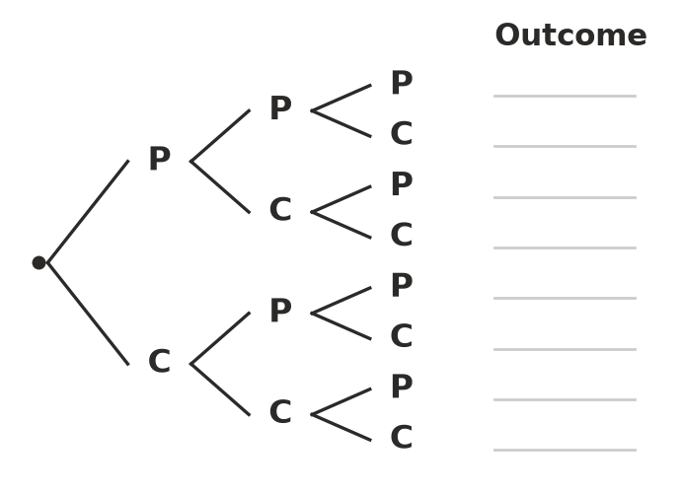
  - Complete the tree diagram by writing every outcome, for example PCC. (1 mark)

  - Find the probability that pasta is served on exactly two of the days. (1 mark)

  - Find the probability that curry is served on at least one of the days. (1 mark)

- A PE bucket holds 3 orange tennis balls and 7 white tennis balls. Mia takes out two balls at random, one after the other, without replacement.
  - Find the probability that the first ball is orange. (1 mark)

  - Find the probability that both balls are orange. (1 mark)

  - Find the probability that both balls are the same colour. Show your working. (2 marks)

  - Now suppose Mia puts the first ball back before taking the second. Find the probability that both balls are the same colour. (1 mark)

- Liam spins a spinner 10 times and it lands on red 6 times, so he says P(red) = 0.6. Priya spins the same spinner 500 times and it lands on red 240 times. Whose estimate of P(red) should you trust more? Explain, and give Priya’s estimate. (2 marks)

- In a class of 40 students, 6 play both cricket and tennis and 10 play neither. The number of students who play only cricket is double the number who play only tennis.
  - How many students play only tennis? Show your working. (2 marks)

  - One student is chosen at random. Find the probability that the student plays cricket. (1 mark)

 Section B: Calculator allowed
- A spreadsheet simulated rolling two fair six-sided dice 1000 times. A double six came up 31 times, and at least one six came up 302 times.
  - Find the experimental probability of a double six. Write it as a decimal. (1 mark)

  - Find the theoretical probability of a double six. Write it as a decimal rounded to 3 decimal places. (1 mark)

  - Find the theoretical probability of at least one six, rounded to 3 decimal places, and compare it with the simulation. (1 mark)

- A family plans a bushwalk on a long weekend. The forecast probability of rain is 0.3 on Saturday, 0.4 on Sunday and 0.5 on Monday. Treat the three days as independent.
  - Find the probability that it rains on all three days. (1 mark)

  - Find the probability that it does not rain at all. (1 mark)

  - Find the probability that it rains on at least one day. (1 mark)

  - Find the probability that it rains on exactly one day. Show your working. (2 marks)

- A survey of 640 households in a country town found that 384 have solar panels, 208 have a rainwater tank and 112 have both.
  - Estimate the probability that a household has solar panels or a rainwater tank (or both). Write it as a decimal. (1 mark)

  - A larger town has 12 400 households. Estimate how many of them have solar panels or a rainwater tank, but not both. (1 mark)

- A fair coin is tossed again and again. What is the smallest number of tosses needed for the probability of getting at least one head to be greater than 0.99? Show your working. (2 marks)

 Answer sheet
Name: ____________________
Write your final answer for each question in the table.
Question | Answer | Marks | Question | Answer | Marks
1a |  | /1 | 6b |  | /1
1b |  | /1 | 6c |  | /2
1c |  | /1 | 6d |  | /1
2a | (on the Venn diagram) | /2 | 7 |  | /2
2b |  | /1 | 8a |  | /2
2c |  | /1 | 8b |  | /1
3a | (in the table) | /2 | 9a |  | /1
3b |  | /1 | 9b |  | /1
3c |  | /1 | 9c |  | /1
4a | (on the array) | /1 | 10a |  | /1
4b |  | /1 | 10b |  | /1
4c |  | /1 | 10c |  | /1
4d |  | /1 | 10d |  | /2
5a | (on the tree diagram) | /1 | 11a |  | /1
5b |  | /1 | 11b |  | /1
5c |  | /1 | 12 |  | /2
6a |  | /1
 |  |  |  | Total | /40

