Probability: Practice test 2
Year 9 Maths · Test · Test 2
Name: ____________________ Date: ______________
Time: 45 minutes
Total: 40 marks
Show your working in the boxes. Then write each final answer on the answer sheet on the last page. Write probabilities as fractions in simplest form unless the question asks for something else.

 Section A: No calculator
- A spinner has five equal sections coloured red, blue, yellow, green and white. Ben spins it 150 times. His results are in the table.
Colour | Red | Blue | Yellow | Green | White
Frequency | 41 | 29 | 27 | 26 | 27

  - Find the relative frequency of red. (1 mark)

  - Use Ben’s results to estimate the probability that the next spin lands on blue or green. (1 mark)

  - If the spinner is fair, how many times would you expect red in 150 spins? (1 mark)

  - Ben says, “Red came up 41 times instead of 30, so the spinner must be unfair.” Give one reason why Ben might be wrong. (1 mark)

- At a church picnic, 80 people were asked what they ate. 52 people had a sausage (S), 30 people had a salad (L) and 15 people had both.
- 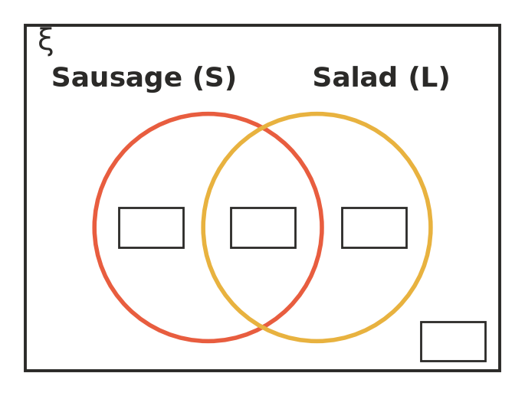
  - Write the number of people in each of the four regions of the Venn diagram. (2 marks)

  - One person is chosen at random. Find the probability that the person had a sausage or a salad (or both). (1 mark)

  - One person is chosen at random. Find the probability that the person had exactly one of these two foods. (1 mark)

  - One person is chosen at random. Find the probability that the person had neither food. (1 mark)

- At a beach on a hot day, 200 people were asked whether they swam between the flags and whether they wore a hat.
 | Hat | No hat | Total
Swam | 46 | 64 | 110
Did not swim | 58 | 32 | 90
Total | 104 | 96 | 200

  - One person is chosen at random. Find the probability that the person swam and wore a hat. (1 mark)

  - One person is chosen at random. Find the probability that the person swam or wore a hat (or both). (1 mark)

  - One person is chosen at random. Find the probability that the person swam or wore a hat, but not both. (1 mark)

  - One of the people who swam is chosen at random. Find the probability that this person did not wear a hat. (1 mark)

- Five cards are numbered 1, 2, 3, 4 and 5. Two cards are taken at random, one after the other, without replacement. The first card is the tens digit and the second card is the units digit of a two-digit number. For example, 4 then 2 makes 42. You may use an array to help you.
  - How many different two-digit numbers are possible? (1 mark)

  - Find the probability that the number is greater than 40. (1 mark)

  - Find the probability that the number is odd. (1 mark)

- At netball training, Sofia takes two shots at goal. Each shot goes in (G) with probability 0.8 or misses (M), and the shots are independent.
- 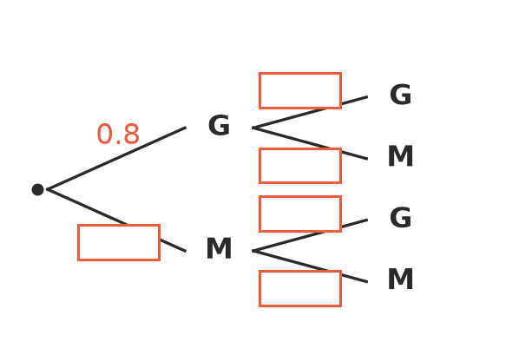
  - Write the missing probabilities in the boxes on the tree diagram. (1 mark)

  - Find the probability that both shots go in. (1 mark)

  - Find the probability that exactly one shot goes in. (1 mark)

- A box holds 10 school hats: 6 are white and 4 are navy. Two hats are taken out at random.
  - The first hat is put back before the second is taken. Find the probability that both hats are navy. (1 mark)

  - This time the first hat is not put back. Find the probability that both hats are navy. (1 mark)

  - Explain why your answer to part b is smaller than your answer to part a. (1 mark)

  - The first hat is not put back. Find the probability that at least one of the hats is white. (1 mark)

- Aria tosses a fair coin 5 times and gets a head every time. She says, “The next toss is more likely to be a tail, because a tail is due.” Is Aria right? Explain your answer. (2 marks)

- A bag holds 12 marbles. Some are red and the rest are blue. Two marbles are taken at random without replacement. The probability that both marbles are red is $\frac{1}{11}$. How many red marbles are in the bag? Show your working. (3 marks)

 Section B: Calculator allowed
- At a fruit shop, 15% of mangoes in a large crate are bruised. A quality checker takes 3 mangoes at random. Treat the three picks as independent. Round each answer to 3 decimal places.
  - Find the probability that none of the 3 mangoes are bruised. (1 mark)

  - Find the probability that at least one mango is bruised. (1 mark)

  - Find the probability that exactly one mango is bruised. Show your working. (2 marks)

- A survey of 350 people who travel to work in the city found that 168 use a train, 112 use a bus and 49 use both a train and a bus.
  - Estimate the probability that a worker uses a train or a bus (or both). Write it as a decimal. (1 mark)

  - Estimate the probability that a worker uses a train or a bus, but not both. Write it as a decimal. (1 mark)

  - The city has 5000 workers. Estimate how many of them use neither a train nor a bus. (1 mark)

- A basketballer scores 70% of her free throws. To simulate two free throws, Hamish uses random digits: 0 to 6 means a score and 7, 8 or 9 means a miss. Each pair of digits below is one trial of two free throws.
- 79 54 22 05 87 91 58 90 62 76 22 30 12 89 16 14 33 61 43 64 50 30 60 67 20
  - Use the 25 trials to find the experimental probability that she scores both free throws. Write it as a decimal. (1 mark)

  - Find the theoretical probability that she scores both free throws. (1 mark)

  - Compare your answers to parts a and b. Why are they different? (1 mark)

- A group of 9 students has 5 girls and 4 boys. Three students are chosen at random to plan the Year 9 social. Find the probability that all three are girls. Round your answer to 3 decimal places. Show your working. (2 marks)

 Answer sheet
Name: ____________________
Write your final answer for each question in the table.
Question | Answer | Marks | Question | Answer | Marks
1a |  | /1 | 5c |  | /1
1b |  | /1 | 6a |  | /1
1c |  | /1 | 6b |  | /1
1d |  | /1 | 6c |  | /1
2a | (on the Venn diagram) | /2 | 6d |  | /1
2b |  | /1 | 7 |  | /2
2c |  | /1 | 8 |  | /3
2d |  | /1 | 9a |  | /1
3a |  | /1 | 9b |  | /1
3b |  | /1 | 9c |  | /2
3c |  | /1 | 10a |  | /1
3d |  | /1 | 10b |  | /1
4a |  | /1 | 10c |  | /1
4b |  | /1 | 11a |  | /1
4c |  | /1 | 11b |  | /1
5a | (on the tree diagram) | /1 | 11c |  | /1
5b |  | /1 | 12 |  | /2
 |  |  |  | Total | /40

