Probability: Practice test 1
Year 9 Maths · Test · Test 1
Name: ____________________ Date: ______________
Time: 45 minutes
Total: 40 marks
Show your working in the boxes. Then write each final answer on the answer sheet on the last page. Write probabilities as fractions in simplest form unless the question asks for something else.

 Section A: No calculator
- The school library recorded the type of item borrowed by the first 80 students on Monday.
Item | Fiction | Non-fiction | Graphic novel | Magazine
Frequency | 34 | 18 | 20 | 8

  - Find the relative frequency of a graphic novel being borrowed. (1 mark)

  - Estimate the probability that the next student borrows fiction or a magazine. (1 mark)

  - On Tuesday, 240 students borrow one item each. About how many of them would you expect to borrow non-fiction? (1 mark)

- Fifty Year 9 students were asked whether they play in the school band (B) and whether they sing in the choir (C). The Venn diagram shows the results.
- 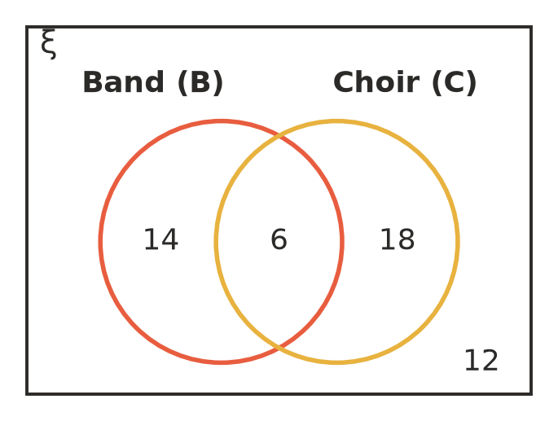
- One of these students is chosen at random. Find the probability that the student:
  - is in the band and the choir (1 mark)

  - is in the band or the choir (or both) (1 mark)

  - is in the band or the choir, but not both (1 mark)

  - is in neither the band nor the choir. (1 mark)

- At a church youth camp, each camper chose one afternoon activity: kayaking or archery. The two-way table shows some of the results. The letters a, b, c, d and e stand for missing numbers.
 | Kayaking | Archery | Total
Junior | 18 | a | 40
Senior | b | 12 | c
Total | 42 | d | e

  - Find the values of a, b, c, d and e. (2 marks)

  - One camper is chosen at random. Find the probability that the camper is a senior and chose archery. (1 mark)

  - One camper is chosen at random. Find the probability that the camper is a senior or chose archery (or both). (1 mark)

  - One of the junior campers is chosen at random. Find the probability that this camper chose kayaking. (1 mark)

- Spinner A has four equal sections numbered 1, 2, 3 and 4. Spinner B has three equal sections numbered 1, 2 and 3. Both spinners are spun and the two numbers are added.
+ | B: 1 | B: 2 | B: 3
A: 1
A: 2
A: 3
A: 4

  - Complete the array to show every possible total. (1 mark)

  - Find the probability that the total is 5. (1 mark)

  - Find the probability that the total is an even number. (1 mark)

  - Find the probability that the total is a prime number. (1 mark)

- For a mufti day, Lucy chooses a T-shirt (red or blue) and a cap (black, white or grey) at random. In the tree diagram, R = red, Bl = blue, Bk = black, Wh = white and Gy = grey.
- 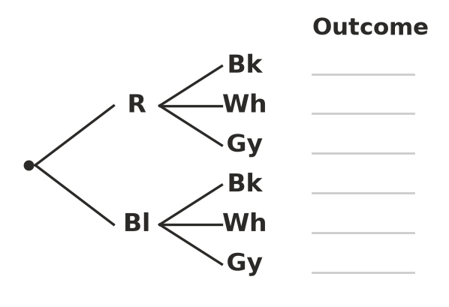
  - Complete the tree diagram by writing every outcome, for example R-Bk. (1 mark)

  - Find the probability that Lucy wears a blue T-shirt and a grey cap. (1 mark)

  - Find the probability that Lucy wears a red T-shirt or a white cap (or both). (1 mark)

- A jar holds 5 mint lollies (M) and 3 strawberry lollies (S). Jake takes one lolly at random and eats it. Then he takes a second lolly at random.
- 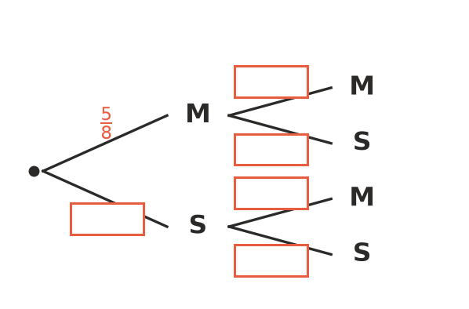
  - Write the missing probabilities in the boxes on the tree diagram. (1 mark)

  - Find the probability that both lollies are mint. (1 mark)

  - Find the probability that Jake gets one lolly of each flavour. (1 mark)

  - Suppose Jake had put the first lolly back in the jar instead of eating it. Find the probability that both lollies are mint. (1 mark)

- Look again at the Venn diagram in Question 2. Leah wrote this:
- “P(B or C) = P(B) + P(C) = $\frac{20}{50}+\frac{24}{50}=\frac{44}{50}$”
- Explain the mistake Leah made, and give the correct value of P(B or C). (2 marks)

- In a group of 60 students, 35 play a team sport, 28 play a musical instrument and 9 do neither. One student is chosen at random.
  - Find the probability that the student plays a team sport and an instrument. Show your working. (2 marks)

  - Find the probability that the student does exactly one of these two activities. (1 mark)

 Section B: Calculator allowed
- A factory tests 1250 phone chargers and finds that 35 of them are faulty.
  - Find the relative frequency of a faulty charger. Write it as a decimal. (1 mark)

  - A shop orders 4000 chargers from this factory. How many faulty chargers would you expect? (1 mark)

- On a road trip, the Nguyen family drives through three sets of traffic lights. Each set of lights is green with probability 0.6, and each set works independently of the others.
  - Find the probability that all three sets of lights are green. (1 mark)

  - Find the probability that none of the lights are green. (1 mark)

  - Find the probability that at least one set of lights is green. (1 mark)

  - Find the probability that exactly two sets of lights are green. Show your working. (2 marks)

- Ella wants to estimate the probability that a family with three children has three girls. She assumes a girl and a boy are equally likely. She tosses three coins at once and counts three heads as “three girls”. She does this 50 times and gets three heads 8 times.
  - Find the experimental probability of three girls from Ella’s simulation. Write it as a decimal. (1 mark)

  - Find the theoretical probability of three girls. Write it as a decimal. (1 mark)

  - Describe how Ella could make her estimate more reliable. (1 mark)

- A class has 25 students and 15 of them are girls. Two students are chosen at random to be class captains (the same student cannot be chosen twice). Find the probability that both captains are girls. Write your answer as a decimal. Show your working. (2 marks)

 Answer sheet
Name: ____________________
Write your final answer for each question in the table.
Question | Answer | Marks | Question | Answer | Marks
1a |  | /1 | 6a | (on the tree diagram) | /1
1b |  | /1 | 6b |  | /1
1c |  | /1 | 6c |  | /1
2a |  | /1 | 6d |  | /1
2b |  | /1 | 7 |  | /2
2c |  | /1 | 8a |  | /2
2d |  | /1 | 8b |  | /1
3a |  | /2 | 9a |  | /1
3b |  | /1 | 9b |  | /1
3c |  | /1 | 10a |  | /1
3d |  | /1 | 10b |  | /1
4a | (on the array) | /1 | 10c |  | /1
4b |  | /1 | 10d |  | /2
4c |  | /1 | 11a |  | /1
4d |  | /1 | 11b |  | /1
5a | (on the tree diagram) | /1 | 11c |  | /1
5b |  | /1 | 12 |  | /2
5c |  | /1
 |  |  |  | Total | /40

