10.05 Multi-stage probability
Year 9 Maths · Worksheet · Level 1 · Warm-up
Name: ____________________ Date: ______________
This worksheet practises probability for experiments with three or more steps. Tip: multiply along the branches to find the probability of one path. For “at least one”, it is often quicker to work out P(none) and use P(at least one) = 1 − P(none).

 Understanding
- Three coins are tossed.
- 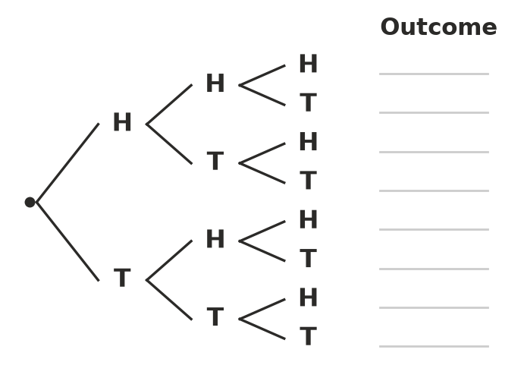
  - Write the eight outcomes on the lines.
  - Find P(three heads). ______________
  - Find P(exactly two heads). ______________
  - Find P(at least one head). ______________
- Jordan has 2 shirts, 3 pairs of pants and 2 pairs of shoes.
  - How many different outfits can he make? ______________
  - He picks each item at random. What is the probability of one particular outfit? ______________
- A quiz has three true-or-false questions. Lily guesses every answer.
  - Find P(all three correct). ______________
  - Find P(exactly two correct). ______________
  - Find P(none correct). ______________

 Fluency
- A seed sprouts (S) with probability 0.8 and does not sprout (N) with probability 0.2. Three seeds are planted.
- 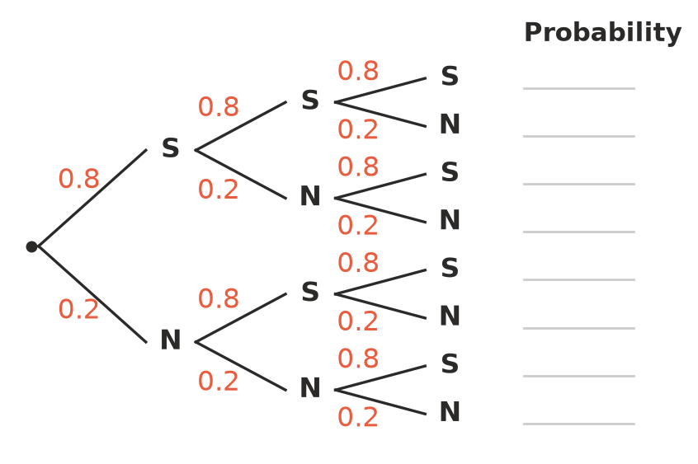
  - Write the probability of each outcome on the lines. (For example, SSS is 0.8 × 0.8 × 0.8.)
  - Find P(all three sprout). ______________
  - Find P(none sprout). ______________
  - Find P(at least one sprouts). ______________
- Three different spinners are spun. The probability of red is $\frac{1}{2}$ on the first spinner, $\frac{1}{3}$ on the second and $\frac{1}{4}$ on the third. Find P(red on all three). ______________

- A coin is tossed four times.
  - Find P(no heads). ______________
  - Use your answer to find P(at least one head). ______________
- A bag holds 3 red and 2 blue counters. Three counters are taken out one at a time, without replacement.
  - Find P(all three are red). ______________

  - Find P(red, then red, then blue). ______________

 Reasoning
- Ali says, “P(head) = $\frac{1}{2}$ for one coin, so P(three heads) = 3 × $\frac{1}{2}$ = $\frac{3}{2}$.” Explain why Ali must be wrong, and give the correct answer.

- Complete the table, then describe the pattern.
Number of coins | 1 | 2 | 3 | 4
P(all heads)

Pattern: ______________

 Problem solving
- A canteen meal deal is a main (pie, wrap or pasta), a drink (water or juice) and a dessert (fruit cup or yoghurt). Ella’s deal is chosen at random. Find P(pie, juice and fruit cup).

- In a dry season the probability of rain on any day is 0.1. Find the probability that there is no rain on any of three days in a row, and the probability that it rains on at least one of them.

