10.05 Multi-stage probability
Year 9 Maths · A5 question sheet · Level 2 · Core
This worksheet practises probability for experiments with three or more stages, with and without replacement. Tip: P(at least one) = 1 − P(none). For “exactly one”, count how many paths have exactly one, find the probability of one path, then multiply.

 Understanding
- Three coins are tossed.
  - Draw a tree diagram on scrap paper and list the eight outcomes.
  - Find P(exactly two heads).
  - Find P(at least two heads).
  - Find P(head, tail, head, in that order).
- On the way to school, Isla goes through three sets of traffic lights. At each one, P(green) = 0.6 and P(red) = 0.4, and the lights work independently.
- 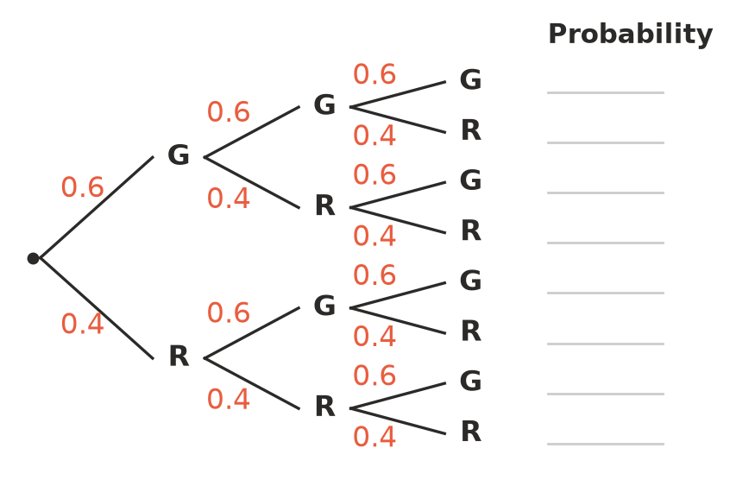
  - Write the probability of each outcome on the lines.
  - Find P(all three green).
  - Find P(exactly two green).
  - Find P(at least one red).

 Fluency
- A die is rolled, a coin is tossed and a spinner with three equal sectors (red, blue, yellow) is spun.
  - How many outcomes are there?
  - Find P(a 6, a head and red).
  - Find P(an even number, a tail and not yellow).
- A bag holds 5 red and 3 blue marbles. Three marbles are taken without replacement.
  - Find P(all three red).
  - Find P(all three blue).
  - Find P(at least one blue).
- A die is rolled three times.
  - Find P(no 6s).
  - Find P(exactly one 6).
  - Find P(at least one 6).
- A footy team plays three games against different teams. The probabilities that it wins are 0.7, 0.5 and 0.4. There are no draws.
  - Find P(it wins all three).
  - Find P(it loses all three).
  - Find P(it wins at least one).

 Reasoning
- Jack says, “The chance of a 6 is $\frac{1}{6}$ on each roll, so if I roll three times the chance of at least one 6 is $\frac{3}{6}$ = $\frac{1}{2}$.” Use your answer to Question 5 to explain why Jack is wrong.
- Explain why P(at least one) = 1 − P(none).

 Problem solving
- A quiz has four multiple-choice questions, each with four options. Theo guesses every answer.
  - Find P(all four correct).
  - Find P(none correct).
  - Find P(at least one correct).
- Three students are chosen at random from 4 Year 9 and 4 Year 10 students.
  - Find P(all three are Year 9).
  - Find P(all three are from the same year).
- A smoke alarm works with probability 0.9. Alarms work independently of each other.
  - A house has two alarms. Find P(at least one works).
  - Find P(at least one works) if there are three alarms.
  - Why do some buildings have several alarms in the same area?
- The chance of rain is 0.2 on Friday, 0.3 on Saturday and 0.5 on Sunday.
  - Find P(no rain on any of the three days).
  - Find P(rain on exactly one of the three days).

