10.04 With and without replacement
Year 9 Maths · Worksheet · Level 2 · Core
Name: ____________________ Date: ______________
This worksheet practises two-step probability with and without replacement, using arrays and tree diagrams. Tip: without replacement, the second-draw fractions have one less on the bottom, and one less on the top if you are taking the same kind again. Always check that each pair of branches adds to 1.

 Understanding
- A bag holds 4 red (R) and 3 blue (B) marbles. A marble is taken, its colour is recorded, and it is put back. Then a second marble is taken.
  - Draw a tree diagram with the probability on each branch.

  - Find P(two red). ______________
  - Find P(two blue). ______________
  - Find P(one of each colour). ______________
- The bag in Question 1 is used again, but this time the first marble is not put back.
  - Draw a tree diagram with the probability on each branch.

  - Find P(two red). ______________
  - Find P(two blue). ______________
  - Find P(one of each colour). ______________

 Fluency
- A packet holds 5 lime (L) and 3 raspberry (R) lollies. Nina eats one lolly, then another.
- 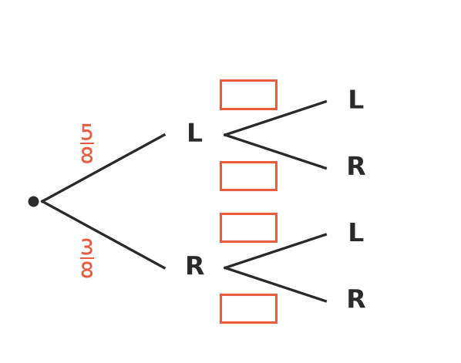
  - Write the missing probabilities in the boxes.
  - Find P(two lime). ______________
  - Find P(two raspberry). ______________
  - Find P(at least one raspberry). ______________
- Five cards are numbered 1 to 5. Two cards are taken without replacement and the numbers are added.
+ | 1 | 2 | 3 | 4 | 5
1 | X
2 |  | X
3 |  |  | X
4 |  |  |  | X
5 |  |  |  |  | X

  - Complete the array. How many outcomes are there? ______________
  - Find P(a total of 6). ______________
  - Find P(an even total). ______________
  - If the first card were put back, what would P(an even total) be? ______________
- A group has 4 Year 9 students and 3 Year 10 students. Two are chosen at random to speak at assembly.
  - Find P(both are Year 9 students). ______________
  - Find P(one Year 9 and one Year 10 student). ______________
- A box holds 10 pens. 3 of them don’t work. Kai takes two pens at random.
  - Find P(both pens work). ______________
  - Find P(at least one pen doesn’t work). ______________

 Reasoning
- Look again at the bag in Question 2 (no replacement).
  - Find P(the second marble is red) by adding the two branch outcomes that end in red. ______________

  - Compare your answer with P(the first marble is red). What do you notice? ______________
- Is each situation like drawing with or without replacement? Write With or Without.
Situation | With or without
Rolling a die twice
Choosing two students for a team
Taking a lolly, eating it, then taking another
Spinning a spinner twice
Testing two phones from a box of new phones

- Jess says, “Without replacement, the probabilities on the second branches are always smaller than on the first branches.” Use the tree in Question 3 to show that Jess is wrong. ______________

 Problem solving
- A teacher picks 2 students at random from a group of 12 to give a talk. 5 of the 12 have given a talk before. Find P(neither of the chosen students has given a talk before).

- A bag holds 6 counters. Some are red. A counter is taken and put back, then a second counter is taken. P(both red) = $\frac{4}{9}$. How many red counters are in the bag? ______________

- A drawer holds 5 black socks and 3 grey socks. Two socks are taken at random. Find P(the two socks match).

