10.04 With and without replacement
Year 9 Maths · A5 question sheet · Level 1 · Warm-up
This worksheet practises finding probabilities when two objects are taken one after the other. With replacement means the first object is put back before the second is taken, so nothing changes. Without replacement means the first object is kept out, so there is one fewer object for the second draw. Tip: for without replacement, take one off the bottom number of the second fraction, and take one off the top number too if it is the same colour as the first draw.

 Understanding
- A bag holds 2 red counters (R1 and R2) and 1 blue counter (B). A counter is taken, its colour is recorded and it is put back. Then a second counter is taken. The rows show the first draw and the columns show the second draw.
 | R1 | R2 | B
R1 | R1 R1
R2
B

  - Copy and complete the array. How many outcomes are there?
  - Find P(two reds).
  - Find P(two blues).
  - Find P(one red and one blue).
- Now the same bag is used, but the first counter is not put back.
 | R1 | R2 | B
R1 | X
R2 |  | X
B |  |  | X

  - Copy and complete the array. The cells marked X cannot happen. How many outcomes are there?
  - Find P(two reds).
  - Find P(two blues).
  - Find P(one red and one blue).
- Complete each sentence with the same as or different from.
  - With replacement, the probabilities for the second draw are ______________ the probabilities for the first draw.
  - Without replacement, the probabilities for the second draw are ______________ the probabilities for the first draw.

 Fluency
- A bag holds 3 green (G) and 2 yellow (Y) lollies. Sam takes one lolly and eats it, then takes another.
- 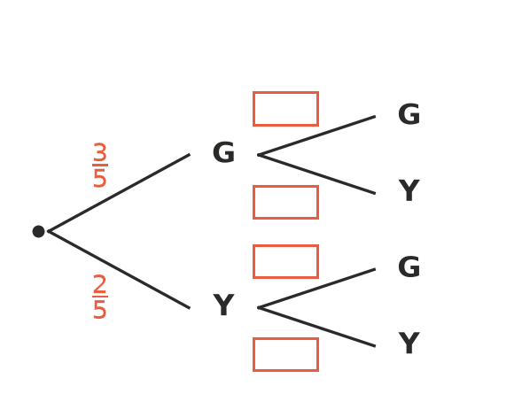
  - Write the missing probabilities in your book. (There are only 4 lollies left for the second draw.)
  - Find P(two green).
  - Find P(two yellow).
  - Find P(one of each colour).
- The bag in Question 4 is refilled with 3 green and 2 yellow lollies. This time Sam takes a lolly, looks at it and puts it back, then takes another.
  - Find P(two green).
  - Find P(two yellow).
  - Find P(one of each colour).
- Four cards are numbered 1, 2, 3 and 4. Two cards are taken without replacement to make a two-digit number. The first card is the tens digit.
  - List all the possible numbers. How many are there?
  - Find P(the number is more than 30).
  - Find P(the number is even).

 Reasoning
- A bag holds 2 red and 2 blue counters. Two counters are taken.
  - Find P(two reds) with replacement.
  - Find P(two reds) without replacement.
  - Explain why taking two reds is less likely without replacement.
- In Question 2, explain why the cells on the diagonal cannot happen.

 Problem solving
- Five students, Ari, Ben, Cai, Dev and Ella, put their names in a hat. Two names are drawn at random to be class captains.
  - List all the possible pairs of captains. How many are there?
  - Find P(Ella is a captain).
  - Find P(Ari and Ben are the captains).
- A drawer holds 4 black socks and 2 white socks. In the dark, Leo takes out two socks. Find P(the two socks are the same colour). Show your working.
- A fruit bowl holds 3 apples and 1 orange. Two people each take a piece of fruit at random. Find P(they both get an apple).

