10.03 Arrays and simple tree diagrams
Year 9 Maths · Worksheet · Level 1 · Warm-up
Name: ____________________ Date: ______________
This worksheet practises listing all the outcomes of a two-step experiment with an array (a table) or a tree diagram, then finding probabilities. Tip: when every outcome is equally likely, P(event) = number of outcomes in the event ÷ total number of outcomes.

 Understanding
- Two coins are tossed. The tree diagram shows the first coin, then the second coin.
- 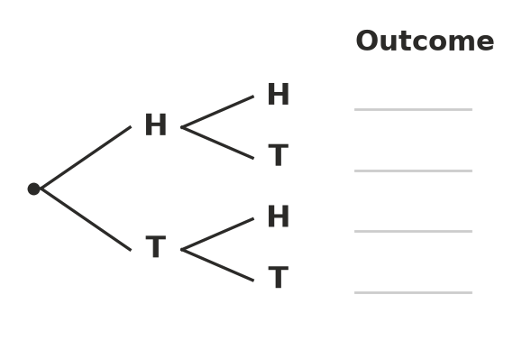
  - Write the four outcomes on the lines.
  - Find P(two heads). ______________
  - Find P(one head and one tail). ______________
  - Find P(at least one head). ______________
- A spinner numbered 1, 2 and 3 is spun and a coin is tossed.
Spinner | H | T
1 | 1H
2
3

  - Complete the array.
  - How many outcomes are there? ______________
  - Find P(3 and a head). ______________
  - Find P(an even number and a tail). ______________
  - Find P(a head or a 1). ______________
- Two dice are rolled and the numbers are added.
+ | 1 | 2 | 3 | 4 | 5 | 6
1 | 2 | 3 | 4 | 5 | 6 | 7
2
3
4
5
6

  - Complete the array of totals.
  - Find P(a total of 7). ______________
  - Find P(a total of 11). ______________
  - Find P(a total less than 5). ______________
  - Which total is the most likely? ______________

 Fluency
- A meal deal has a main (wrap, pie or pasta) and a drink (water or juice).
  - Draw a tree diagram to show all the possible meal deals.

  - How many different meal deals are there? ______________
  - Ben chooses his meal deal at random. Find P(pie and juice). ______________
- Two spinners, each numbered 1 to 4, are spun and the numbers are multiplied.
× | 1 | 2 | 3 | 4
1
2
3
4

  - Complete the array of products.
  - Find P(the product is even). ______________
  - Find P(the product is 4). ______________
  - Find P(the product is more than 6). ______________
- For lunch, Kate picks a sandwich at random: ham (H), egg (E) or salad (S). Then she picks a piece of fruit at random: apple (A) or banana (B).
- 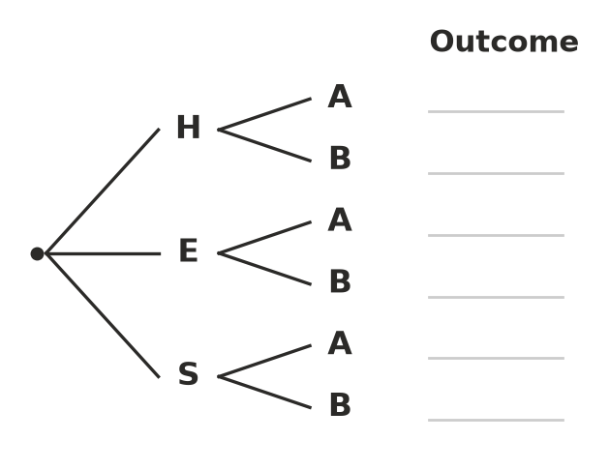
  - Write the six outcomes on the lines.
  - Find P(egg sandwich and banana). ______________
  - Find P(apple). ______________
- Two dice are rolled. Use your array from Question 3 to help.
  - Find P(a 6 on the first die). This is a simple event. ______________
  - Find P(a 6 on both dice). ______________
  - Find P(at least one 6). ______________
  - Which of these three events is the most likely? ______________

 Reasoning
- Lucy says, “When you toss two coins there are three outcomes: two heads, two tails, or one of each. So P(two heads) = $\frac{1}{3}$.” Explain Lucy’s mistake.

- When two dice are rolled, is a total of 7 or a total of 8 more likely? Explain using your array. ______________

 Problem solving
- A locker code is one letter (A, B or C) followed by one digit (1, 2, 3 or 4), for example B3.
  - How many different codes are there? ______________
  - A code is chosen at random. Find P(the code starts with A and ends with an even digit). ______________
- One spinner is numbered 1, 2, 3 and another is numbered 1, 2, 3, 4. Both are spun and the numbers are added. Find P(the total is even). Show your array.

