10.03 Arrays and simple tree diagrams
Year 9 Maths · A5 question sheet · Level 2 · Core
This worksheet practises listing outcomes of two-step experiments with arrays and tree diagrams, and finding probabilities of compound events. Tip: on a tree diagram, multiply the probabilities along the branches to get the probability of each outcome. Then add the outcomes you want.

 Understanding
- Two dice are rolled. The score is the larger number minus the smaller number (if they are the same, the score is 0).
− | 1 | 2 | 3 | 4 | 5 | 6
1 | 0 | 1
2
3
4
5
6

  - Copy and complete the array.
  - Find P(a score of 0).
  - Find P(a score of 1).
  - Find P(a score of 3 or more).
  - Which score is the most likely?
- A spinner has three equal sectors: red (R), yellow (Y) and blue (B). It is spun twice.
  - Draw a tree diagram and list all the outcomes.
  - Find P(the same colour twice).
  - Find P(at least one yellow).
  - Find P(red then blue).
  - Find P(one red and one blue, in either order).

 Fluency
- A school bus is on time (O) with probability 0.8 and late (L) with probability 0.2 each day. The tree diagram shows Monday and Tuesday.
- 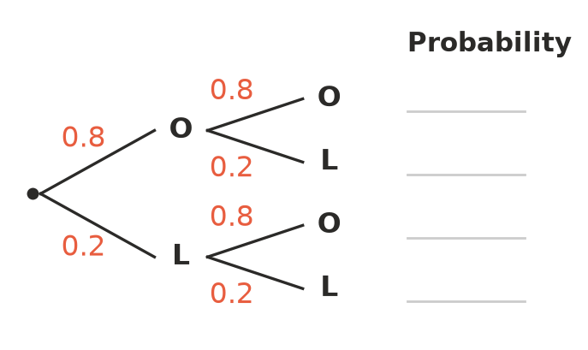
  - Write the probability of each outcome on the lines.
  - Find P(on time both days).
  - Find P(late on exactly one day).
  - Find P(late on at least one day).
  - Check that your four answers to part a) add up to 1.
- A 4-sided die (1 to 4) and a normal 6-sided die are rolled and the numbers are added.
+ | 1 | 2 | 3 | 4 | 5 | 6
1
2
3
4

  - Copy and complete the array. How many outcomes are there?
  - Find P(a total of 5).
  - Find P(a total of 8 or more).
  - Find P(both dice show the same number).
  - Find P(a total of 8 or both dice the same).
- A cafe offers 4 mains and 3 drinks.
  - How many different main-and-drink combinations are there?
  - The cafe adds a choice of 2 desserts. How many main, drink and dessert combinations are there now?
- A coin is tossed and a die is rolled.
  - Draw an array of the outcomes on scrap paper. How many are there?
  - Find P(a head and an even number).
  - Find P(a head or an even number).
  - Find P(a head or an even number but not both).

 Reasoning
- Mia says, “With one die, P(a 6) = $\frac{1}{6}$. With two dice you get two chances, so P(at least one 6) = $\frac{2}{6}$.” Find the correct probability and explain Mia’s mistake.
- Explain why the probabilities at the ends of the branches of a tree diagram always add up to 1.
- In Question 2, explain why P(red then blue) can be found by working out $\frac{1}{3}$ × $\frac{1}{3}$.

 Problem solving
- Spinner A has four equal sectors numbered 1, 2, 3 and 4. Spinner B is numbered 1, 2 and 3, but the 1 takes up half of the spinner and the 2 and 3 each take up a quarter. Both spinners are spun and the numbers are added.
  - Find P(a total of 2).
  - Find P(a total of 4).
- Ruby picks a shirt (blue, white or grey) and a hat (white or black) at random.
  - Find P(blue shirt and white hat).
  - Find P(the shirt and hat are the same colour).
- A basketball player scores from a free throw with probability 0.7. She takes two free throws.
  - Draw a tree diagram on scrap paper. Find P(she scores both).
  - Find P(she scores exactly one).
  - Find P(she misses both).
  - Compare P(scores the first shot) with P(scores both). Which is more likely, and why?

