10.02 Venn diagrams and two-way tables
Year 9 Maths · Worksheet · Level 2 · Core
Name: ____________________ Date: ______________
This worksheet practises probabilities of “and”, inclusive “or” and exclusive “or” from Venn diagrams, two-way tables and survey data. A or B (inclusive) means A, B or both: A ∪ B. A or B but not both (exclusive) means exactly one of them. A and B means both: A ∩ B. Tip: P(A or B) = P(A) + P(B) − P(A and B). You take away the overlap because it was counted twice.

 Understanding
- The Venn diagram shows 80 Year 9 students who are in the science club (S) and the music program (M). One student is chosen at random.
- 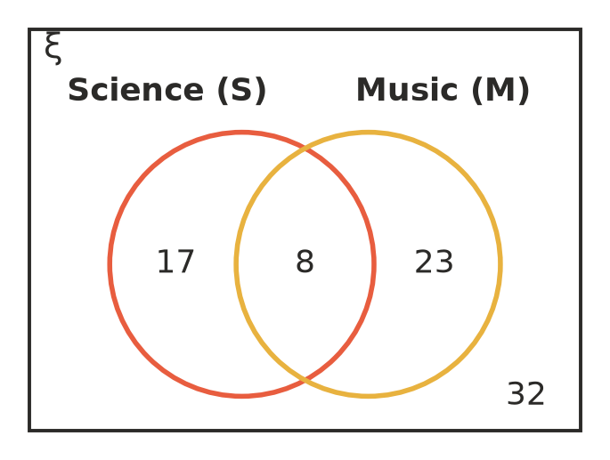
  - P(S and M) ______________
  - P(S or M) ______________
  - P(S or M but not both) ______________
  - P(not M) ______________
  - P(neither) ______________
- The regions of this Venn diagram are labelled W, X, Y and Z.
- 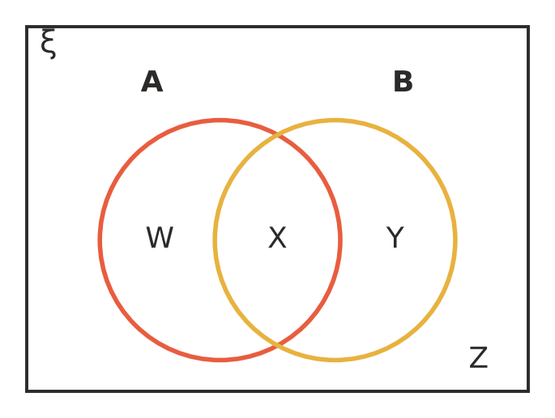
- Describe each group of regions in words (use “and”, “or”, “or but not both” or “not”), then in symbols if you can.
  - W, X and Y ______________
  - W and Y ______________
  - X only ______________
  - Y and Z ______________

 Fluency
- A stall holder at a market recorded whether 120 customers bought coffee and whether they bought food.
 | Food | No food | Total
Coffee | 34 |  | 58
No coffee
Total | 51 |  | 120

  - Complete the two-way table.
  - Find P(coffee and food). ______________
  - Find P(coffee or food). ______________
  - Find P(coffee or food but not both). ______________
  - Find P(neither). ______________
- At a church picnic of 90 people, 52 played cricket (C), 37 played volleyball (V) and 15 played both.
- 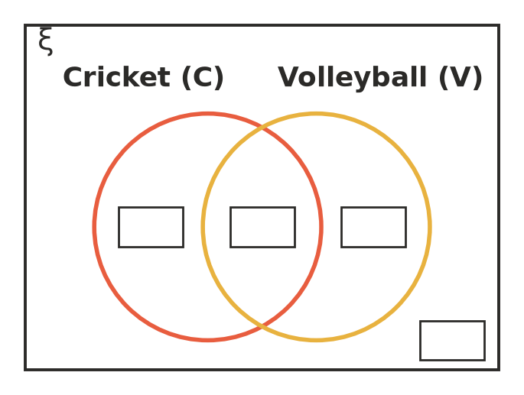
  - Complete the Venn diagram.
  - Find P(C or V). ______________
  - Find P(C or V but not both). ______________
- A number from 1 to 20 is chosen at random. A is the event “a multiple of 4” and B is the event “a factor of 24”.
  - List the numbers in A and the numbers in B. ______________

  - Find P(A and B). ______________
  - Find P(A or B). ______________
  - Find P(A or B but not both). ______________
- The Venn diagram shows 45 people at a morning tea who drank tea (T) and coffee (C).
- 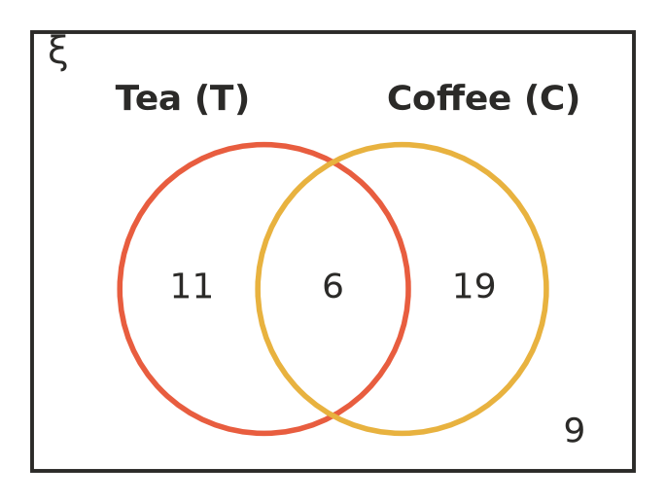
  - Show the same information in the two-way table.
 | Coffee | No coffee | Total
Tea
No tea
Total |  |  | 45

  - Find P(T or C). ______________

 Reasoning
- For two events, P(A) = 0.45, P(B) = 0.3 and P(A and B) = 0.12.
  - Find P(A or B). ______________
  - Find P(A or B but not both). ______________
  - Explain why P(A) + P(B) gives too big an answer for P(A or B). ______________

- Explain why P(A or B but not both) = P(A) + P(B) − 2 × P(A and B). Check that it works for the Venn diagram in Question 1. ______________

 Problem solving
- In a survey of 200 households, 128 have a vegetable garden, 70 keep chickens and 38 have neither.
  - How many households have both? ______________

  - Find P(garden or chickens but not both). ______________
- A survey of 150 Year 9 students asked whether they have a part-time job (J) and whether they play weekend sport (S).
 | Sport | No sport | Total
Job | 24 | 21 | 45
No job | 63 | 42 | 105
Total | 87 | 63 | 150

  - Estimate P(J or S). ______________
  - Estimate P(J or S but not both). ______________
  - A school has 225 Year 9 students. Estimate how many have a job and play weekend sport. ______________
- There are 60 people in this Venn diagram.
- 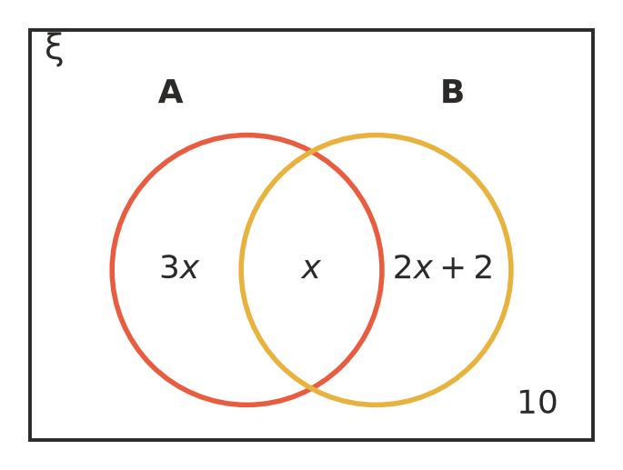
  - Write an equation and solve it to find $x$. ______________

  - Find P(A or B but not both). ______________
- Two dice are rolled. A is the event “at least one 6” and B is the event “a total of 10 or more”. Use a 6 by 6 grid of outcomes on scrap paper.
  - How many of the 36 outcomes are in A? In B? In A and B? ______________
  - Find P(A or B). ______________
  - Find P(A or B but not both). ______________

