10.02 Venn diagrams and two-way tables
Year 9 Maths · Worksheet · Level 1 · Warm-up
Name: ____________________ Date: ______________
This worksheet practises finding probabilities from Venn diagrams and two-way tables. There are two kinds of “or”. A or B means A, or B, or both (this is the usual meaning). A or B but not both means exactly one of them. A and B means both at once. Tip: always check which kind of “or” a question asks for.

 Understanding
- The Venn diagram shows the 30 students in a class who play netball (N) and basketball (B). One student is chosen at random.
- 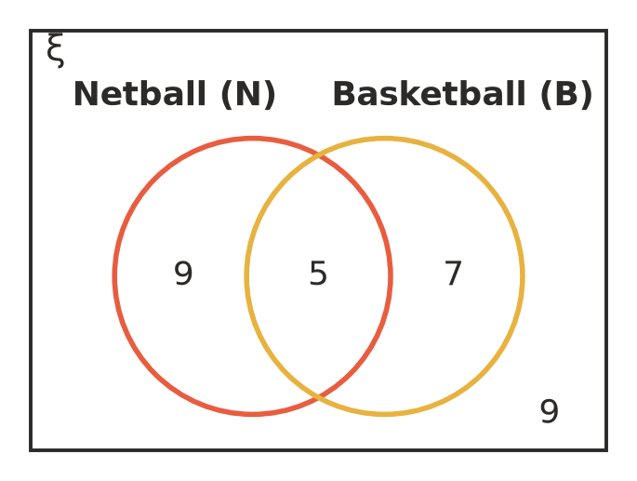
  - How many students play both sports? ______________
  - How many students play netball? ______________
  - Find P(netball and basketball). ______________
  - Find P(netball or basketball). ______________
  - Find P(netball or basketball but not both). ______________
  - Find P(neither sport). ______________
- The regions of this Venn diagram are labelled W, X, Y and Z.
- 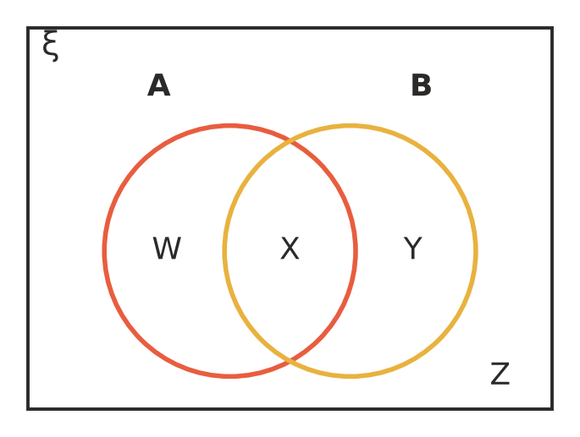
- Write the letter or letters of the regions for each event.
  - A and B ______________
  - A or B ______________
  - A or B but not both ______________
  - neither A nor B ______________
- A class of 40 students was asked whether they own a dog and whether they own a cat.
 | Cat | No cat | Total
Dog | 6 |  | 20
No dog | 8
Total | 14 |  | 40

  - Complete the two-way table.
  - Find P(dog and cat). ______________
  - Find P(dog or cat). ______________
  - Find P(dog or cat but not both). ______________

 Fluency
- At a youth group of 25 people, 12 like pizza (P), 10 like tacos (T) and 4 like both.
- 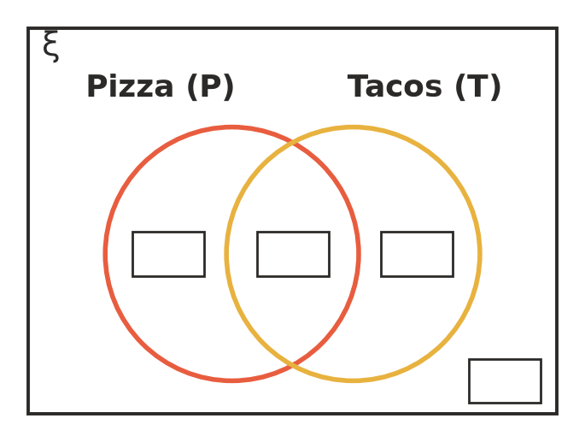
  - Complete the Venn diagram. Start with the 4 in the overlap.
  - Find P(pizza or tacos). ______________
  - Find P(pizza or tacos but not both). ______________
- A number from 1 to 12 is chosen at random. A is the event “an even number” and B is the event “a multiple of 3”.
  - List the numbers that are in A and B. ______________
  - List the numbers that are in A or B. ______________
  - List the numbers that are in A or B but not both. ______________
  - Find P(A and B), P(A or B) and P(A or B but not both). ______________
- Show the information from the two-way table in Question 3 in this Venn diagram.
- 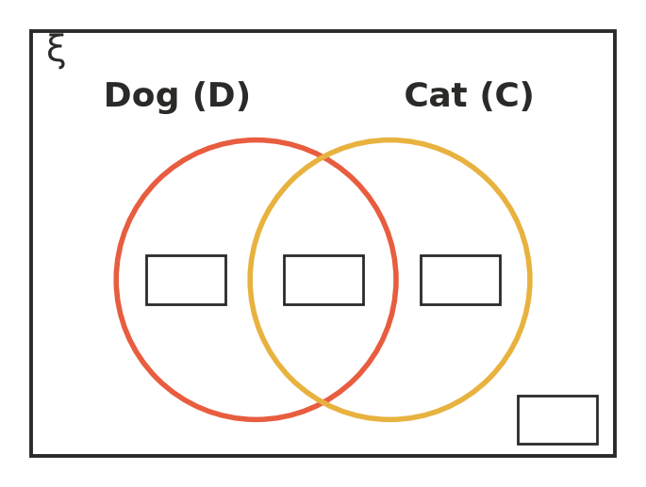

 Reasoning
- Sam used the Venn diagram in Question 1 like this: “14 play netball and 12 play basketball, so P(netball or basketball) = $\frac{26}{30}$.” Explain Sam’s mistake.

- For any two events A and B, which is bigger: P(A or B) or P(A or B but not both)? Explain using a Venn diagram. ______________

 Problem solving
- On a camp, 50 students chose activities. 28 went kayaking, 20 went hiking and 9 did both.
  - How many students did neither activity? ______________

  - Find P(kayaking or hiking but not both). ______________
- The canteen recorded what 60 students bought at lunch.
 | Drink | No drink | Total
Hot food | 18 | 12 | 30
No hot food | 10 | 20 | 30
Total | 28 | 32 | 60

  - Find P(hot food and a drink). ______________
  - Find P(hot food or a drink). ______________
  - Tomorrow 300 students are expected to buy lunch. Estimate how many will buy hot food and a drink. ______________

