10.02 Venn diagrams and two-way tables
Year 9 Maths · A5 question sheet · Level 3 · Challenge
This worksheet practises “and”, inclusive “or” and exclusive “or” with Venn diagrams, two-way tables, unknowns and three sets. Tip: P(A or B) = P(A) + P(B) − P(A and B), and P(A or B but not both) = P(A or B) − P(A and B). Draw a Venn diagram whenever a question gives you totals.

 Understanding
- The Venn diagram shows 120 members of a community centre who use the library (L) and the gym (G). One member is chosen at random.
- 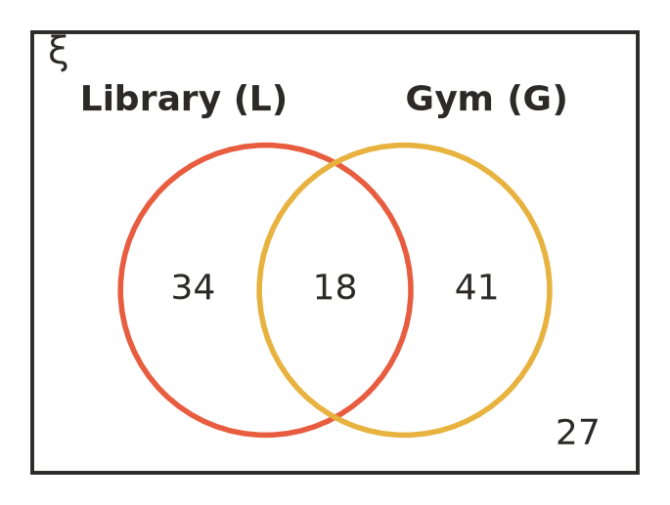
  - P(L or G)
  - P(L or G but not both)
  - P(L and not G)
  - P(not both L and G)
- The table shows the relative frequencies for vehicles at a highway rest stop. Each vehicle is either a ute or not, and is either towing a trailer or not.
 | Towing | Not towing | Total
Ute | 0.12 |  | 0.30
Not a ute
Total | 0.20 |  | 1

  - Copy and complete the table.
  - Find P(ute or towing).
  - Find P(ute or towing but not both).
  - 250 vehicles stopped on Saturday. Estimate how many were utes towing a trailer.

 Fluency
- For two events, P(A) = 0.55, P(B) = 0.4 and P(A or B) = 0.7.
  - Find P(A and B).
  - Find P(A or B but not both).
  - Find P(neither A nor B).
- There are 100 people in this Venn diagram.
- 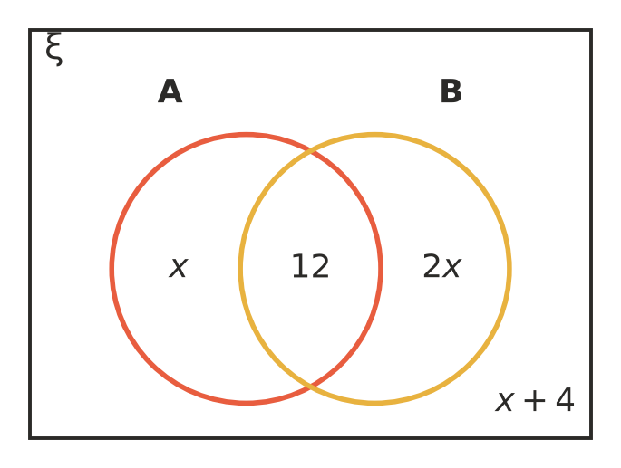
  - Find the value of $x$.
  - Find P(B).
  - Find P(A or B but not both).
- In a survey of 300 people, 174 read books on the weekend, 132 play video games on the weekend and 40 do neither.
  - Find P(reads and plays video games).
  - Find P(reads or plays video games but not both).
- The Venn diagram shows the 50 students in a performing arts program who study Art (A), Drama (D) and Music (M).
- 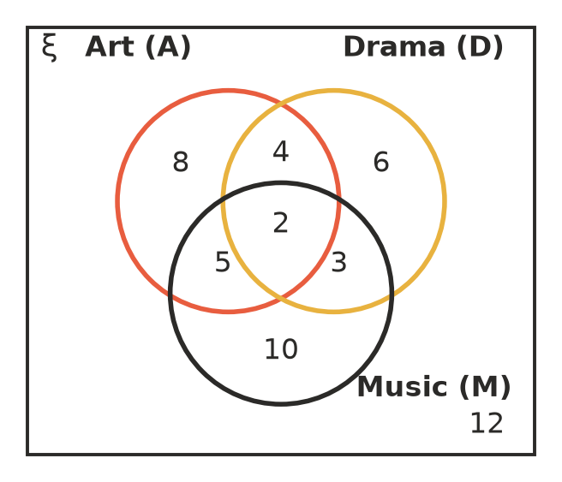
  - Find P(A or D).
  - Find P(exactly one of the three subjects).
  - Find P(A and M).
  - Find P(A or M but not both).
  - Find P(none of the three).

 Reasoning
- When is P(A or B) = P(A) + P(B) true? Explain, and give an example with a die.
- For two events, P(A) = 0.6 and P(B) = 0.7.
  - Explain why A and B must be able to happen at the same time.
  - Find the smallest possible value of P(A and B).
  - Find the largest possible value of P(A and B).

 Problem solving
- Two dice are rolled. A is the event “both numbers are odd” and B is the event “the total is 8 or more”.
  - How many of the 36 outcomes are in A, in B, and in A and B?
  - Find P(A or B).
  - Find P(A or B but not both).
- An orchard checked 400 apples. 48 were too small, 30 were bruised and 14 were both. An apple is rejected if it is too small or bruised.
  - Estimate the probability that an apple is rejected.
  - Estimate how many apples in a load of 12 500 will be rejected.
  - Estimate P(an apple has exactly one of the two faults).
- At a sports carnival, 70% of the people bought food, 45% bought a drink and 25% bought both. 36 people bought neither.
  - How many people were at the carnival?
  - How many bought food or a drink but not both?
- For two events, P(A) = 0.5, P(B) = 0.4 and P(A or B but not both) = 0.5. Find P(A and B).

