Measurement: Practice test 3
Year 9 Maths · Test · Test 3
Name: ____________________ Date: ______________
Time: 45 minutes
Total: 40 marks
Show your working in the boxes. Then write each final answer on the answer sheet on the last page. Diagrams marked “Not to scale” are not drawn accurately, so use the measurements given instead of measuring.

 Section A: No calculator
In this section, leave $π$ in your answers when a question asks for an exact answer (for example, $25π$ cm²).
- Find the area of each shape.
  - This triangle. (1 mark)
- 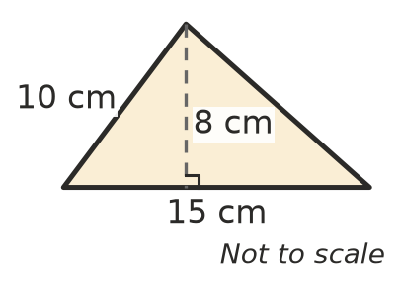

  - This rhombus. Its diagonals are 12 cm and 7 cm long. (1 mark)
- 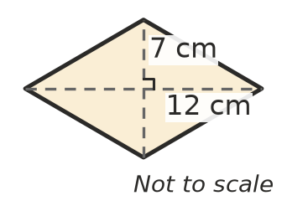

- Give each answer in terms of $π$.
  - Find the area of a circle with a radius of 5 cm. (1 mark)

  - Find the area of three-quarters of a circle with a radius of 4 cm. (1 mark)

- A school sports field is a rectangle with a semicircle on each end. Find the area of the field. Give your answer in terms of $π$. (2 marks)
- 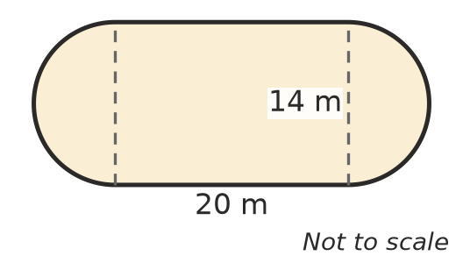

- A kite has an area of 60 cm². One of its diagonals is 15 cm long. Find the length of the other diagonal. (2 marks)

- Lucas drew this net for a closed box, but he left out one face.
- 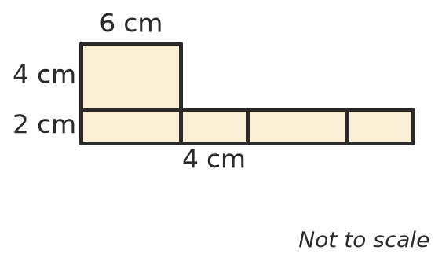
  - What are the length and width of the missing face? Sketch it on the net where it would fold correctly. (1 mark)

  - Find the surface area of the closed box. (2 marks)

- A sandpit has no top. It is 3 m long, 2 m wide and 0.5 m deep. The base and the four sides are lined with plastic. Find the area of plastic needed. (2 marks)

- Find the volume of each prism.
  - A triangular prism. (1 mark)
- 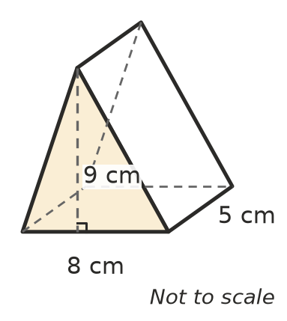

  - A prism with a T-shaped cross-section. (2 marks)
- 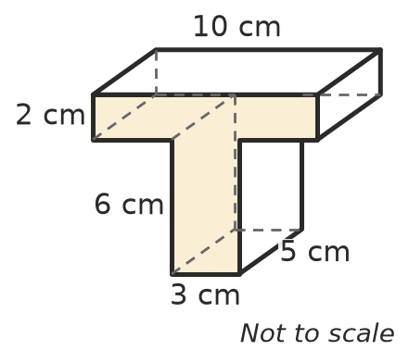

- A concrete slab for a shed is 6 m long, 4 m wide and 0.1 m thick.
  - Find the volume of concrete needed, in cubic metres. (1 mark)

  - Concrete costs $250 per cubic metre. Find the cost of the concrete for the slab. (1 mark)

- A round cake tin is a cylinder with a radius of 6 cm and a height of 5 cm. Find its volume in terms of $π$. (2 marks)

- A pencil holder is a cylinder with a base but no lid. Its radius is 4 cm and its height is 10 cm. Find its outside surface area in terms of $π$. (2 marks)

- At the athletics carnival, Ruby’s time for the 100 m sprint is 12.6 seconds, correct to the nearest 0.1 second.
  - Write the shortest and the longest time that Ruby’s real time could be. (1 mark)

  - What is the largest possible absolute error? (1 mark)

- At the school fete, Jack guesses that there are 135 lollies in a jar. There are actually 150.
  - Find the absolute error in Jack’s guess. (1 mark)

  - Find the percentage error, compared with the actual number. (1 mark)

- Give each answer in scientific notation.
  - A sheet of paper is about 0.0001 m thick. (1 mark)

  - The diameter of the Sun is about 1 390 000 km. Write this distance in metres. (1 mark)

 Section B: Calculator allowed
- A church camp has a cylindrical water tank with a radius of 1.8 m and a height of 2.2 m.
- 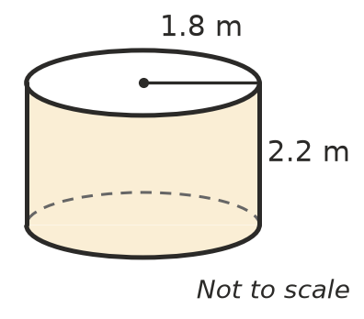
  - Find the volume of the tank in cubic metres, correct to 2 decimal places. (1 mark)

  - How many litres does the tank hold when it is full? Give your answer to the nearest litre. (1 m³ = 1000 L) (1 mark)

  - The camp uses 950 L of water each day. For how many full days will a full tank last? (2 marks)

- The roof of a shed is a triangular prism. Its end is an isosceles triangle with a base of 4.8 m and a height of 1 m. The roof is 6 m long.
- 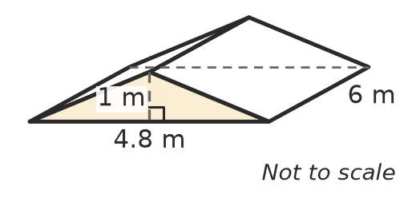
  - Find the length of each sloping side of the triangle. (1 mark)

  - Roofing iron covers the two sloping rectangles only. Find the area of roofing iron needed. (2 marks)

- A box is measured to the nearest centimetre. It is 30 cm long, 20 cm wide and 12 cm high, so its volume is calculated as 7200 cm³.
  - Find the smallest possible volume of the box. (2 marks)

  - Find the difference between 7200 cm³ and the smallest possible volume, as a percentage of 7200 cm³. Round to 1 decimal place. (1 mark)

- A cylinder has a radius r and a height h. Mia makes a new cylinder by doubling the radius and keeping the same height. Ellie makes a new cylinder by doubling the height and keeping the same radius.
  - How many times bigger than the original volume is the volume of Mia’s cylinder? Show how you know. (1 mark)

  - How many times bigger is the volume of Ellie’s cylinder? Whose cylinder has the bigger volume? (1 mark)

 Answer sheet
Name: ____________________
Write your final answer for each question in the table.
Question | Answer | Marks | Question | Answer | Marks
1a |  | /1 | 11a |  | /1
1b |  | /1 | 11b |  | /1
2a |  | /1 | 12a |  | /1
2b |  | /1 | 12b |  | /1
3 |  | /2 | 13a |  | /1
4 |  | /2 | 13b |  | /1
5a |  | /1 | 14a |  | /1
5b |  | /2 | 14b |  | /1
6 |  | /2 | 14c |  | /2
7a |  | /1 | 15a |  | /1
7b |  | /2 | 15b |  | /2
8a |  | /1 | 16a |  | /2
8b |  | /1 | 16b |  | /1
9 |  | /2 | 17a |  | /1
10 |  | /2 | 17b |  | /1
 |  |  |  | Total | /40

