Measurement: Practice test 2
Year 9 Maths · Test · Test 2
Name: ____________________ Date: ______________
Time: 45 minutes
Total: 40 marks
Show your working in the boxes. Then write each final answer on the answer sheet on the last page. Diagrams marked “Not to scale” are not drawn accurately, so use the measurements given instead of measuring.

 Section A: No calculator
In this section, leave $π$ in your answers when a question asks for an exact answer (for example, $25π$ cm²).
- Find the area of each shape.
  - This parallelogram. (1 mark)
- 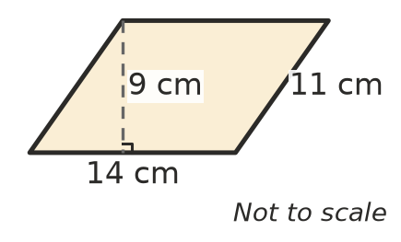

  - This rhombus. Its diagonals are 16 cm and 9 cm long. (1 mark)
- 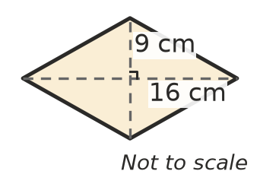

- Give each answer in terms of $π$.
  - Find the area of a circle with a diameter of 18 cm. (1 mark)

  - Find the area of a quarter circle with a radius of 8 cm. (1 mark)

- A metal plate is a rectangle with one corner cut off. Find the area of the plate. (2 marks)
- 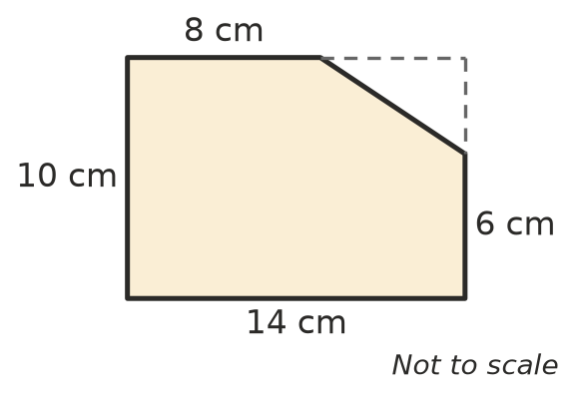

- A circular fish pond has an area of $64π$ m². Find the diameter of the pond. (2 marks)

- This net folds up to make a solid.
- 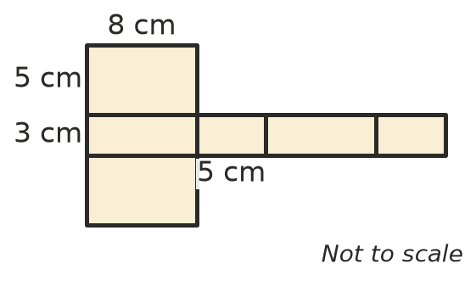
  - Name the solid. (1 mark)

  - Find the surface area of the solid. (2 marks)

- A swimming pool is 8 m long, 4 m wide and 2 m deep. The floor and the four walls are tiled. Find the area that is tiled. (2 marks)

- Find the volume of each prism.
  - A triangular prism. (1 mark)
- 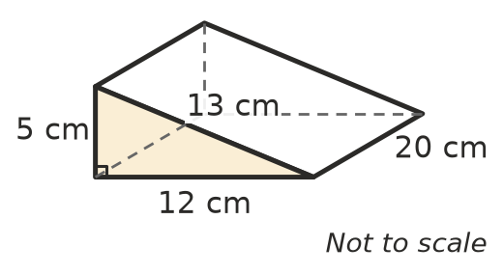

  - A prism with a trapezium-shaped cross-section. (2 marks)
- 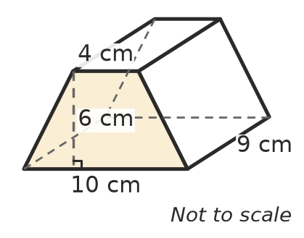

- A water trough for cattle is a rectangular prism 1.2 m long, 0.5 m wide and 0.4 m deep.
  - Find the volume of the trough in cubic metres. (1 mark)

  - How many litres of water does the trough hold when it is full? (1 m³ = 1000 L) (1 mark)

- A candle is a cylinder with a diameter of 10 cm and a height of 8 cm. Find its volume in terms of $π$. (2 marks)

- A tin with a lid is a closed cylinder with a radius of 5 cm and a height of 9 cm. Find its total surface area in terms of $π$. (2 marks)

- A plank of wood is measured as 2.4 m long, correct to the nearest 0.1 m.
  - Write the smallest and the largest value that the real length could be. (1 mark)

  - What is the largest possible absolute error? (1 mark)

- Ella’s kitchen scales show 240 g for a bag of flour. The flour actually has a mass of 250 g.
  - Find the absolute error. (1 mark)

  - Find the percentage error, compared with the actual mass. (1 mark)

- Give each answer in scientific notation.
  - A red blood cell is about 0.000 007 m wide. (1 mark)

  - The mass of the Moon is about $7.3×{10}^{22}$ kg. Write this mass in tonnes. (1 t = 1000 kg) (1 mark)

 Section B: Calculator allowed
- A round hay bale is a cylinder with a diameter of 1.5 m and a height of 1.2 m. It is standing on one end.
- 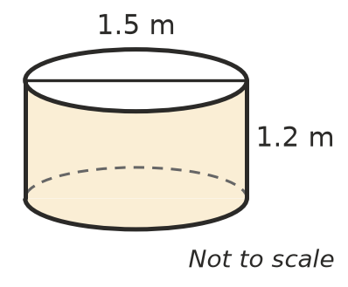
  - Find the volume of the bale in cubic metres, correct to 2 decimal places. (1 mark)

  - The whole bale (the curved surface and both ends) is wrapped in plastic. Find the area of plastic needed for one bale, correct to 1 decimal place. (1 mark)

  - A roll of plastic covers 100 m². How many bales can be fully wrapped with one roll? (2 marks)

- A wheelchair ramp is a solid triangular prism. Its side is a right-angled triangle that rises 0.7 m over a horizontal distance of 2.4 m. The ramp is 1.5 m wide.
- 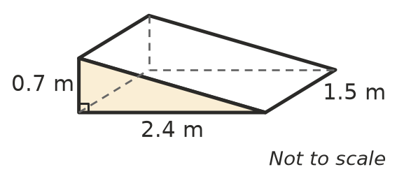
  - Find the length of the sloping surface. (1 mark)

  - All five faces of the ramp are painted. Find the total surface area. (2 marks)

- A cylindrical container is measured to the nearest centimetre. Its radius is 5 cm and its height is 12 cm, so its volume is calculated as $300π$ cm³ (about 942.5 cm³).
  - Find the largest possible volume of the container, correct to 1 decimal place. (2 marks)

  - Find the largest possible error in the volume as a percentage of the calculated volume. Round to 1 decimal place. (1 mark)

- Tom says, “A box with a bigger volume always needs more cardboard.” Here are two closed boxes.
- Box P: 6 cm long, 6 cm wide and 1 cm high.
- Box Q: 4 cm long, 4 cm wide and 3 cm high.
  - Find the volume and the surface area of each box. (1 mark)

  - Explain how these two boxes show that Tom is wrong. (1 mark)

 Answer sheet
Name: ____________________
Write your final answer for each question in the table.
Question | Answer | Marks | Question | Answer | Marks
1a |  | /1 | 11a |  | /1
1b |  | /1 | 11b |  | /1
2a |  | /1 | 12a |  | /1
2b |  | /1 | 12b |  | /1
3 |  | /2 | 13a |  | /1
4 |  | /2 | 13b |  | /1
5a |  | /1 | 14a |  | /1
5b |  | /2 | 14b |  | /1
6 |  | /2 | 14c |  | /2
7a |  | /1 | 15a |  | /1
7b |  | /2 | 15b |  | /2
8a |  | /1 | 16a |  | /2
8b |  | /1 | 16b |  | /1
9 |  | /2 | 17a |  | /1
10 |  | /2 | 17b |  | /1
 |  |  |  | Total | /40

