Measurement: Practice test 1
Year 9 Maths · Test · Test 1
Name: ____________________ Date: ______________
Time: 45 minutes
Total: 40 marks
Show your working in the boxes. Then write each final answer on the answer sheet on the last page. Diagrams marked “Not to scale” are not drawn accurately, so use the measurements given instead of measuring.

 Section A: No calculator
In this section, leave $π$ in your answers when a question asks for an exact answer (for example, $25π$ cm²).
- Find the area of each shape.
  - This trapezium. (1 mark)
- 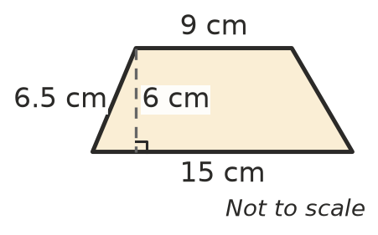

  - This kite. Its diagonals are 14 cm and 10 cm long. (1 mark)
- 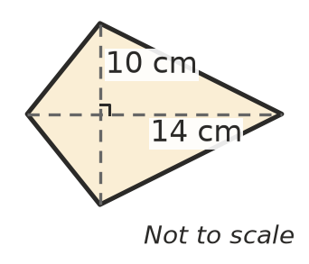

- Give each answer in terms of $π$.
  - Find the area of a circle with a radius of 7 cm. (1 mark)

  - Find the area of a semicircle with a diameter of 12 cm. (1 mark)

- A school badge is a rectangle with a semicircle on one end. Find the area of the badge. Give your answer in terms of $π$. (2 marks)
- 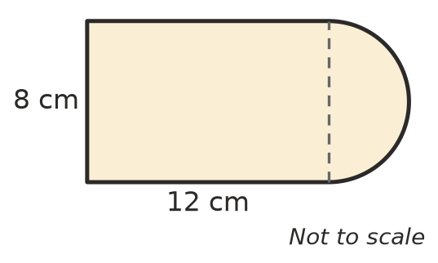

- A garden bed is shaped like a trapezium. Its area is 72 m² and its parallel sides are 5 m and 11 m long. Find the perpendicular distance between the parallel sides. (2 marks)

- This net folds up to make a solid.
- 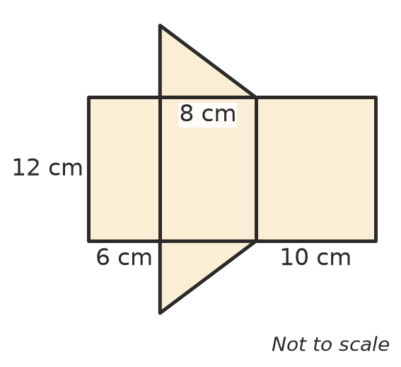
  - Name the solid. (1 mark)

  - Find the surface area of the solid. (2 marks)

- In Woodtech, Kai makes a planter box with no lid. It is 40 cm long, 25 cm wide and 20 cm high. Find the outside surface area of the box. Ignore the thickness of the wood. (2 marks)

- Find the volume of each prism.
  - A triangular prism. (1 mark)
- 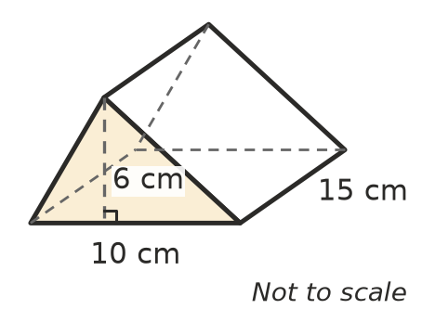

  - A prism with an L-shaped cross-section. (2 marks)
- 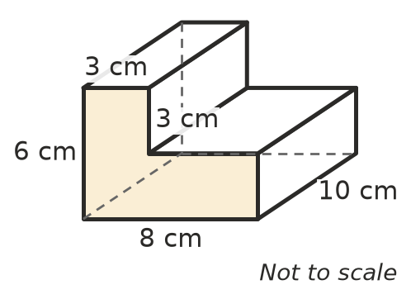

- A fish tank is a rectangular prism 60 cm long, 30 cm wide and 40 cm high.
  - Find the volume of the tank in cubic centimetres. (1 mark)

  - How many litres of water does the tank hold when it is full? (1 cm³ = 1 mL) (1 mark)

- A can of tomatoes is a cylinder with a radius of 4 cm and a height of 10 cm. Find its volume in terms of $π$. (2 marks)

- A closed cylinder has a radius of 3 cm and a height of 7 cm. Find its total surface area in terms of $π$. (2 marks)

- The distance from the goal line to the centre of a footy oval is measured as 82 m, correct to the nearest metre.
  - Write the smallest and the largest value that the real distance could be. (1 mark)

  - What is the largest possible absolute error? (1 mark)

- Sam estimates that the school hall is 40 m long. It is actually 50 m long.
  - Find the absolute error in Sam’s estimate. (1 mark)

  - Find the percentage error, compared with the actual length. (1 mark)

- Give each answer in scientific notation.
  - A human hair is about 0.000 08 m wide. (1 mark)

  - The Sun is about $1.5×{10}^{8}$ km from Earth. Write this distance in metres. (1 mark)

 Section B: Calculator allowed
- A farm has a cylindrical rainwater tank with a diameter of 3.2 m and a height of 2.5 m.
- 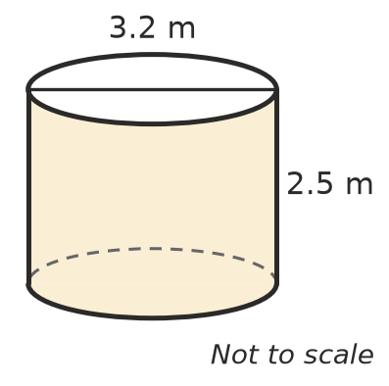
  - Find the volume of the tank in cubic metres, correct to 2 decimal places. (1 mark)

  - How many litres does the tank hold when it is full? Give your answer to the nearest litre. (1 m³ = 1000 L) (1 mark)

  - The curved side and the flat top of the tank are painted. The base is not. Find the area to be painted, correct to 1 decimal place. (2 marks)

- A tent is a triangular prism. Its front is an isosceles triangle with a base of 2.4 m and a height of 1.6 m. The tent is 3 m long.
- 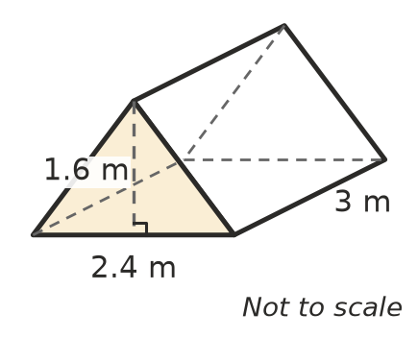
  - Find the length of each sloping side of the triangle. (1 mark)

  - The floor, the two triangular ends and the two sloping sides are all made of fabric. Find the total area of fabric. (2 marks)

- A box is measured to the nearest centimetre. It is 20 cm long, 15 cm wide and 10 cm high, so its volume is calculated as 3000 cm³.
  - Find the largest possible volume of the box. (2 marks)

  - Find the largest possible error in the volume as a percentage of 3000 cm³. Round to 1 decimal place. (1 mark)

- Two closed boxes each hold 64 cm³. Box A is a cube with sides of 4 cm. Box B is 16 cm long, 2 cm wide and 2 cm high.
  - Find the surface area of each box. (1 mark)

  - Which box needs less cardboard? Explain what this tells you about the best shape for a box that must hold a set volume. (1 mark)

 Answer sheet
Name: ____________________
Write your final answer for each question in the table.
Question | Answer | Marks | Question | Answer | Marks
1a |  | /1 | 11a |  | /1
1b |  | /1 | 11b |  | /1
2a |  | /1 | 12a |  | /1
2b |  | /1 | 12b |  | /1
3 |  | /2 | 13a |  | /1
4 |  | /2 | 13b |  | /1
5a |  | /1 | 14a |  | /1
5b |  | /2 | 14b |  | /1
6 |  | /2 | 14c |  | /2
7a |  | /1 | 15a |  | /1
7b |  | /2 | 15b |  | /2
8a |  | /1 | 16a |  | /2
8b |  | /1 | 16b |  | /1
9 |  | /2 | 17a |  | /1
10 |  | /2 | 17b |  | /1
 |  |  |  | Total | /40

