9.08 Volume of cylinders
Year 9 Maths · Worksheet · Level 3 · Challenge
Name: ____________________ Date: ______________
This worksheet challenges you with hollow and composite solids, working backwards, scaling, and design problems where volume and surface area both matter. Tip: V = $πr^{2}h$. Keep answers exact in terms of $π$ for as long as you can, and round only at the end.

 Understanding
- Find the exact volume of each solid, in terms of $π$.
  - a pipe 50 cm long with an outside diameter of 10 cm and an inside diameter of 8 cm ______________
  - a half cylinder with a radius of 6 cm and a length of 20 cm ______________
- A cylinder’s height is three times its radius.
  - Show that its volume is $3πr^{3}$. ______________
  - Its volume is $81π$ cm³. Find its radius and height. ______________

 Fluency
- A cylindrical container must hold exactly 1 L and be 15 cm tall. Find its radius, to 2 decimal places.

- A cylindrical hole with a radius of 4 cm is drilled straight down through a block of wood 20 cm by 20 cm by 10 cm. Find the volume of wood left, to 1 decimal place.
- 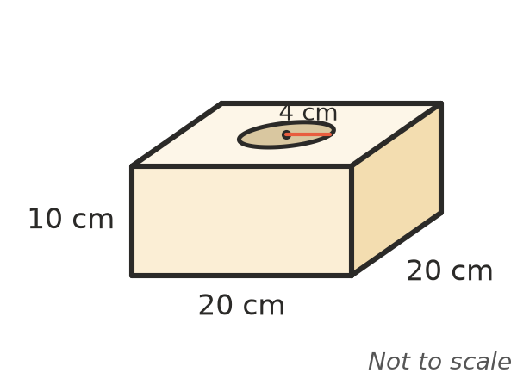

 Reasoning
- The radius and the height of a cylinder are both increased by 20%. By what percentage does its volume increase? Explain.

- An A4 sheet of paper is 29.7 cm by 21 cm. It can be rolled into an open tube with the long side going around, or with the short side going around.
  - Find the volume of each tube, to 1 decimal place. ______________
  - Which holds more? Show that the ratio of the two volumes is 29.7 : 21. ______________
- Show that the largest cylinder that fits inside a cube with edges of s cm has exactly $\frac{π}{4}$ of the cube’s volume.

 Problem solving
- A drink company wants a can that holds 375 mL.
  - If the radius is 3.3 cm, find the height and the surface area of the closed can, to 2 decimal places. ______________
  - If the radius is 3.9 cm, find the height and the surface area. ______________
  - Which design uses less aluminium? Why might the company still choose the other one? ______________
- 20 mm of rain falls on a roof with an area of 150 m². All the water runs into an empty cylindrical tank with a radius of 1.1 m. How deep is the water in the tank, to the nearest centimetre?

- Water flows through a hose with an inside diameter of 2 cm at a speed of 1.5 m per second.
  - What volume of water comes out each second, in cm³? (Think of a cylinder of water 150 cm long.) ______________
  - How long does it take to fill a 200 L bath, to the nearest tenth of a minute? ______________
- A metal cube with edges of 4 cm is dropped into a cylindrical jar of water with a radius of 5 cm. The cube sinks to the bottom and is completely covered. By how much does the water level rise, to 2 decimal places?

- A solid metal block 10 cm by 8 cm by 6 cm is melted down and made into a cylindrical rod with a radius of 2 cm. How long is the rod, to 1 decimal place?

- Twelve cans, each with a radius of 4 cm and a height of 12 cm, are packed in 4 rows of 3 in a box that fits them exactly.
  - Find the percentage of the box that is empty space, to 1 decimal place. ______________
  - Show that the answer does not depend on the size of the cans or how many there are, as long as they are packed in rows like this. ______________

