9.08 Volume of cylinders
Year 9 Maths · Worksheet · Level 1 · Warm-up
Name: ____________________ Date: ______________
A cylinder is like a prism with a circle for its cross-section, so its volume is the area of the circle times the height: V = $πr^{2}h$. Tip: always use the radius, not the diameter, and remember that 1 cm³ = 1 mL and 1 m³ = 1000 L.

 Understanding
- A cylinder has a radius of 3 cm and a height of 10 cm.
  - Find the area of its circular base, to 2 decimal places. ______________
  - Multiply by the height to find its volume, to 1 decimal place. ______________

 Fluency
- Find the volume of each cylinder, to 1 decimal place.
- 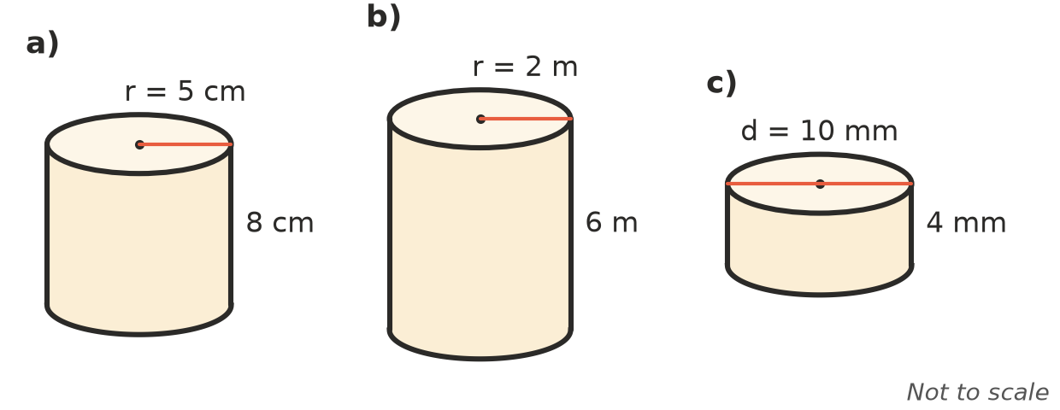
  - ______________
  - ______________
  - ______________
- Find the exact volume of a cylinder with a radius of 4 cm and a height of 5 cm, in terms of $π$. ______________
- A drink can has a radius of 4 cm and a height of 12 cm.
  - Find its volume, to 1 decimal place. ______________
  - How many millilitres does it hold, to the nearest millilitre? ______________

 Reasoning
- Explain why the volume of a cylinder can be found the same way as the volume of a prism.

- A cylinder has a diameter of 6 cm and a height of 10 cm. Ravi works out $π$ × $6^{2}$ × 10 = 1131 cm³. Explain his mistake and find the correct volume, to 1 decimal place.

 Problem solving
- A water tank is a cylinder with a radius of 1 m and a height of 2 m. How many litres does it hold, to the nearest litre?

- A glass is a cylinder with a radius of 3.5 cm and a height of 12 cm.
  - How many millilitres does it hold, to 1 decimal place? ______________
  - How many glasses can be filled completely from a 1.5 L bottle? ______________
- A water pipe is 10 m long and has an inside radius of 5 cm. How many litres of water does it hold when full, to 1 decimal place? (Hint: change 10 m to centimetres.)

- A round hay bale is a cylinder with a diameter of 1.5 m and a length of 1.2 m. Find its volume, to 2 decimal places.

- A round cake tin has a diameter of 20 cm and a height of 8 cm. Find its volume to the nearest cm³, and its capacity in litres to 1 decimal place.

